TOWN OF BURKE - NEWSLETTER
DECEMBER 2021

www.townofburke.com

*************************************************************************

The Town Board and Staff would like to wish you all a very happy and memorable holiday season!

PROPERTY TAX PAYMENTS
Real Estate Property Tax Payments can be mailed, dropped in the night drop, or brought into the Town Hall office up to February 1, 2022. Payments postmarked on or before December 31 will be receipted same.
If you wish to have a receipt mailed to you, please include a self-addressed stamped envelope. Property tax payments made after February 1 must be payable to and mailed to the Dane County Treasurer. No receipts will be mailed without self-addressed stamped envelope.
If your escrow check received is more than the property taxes owed for this year, the Town will issue a refund check to you by the end of February.
Lottery Credit: If you lived in your home as of January 1, 2021 there should be a lottery credit on your tax bill; if the credit is not on your tax bill, complete a lottery credit claim form and submit it with your tax payment. Form can be found at: Treasurer.countyofdane.com/ Property Information / Lottery Credit.
For questions regarding your assessment, please contact Accurate Assessor at 1-800-770-3927 or info@accurateassessor.com.

PELLITTERI

STATE OF WISCONSIN
DOG LICENSE LAW

Wisconsin State Statute 174.07 requires all dogs over the age of 5 months be licensed. This is a service provided to you by the Town Clerk.

APPLICATION
The annual license fee is $30.00 or $20.00 if spayed or neutered (check or cash-separate from tax payment).

OWNERS NAME

DOG’S NAME
MALE/FEMALE SPAYED/NEUTERED

BREED

ADDRESS

PHONE
Proof of current rabies (from a licensed veterinarian) must be included subject to the provisions of chap. 174 of the statutes, and such provisions and regulations as may at any time be imposed by the state of Wisconsin.

SIGNATURE

DATE

Manufacturer and lot # of rabies shot, payment, and this completed form can be mailed, deposited in our night drop, or hand delivered to the Town office. Please include a self-addressed stamped envelope to receive your tag in the mail.
State Mandated $5.00 Late Fee effective April 1 so make sure to get your dog licensed as soon as possible.
Welcome Pellitteri to the Town of Burke. You will notice new trash and recycle bins for 2022. The Town Board held discussions regarding the Town trash/recycling and yard waste plans for 2022 and beyond. The Board determined the local company out of Madison would be a welcome fit.
Pellitteri will be picking up recycling and trash weekly, yes, weekly! They may also be picking up yard waste such as leaves and garden clippings. Watch the Town website for future calendars.
Pellitteri is well known for their customer service so feel free to call them directly if you have questions or better yet, sign up for their emails that will keep you up to date with holiday pickup information as well as recycling changes or improvements.
Please make sure to keep your trash and recycle bins behind the road/curb-line this winter for the safety of others.

TOWN BOARD SUPERVISOR POSITION
The Town of Burke has an open seat on the Board of Supervisors. Have you considered getting more involved in your municipality?
This position is an interim position from now until the seat is on the ballot in April. This may be the perfect trial period for you to make the decision that the work being done at the Town is very important and you would love to be a vital voice in it.
Please call the Town office to get more information or contact a current Town Supervisor.

2022 LOCAL ELECTIONS
There are two Supervisor positions up for election in spring, 2022. December 1, 2021 is the first day for candidates to begin circulating nomination papers for these seats with papers due to the Town Clerk no later than 5 p.m. on January 4, 2022. The Spring Election will be held April 5, 2022. The term is for two years. For questions, contact the Town office at 608-825-8420.

WINTER PARKING
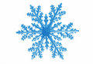
The Town of Burke follows alternate side parking rules from November 15 through April 15. You must park on the even house numbered side of the road between hours of 12:01 a.m. and 9:00 a.m. on even numbered days. You must park on the odd house numbered side of the road between hours of 12:01 a.m. and 9:00 a.m. on odd numbered days. There is no parking in cul-de-sacs or within 300 feet of the terminus of a dead-end.

2022 PROPERTY REVALUATION
The Town of Burke received its first notice of non-compliance with WI Statutes 70.05(5)(b) requiring all taxation districts to assess property at full value at least once in every 5-year period. If the Town does not undertake a revaluation of properties, it faces a Department of Revenue supervised revaluation which can be very costly. Town properties will undergo a revaluation for 2022. Stay tuned to the Town web site for more information about the revaluation. To contact the Assessor, call 1-800-770-3927 or email info@accurateassessor.com

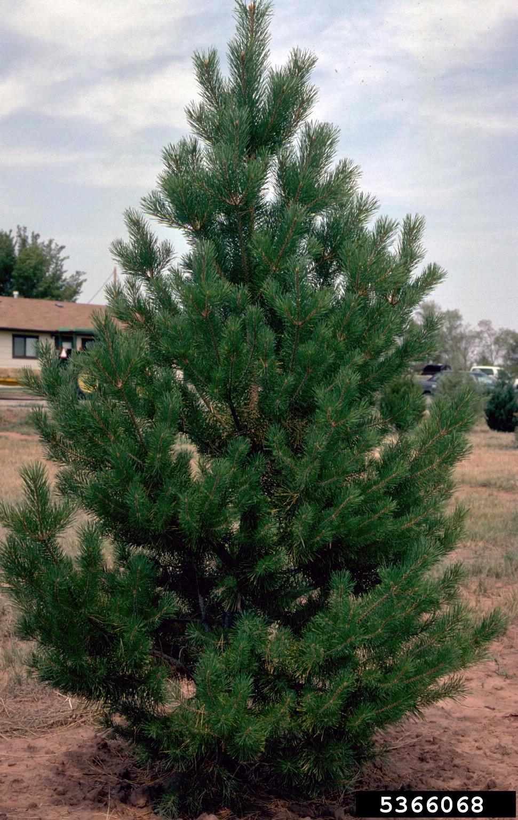
HOLIDAY TREES
Please check the Town website for pick up dates.
Make sure to remove all decorations, lights, and all inorganics.

Your Government
BOARD MEMBERS
Chairman Kevin Viney
Supervisor Steve Berg
Supervisor Jeff Stieren Supervisor Chris Truitt
Supervisor Vacant

Town Board meets at 6:00 p.m. the third Wednesday of the month at the Town of Burke municipal building, 5365 Reiner Road.
TOWN OFFICE
5365 Reiner Road
Madison WI 53718

PJ Lentz, CMC, WCMC
Administrator Clerk Treasurer
608-825-8421 townofburke@frontier.com
Elissa Friedl, WCMC
Deputy Clerk Treasurer
608-825-8420 townofburke2@frontier.com
OFFICE HOURS
M, T, W, Th: 9:00 a.m. – 3:00 p.m.
Friday: 9:00 a.m. – 12:00 p.m.
Or by Appointment
Office will be closed December 24 and December 31 in celebration of Christmas and New Year’s Day.

PUBLIC WORKS DEPT
Office825-8420
Ron Kurt445-2834

PELLITTERI WASTE SYSTEMS
Trash and Recycling257-4285

BUILDING INSPECTOR
Chris Butschke576-6371
Inspections688-0997

