CHAPTER 2

WELL HEAD PROTECTION

    - Purpose
    - Definitions
    - Applicability
    - Conflicts and Severability
    - Well Head Protection Area Overlay District
    - Enforcement and Abatement
    - Severability
    - Effective Date

SEC. 6-2-1 Purpose

The Town Board finds that a well head protection plan is necessary to protect municipal water wells from becoming contaminated from known sources of water contaminants, all as provided for or otherwise required pursuant to NR 811, Wis. Adm. Code.

SEC. 6-2-2 Definitions

The following words are defined in this chapter as follows:
- Well Head. A piece of land with a 50-foot radius centered on the drilled well.
- Cone of Depression. A depression in the water table created when a well pumps water at a faster rate than the aquifer can supply water to a well located in a unconfirmed aquifer.
- Recharge Area. Area in which water reaches the Groundwater by surface infiltration and encompasses all areas or features that supply groundwater recharge to a well.
- Zone of Influence. This is the outer diameter of the Cone of Depression or cone shaped area around a well in which the water level has been lowered by pumping of a given well at its design capacity.
- Well Head Protection Area. The well head protection area shall encompass, at a minimum, that portion of the Recharge Area equivalent to a 5-year time of travel to the well.
- Five Year Time of Travel (TOT). The five-year TOT is the Recharge Area up­ gradient of the Cone of Depression, the outer boundary of which it is determined or estin1ated that groundwater and potential contaminants will take five years to reach a pumping well(s).
- Zone of Contribution. This is the area from which the well receives water to refill the Cone of Depression to a maximum of the five-year Time of Travel plus that portion of the zone of influence which flows to the well.
- Facilities. This means any and all structures, buildings, storage tanks, facilities or other improvements to real estate which are used or useable for any activity.

Any other terms not expressly defined herein, shall have the meanings given in NR 811, Wis. Adm. Code.

SEC. 6-2-3 Applicability

This Chapter shall apply to all persons (organizations or individuals) and appropriate water pumping activities within the corporate limits of the Town of Burke (the "Town").

SEC, 6-2-4 Conflicts and Severability

The provisions of this Chapter shall be held to be minimum requirements; and shall not be deemed a limitation or repeal of any other power, limitation, requirement or standard as established by the Wisconsin Statutes or Dane County Ordinances or administrative rules, and their interpretation and application. Because this Chapter creates a comprehensive, mandatory source separation recycling program in the Town, where any terms or requirements of this Chapter may be inconsistent or conflicting the more restrictive requirements or interpretations consistent with state and county law shall control. If any section, provision, or portion of this Chapter is found unconstitutional or invalid by a court, the remainder of the Chapter shall remain enforceable and shall not be affected by that ruling.

SEC. 6-2-5 Well Head Protection Area Overlay District (Hereinafter called the "District")

- INTENT. The geographic area to be protected is the area surrounding the Token Creek Sanitary District (the "Sanitary District") Municipal Water well(s). Accordingly, there is hereby established a Well Head Protection Area which is delineated on the attached Exhibit 1, which Exhibit is incorporated herein. The Well Head Protection Area is subject to development restrictions as hereinafter provided, because of their close proximity to the Sanitary District well head and the corresponding high threat of contaminants.
- PERMITTED USES. All uses in the Well Head Protection Area which are authorized under the assigned zoning District(s) from time to me in effect, are subject to the requirements/restrictions listed herein.
- REQUIREMENTS FOR EXISTING FACILITIES. Owners and/or operators of Facilities that are located within the Well Head Protection Area as of the effective date of this Ordinance, are subject to the following requirements:
  - Owners and/or operators of such Facilities shall provide to the Town copies of all federal, state, and local certificates or approvals given or granted to such persons which relate in any way to the operation of such Facilities. In the event any such Facilities are required to submit reports to any governmental authority having appropriate jurisdiction concerning any environmental matter in, on or near the Facility, a copy of such report(s) shall be given to the Town. Copies required to be given to the Town hereunder shall be given as and when filed with the other governmental authorities.
  - Owners and/or operators of such Facilities shall provide to the Town additional environmental and/or safety monitoring reports and information as may be reasonably required by the Town in order to prevent groundwater contamination. Such reports and information may include stormwater runoff management and monitoring.
  - In the event any equipment is located with any Facilities, which equipment causes or may cause contamination of the groundwater, then in such event, the Town may require the owner of the Facilities to replace such equipment so as to eliminate the potential for groundwater contamination.
l
  - The owners and/or operators of all Facilities shall prepare and file with the Town, a contingency plan which responds in the event of an emergency at the Facility that would cause contamination of groundwater within the Well Head Protection Area. Such plan shall be subject to the approval of the Town and shall include immediate notification of Town and other governmental authorities of any such emergency.
- REQUIREMENTS FOR NEW FACILITIES. Prior to the issuance of a building permit for any proposed Facilities to be located within the Well Head Protection Area, all Builders/Owners shall file with the Town a report concerning the construction and operation of the Facility, including a site plan which provides for the following information at a minimum:
  - A contingency plan satisfactory to the Town for the immediate notification of Town officials in the event of an emergency at the Facility that could potentially contaminate the groundwater in the Well Head Protection Area.
  - Environmental or safety monitoring of the Facility as deemed necessary by the Town, which may include but are not limited to stormwater runoff management and monitoring.
- SEPARATION STANDARDS/LIMITATIONS. The Wells of the Sanitary District shall be adequately separated from potential sources of contamination. Unless a hydrogeologic investigation indicates lesser separation, distances would provide adequate protection of a well of the Sanitary District from contamination, the minimum separation distances provided shall be:
  - Fifty feet between such well and a storm sewer main.
  - Two hundred feet between such well and any sanitary sewer main, lift station or single-family residential fuel oil tank. A lesser separation distance may be allowed for sanita1y sewer mains when the sanitary sewer main is constructed of water main materials and joints and pressure tested in-place to meet current AWWA 600 specifications. In no case may the separation distance between such well and a sanitary sewer main be less than 50 feet.
  - Four hundred feet between such well and a septic tank receiving less than 8,000 gallons per day, a cemete1y or a storm water drainage pond.
  - Six hundred feet between such well and any gasoline or fuel oil storage tank installation that has received written approval from the Department of Industry, Labor and Human Relations or its designated agent under s. ILHR 10.10.
  - One thousand feet between such well and land application of municipal, commercial, or industrial waste or sludge; industrial, commercial or municipal wastewater lagoons or storage structures; manure stakes or storage structures; and septic tanks or soil absorption units receiving 8,000 gallons per day or more.
  - Twelve hundred feet between such well and any solid waste storage, transportation, transfer, incineration, air curtain destructor, processing, wood burning, one time disposal or small demolition facility; sanitary landfill; coal storage area; salt or deicing material storage area; gasoline or fuel storage tanks that have not received written approval from the Department of Industry, Labor and Human Relations or its designated agent under s. ILHR 10.10; bulk fuel storage facilities; and pesticide or fertilizer handling or storage facilities.

SEC. 6-2-6 Enforcement and Abatement

- Violations Constitute Public Nuisance. Any violation by any person of the provisions of this Ordinance shall constitute a public nuisance; and such nuisance may be enjoined, and this Ordinance enforced as provided for in Chapter 823 of the Wisconsin Statutes.
- Damages. Any person found in violation of this Ordinance shall pay to the Sanitary District and/or Town such damages, losses or expenses as may be sustained by them as a result of the violation, including but not limited to attorney's fees and other costs of enforcement proceedings.
- Mandatory Abandonment. If any person found in violation of this Ordinance shall fail to comply with the terms hereof for more than three (3) days after receipt of written notice of such violation, the Town may enter upon the premises of such person, may cause the well contamination to be corrected and may assess the cost and expense thereof, as a special tax or charge against the said premises.
- Fines. Any person found in violation of any provision of this Ordinance shall forfeit the sum of One Thousand Dollars ($1,000.00) for each day the violation shall continue; and it is hereby declared that each clay a violation shall continue shall constitute a separate violation for purposes hereof.
- Remedies Cumulative. All remedies provided for in this Ordinance are distinct and cumulative to any other right or remedy contained herein or afforded by law or in equity; and may be exercised by the Town concurrently, independently, or successively.

SEC. 6-2-7 Severability

If any provision of this Ordinance is invalid or unconstitutional or if the application of this Ordinance to any person or circumstance is invalid or unconstitutional, such invalidity or unconstitutionality shall not affect the other provisions or applications of this Ordinance which can be given effect without the invalid or unconstitutional provisions or applications.

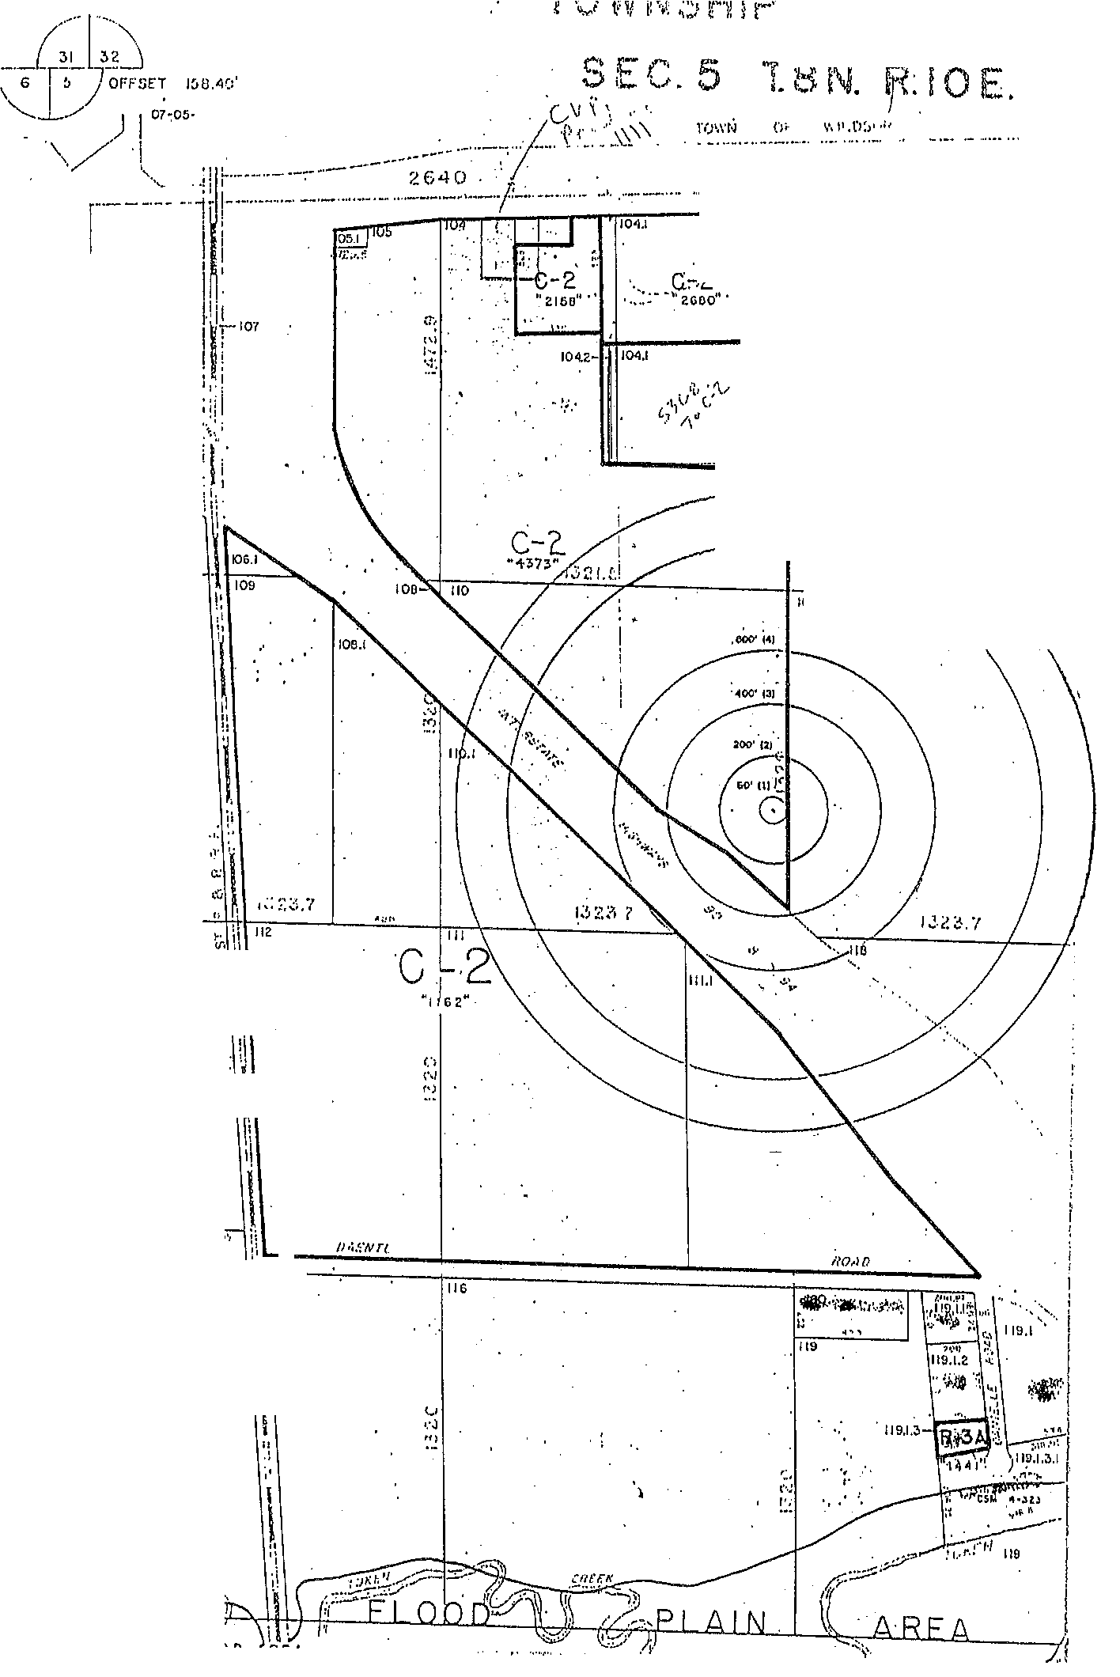

\
\
\
:i

