NOTICE OF PUBLIC HEARING
Notice of Public Hearing on Proposed Intergovernmental Revenue Sharing Agreement
between the Village of DeForest and the Town of Burke

Thursday, June 15, 2023 at 6:00 PM
DeForest Municipal Building
120 South Stevenson Street, DeForest, WI 53532

Attend in-person at the address above or Join Zoom Meeting
https://us06web.zoom.us/j/89853514264?pwd=dmpFV1hLWnd0SjVJV2JGcHdGZTIvdz09
Meeting ID: 898 5351 4264 Passcode: 305180 Phone: (312) 626-6799

Notice is hereby given that the governing bodies of the Village of DeForest and the Town of Burke will hold a joint public hearing on June 15, 2023 at 6 p.m. at the Village of DeForest Village Hall, located at 120 South Stevenson Street. The public hearing will be held to receive public comments on a proposed intergovernmental revenue sharing agreement between the Village of DeForest and the Town of Burke. Copies of the proposed agreement may be obtained from the DeForest Village Clerk or Burke Town Clerk at the addresses below.

PJ Lentz, Clerk Callista Lundgren, Clerk
Town of Burke Village of DeForest
5365 Reiner Rd 120 S Stevenson Street
Madison, WI 53718 DeForest, WI 53532

Written comments on the proposed agreement may be submitted to either clerk prior to the public hearing.

Class 3 Notice Published May 19, May 26 and June 2, 2023 in the DeForest Daily Times.

POSTED AT: DeForest Village Hall www.vi.deforest.wi.us

Posted: May 11, 2023

________________________________________________________

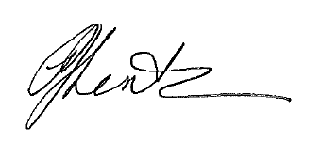
Notice Posted May 10, 2023 at Town Hall and TownofBurke.com

