NOTICE OF PUBLIC HEARING

NOTICE IS HEREBY GIVEN, that a Public Hearing will be held before the Town Board of the Town of Burke on Tuesday April 16, at 5:50 pm located at Burke Town Hall, 5365 Reiner Road, Madison, Wisconsin, regarding the Town of Burke Comprehensive Plan recommended update per State Statute 66.1001(2)(i) by the Town of Burke Plan Commission on March 6, 2024. A copy of the Town of Burke Comprehensive Plan may be inspected prior to the public hearing at the Burke Town Hall. Please contact the Town Clerk if you wish to view the draft electronically.

NOTE: If you cannot attend the Public Hearing, and wish to express your opinion on this issue, you may write a letter of support or opposition to the Town and mail it to:

Town of Burke
5365 Reiner Road
Madison WI 53718
Clerk@TownofBurke.com

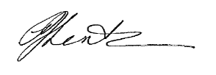
PJ Lentz
Administrator/Clerk/Treasurer
Town of Burke
3.14.2024

