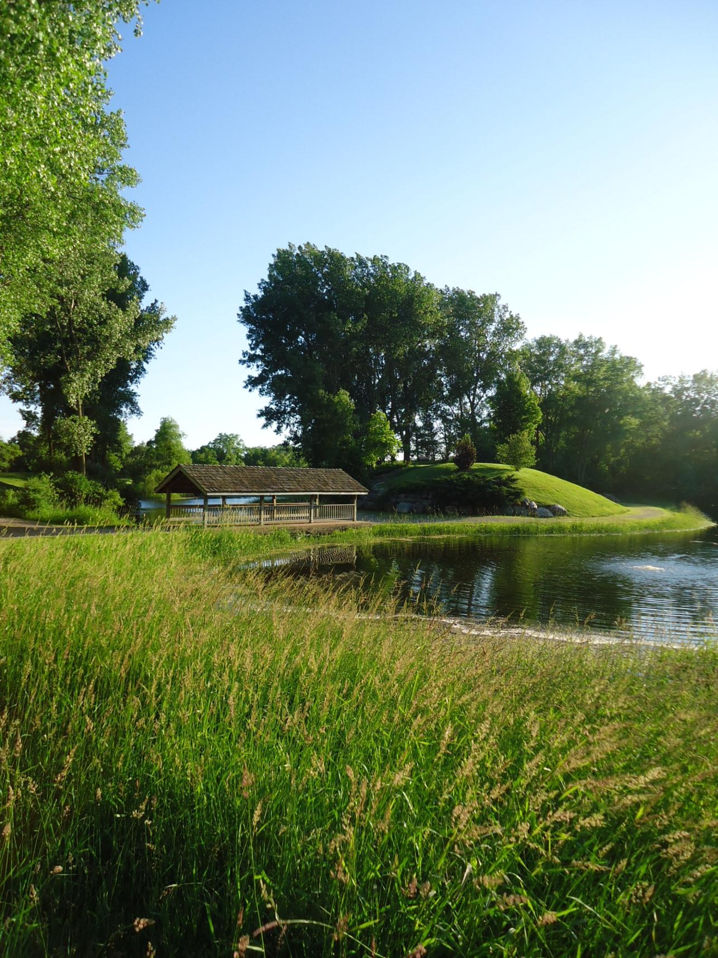
TOWN OF BURKE
DANE COUNTY, WISCONSIN

COMPREHENSIVE PLAN 2034

Plan Commission Recommended Adoption: March 6, 2024
Town Board Adoption: April 16, 2024
Dane County Board Adoption:

THIS PAGE LEFT BLANK INTENTIONALLY

ADOPTING ORDINANCES & RESOLUTIONS

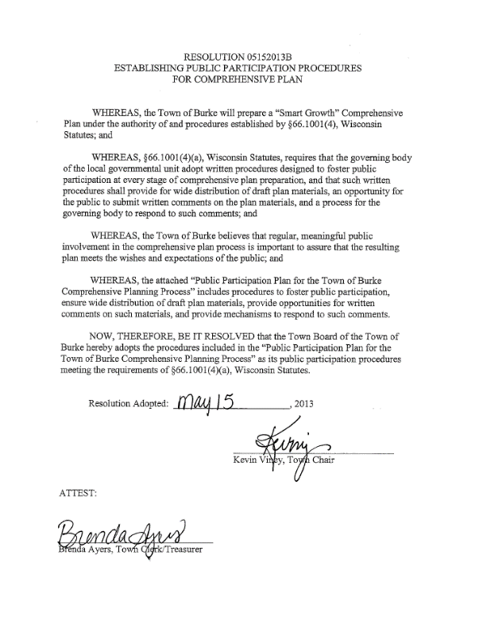

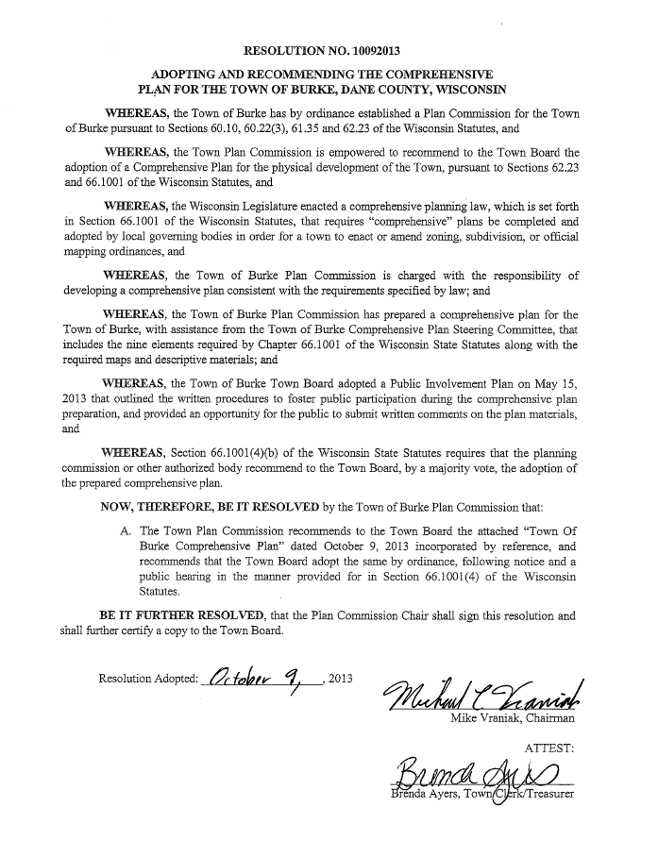

Insert new Resolution once passed.

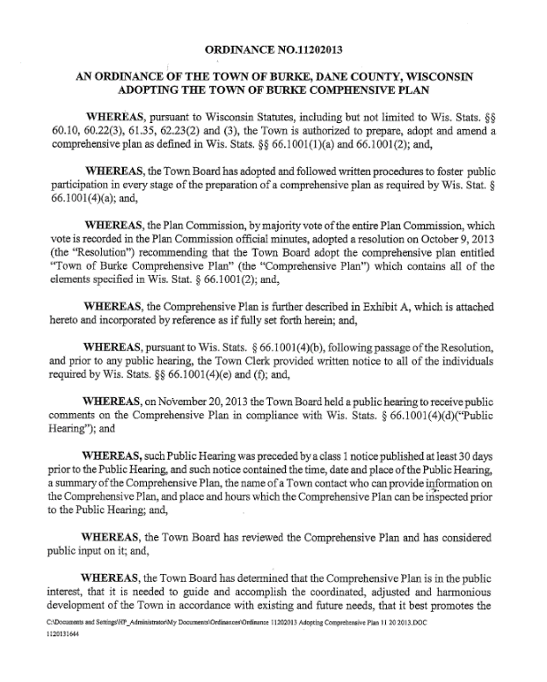

Insert new Ordinance once passed.

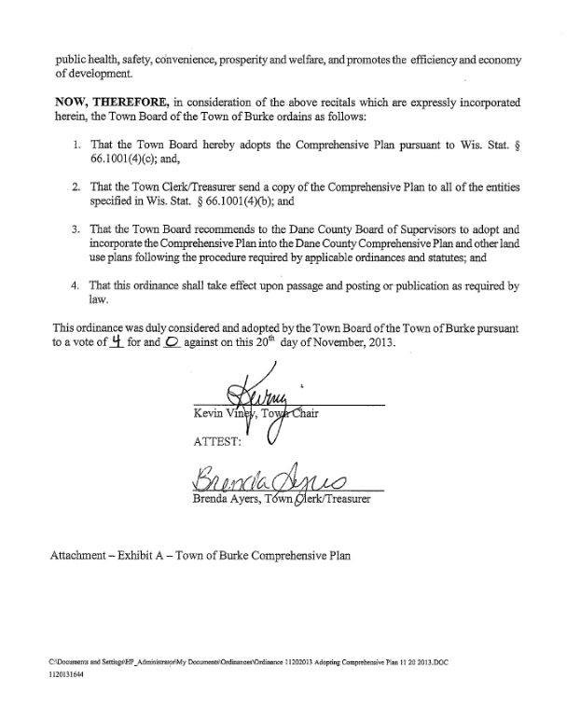

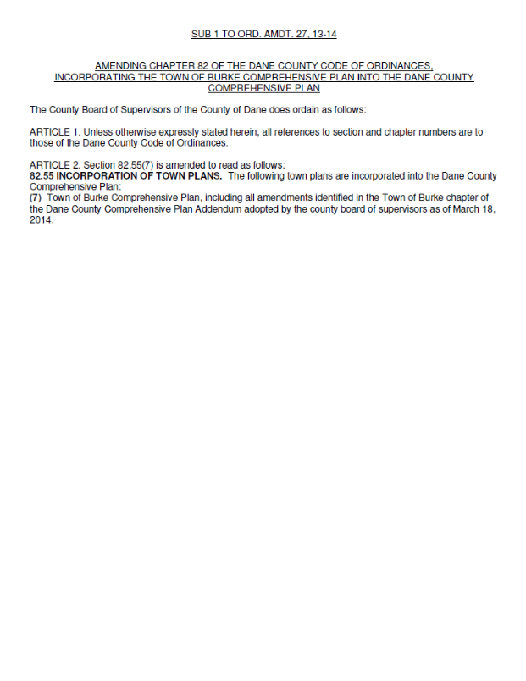

Insert new Ordinance once passed.

ACKNOWLEDGEMENTS

Town Board
Kevin Viney, Town Chair
Steve Berg

PJ & Plan Commission –

Please confirm correct Acknowledgements considering March 2024 PC approval and April 2024 Board approval.
Lisa Rubrich
Jeff Stieren
Chris Truitt

Town Plan Commission
Steve Berg
Ron Dorsh
Skip Kraiss
Pam Lano
Garrick Palay
Lindsey Slack
Joan Stoflet

Town Staff
PJ Lentz, CMC, WCMC – Administrator, Clerk, Treasurer
Ron Kurt, Public Works

Planning Assistance by:
Mark Sauer, AICP
Mike Lewis

2440 Deming Way
Middleton, WI 53562
www.meadhunt.com

Cover Photo courtesy Mead & Hunt, Inc., 2013

TOWN OF BURKE COMPREHENSIVE PLAN SUMMARY_____________

The Town of Burke Comprehensive Plan (Plan) was originally adopted by the Town in 2013 as a decision-making guide for the physical, social, and economic development of the community over a 20-year planning horizon. The plan was amended twice over a ten year period between 2013 and 2023. In 2023, the Town Plan Commission reviewed and made minor edits to the 2013 Plan as an update to serve as the town’s guide for the next 12 years. Per the Final Town of Burke, Village of DeForest, City of Sun Prairie and City of Madison Cooperative Plan, the Town of Burke will be dissolved by October 27, 2036.

WHO WILL USE THIS PLAN

What does this Comprehensive Plan Include?

Chapter 1: The Town’s vision for the next 12 years.

Chapter 2: The Town’s plan for joint planning and decision making with other surrounding jurisdictions.

Chapter 3: Opportunities and constraints posed by the Town’s agricultural, natural, and cultural assets.

Chapter 4: Where and how land will develop over the next 12 years.

Chapter 5: Opportunities of the Town’s transportation network.

Chapter 6: An inventory of community utilities and facilities.

Chapter 7: The future character of housing in the Town.

Chapter 8: Strategies for attracting and retaining businesses.

Chapter 9: Key recommendations of the Comprehensive Plan and steps to carry them out.

This Plan will be utilized by elected officials and decision makers from the Town of Burke and surrounding municipalities. Residents, visitors, and developers will also find this Plan useful in answering questions related to community decision making on land use, community character, and economic development.

WHAT THIS PLAN DOES
This Plan provides a framework and strategy for making decisions about development in and around the Town. The Plan contains background information from the Town and surrounding municipalities in order for its readers to understand why development has occurred where it has and how development might occur in the future.

WHY THIS PLAN WAS PREPARED
Wisconsin Statutes require the Town’s Comprehensive Plan to be updated every 10 years. This plan complies with the State requirement. The Town of Burke Board of Supervisors and the Town of Burke Plan Commission have approved the final Comprehensive Plan for the Town’s remaining years.

WHERE THIS PLAN IS FOUND
This Plan is found at the Burke Town Hall and on the Town website: www.townofburke.com.

WHEN THE PLAN IS IMPLEMENTED
This Plan is a guide for the remaining years for the Town of Burke ending in October 2036. Incorporated into this Plan are recommendations for updating this Plan over the next 12 years. This Plan will need to be reviewed continuously and updated by the Town, as needed, following its adoption.

HOW THIS PLAN IS PREPARED
The Plan is a compilation of research, public input, and official Town actions.

TABLE OF CONTENTS
Page
Introduction 15
Purpose of this Plan 15
Planning Process 16
Town of Burke Legacy 18

Chapter One: Issues and Opportunities 19
Population Trends and Forecasts 20
Table 1: Historic Population, 1970 – 2020 20
Table 2: Population Trends, 1980 – 2020 21
Map 1: Jurisdictional Boundaries 22
Table 3: Population Forecasts, 2020 – 2040 23
Household Trends and Forecasts 23
Table 4: Household Characteristic Comparisons, 2020 24
Table 5: Housing Occupancy Characteristics Comparison, 2020 25
Table 6: Household Projections, 2020 – 2030 25
Age and Gender Trends and Forecasts 26
Table 7: Age and Gender Characteristics, 2020 26
Table 8: Dane County Age Cohort Forecasts, 2010 – 2035 26
Employment Trends and Forecasts 27
Table 9: Labor Force Characteristics, 2020 27
Education and Income Levels 28
Table 10: Educational Attainment, 2020 28
Table 11: Income Comparison, 2020 29
Public Involvement 29
Key Planning Issues 32
Regional and County Opportunities 32
Map 2: Regional Influences 34
Overall Goals, Objectives, Policies, Programs and Recommendations 35
Town of Burke Vision Statement 36

Chapter Two: Intergovernmental Cooperation 37
Map 3: Final Boundary Adjustment Areas (Cooperative Agreement) 40
Map 4: Town of Burke Protected Areas (Cooperative Agreement) 41
Map 4a. Protected Areas in Detail 42
Existing Regional Framework 45
Intergovernmental Conflicts and Resolution 49
Intergovernmental Cooperation Goals, Objectives and Policies 49
Intergovernmental Cooperation Programs and Recommendations 50

Chapter Three: Agricultural, Natural and Cultural Resources 51
Agricultural Resources 52
Figure 1: Land Use Trends in Dane County, 2010 – 2020 52
Map 5: Soils 54
Agricultural Resource Goals, Objectives, and Policies 56
Agricultural Resource Programs and Recommendations 56
Natural Resource Inventory 57
Table 12: Threatened Endangered and Special Concern Species in Burke 64
Map 6: Natural Features 65
Natural Resource Goals, Objectives, and Policies 66
Natural Resource Programs and Recommendations 67
Cultural Resources 70
Cultural Resource Goals, Objectives, and Policies 72
Cultural Resource Programs and Recommendations 73

Chapter Four: Land Use 75
Existing Land Use Map Categories 76
Map 7: Existing Land Use 78
Existing Land Use Pattern 79
Table 13: Existing Land Use Totals, Burke 79
Land Development and Market Trends 80
Table 14: Total Equalized Values 80
Land Supply 81
Projected Land Use Demand 81
Table 15: Projected Residential Land Use Demand 82
Potential Land Use Conflicts 83
Land Use Goals, Objectives, and Policies 83
Land Use Programs and Recommendations 84
Map 8: Future Land Use 92

Chapter Five: Transportation 93
Existing Transportation Network 94
Map 9: Planned Transportation Facilities 98
County, State, and Regional Transportation Plans, Studies, and Projects 99
Transportation Goals, Objectives, and Policies 101
Transportation Programs and Recommendations 102

Chapter Six: Utilities & Community Facilities 104
Table 16: Park Inventory 106
Table 17: School District Enrollment, 2018/19 – 2022/23 108
Map 10: School Districts 110
Utilities and Community Facilities Goals, Objectives, and Policies 114
Utilities and Community Facilities Programs and Recommendations 114
Table 18: Timetable to Expand, Rehabilitate, or Create New Community Utilities or Facilities 116

Chapter Seven: Housing & Neighborhood Development 117
Existing Housing Framework 118
Table 19: Housing Types, 2000 – 2021 118
Table 20: Select Housing Tenure and Householder Characteristics 119
Figure 2: Age of Housing as a Percentage of the Total Housing Stock, Town of Burke 120
Figure 3: Age of Housing as a Percentage of the Total Housing Stock, Dane County 120
Figure 4: Housing Affordability 121
Housing Programs 122
Existing Neighborhood Development Pattern 122
Planned Neighborhood Development Pattern 124
Housing and Neighborhood Development Goals, Objectives, and Policies 126
Housing and Neighborhood Development Programs and Recommendations 127

Chapter Eight: Economic Development 129
Existing Economic Development Framework 130
Environmentally Contaminated Sites 132
Economic Development Programs 133
Assessment of Desired Economic Development Focus 135
Table 21: Town Strengths and Weaknesses for Economic Development 135
Economic Development Goals, Objectives, and Policies 135
Economic Development Programs and Recommendations 136

Chapter Nine: Implementation 138
Plan Adoption Process 139
Implementation Recommendations 140
Table 22: Recommended Implementation Programs and Actions 141
Plan Monitoring and Use, Amendments, and Update 142
Consistency Among Plan Elements 142

Appendix A: Public Participation Plan 144

I
NTRODUCTION

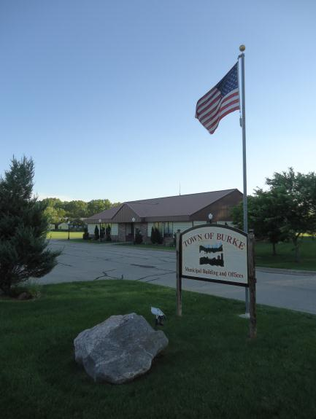
The Town of Burke is a great place to live in Dane County. It is a community that was founded on and grew from the area’s abundant natural and agricultural resources. While these remain important defining characteristics of the community, the Town’s residents have also benefited from its strategic location at the interchange of Interstates 39, 90, and 94, between the cities of Madison and Sun Prairie, and adjacent to the Dane County Regional Airport.
Town of Burke Town Hall.

The beautiful countryside of Burke is rich with productive farmland. Generations of Burke families have enjoyed the quiet rural character and strong sense of community found here. However, the Town’s population has been increasing steadily, presenting both opportunities and challenges. Economic growth has provided local employment opportunities, urban amenities, and a larger, diversified tax base. However, as population increases, so does the need for services to keep pace with growth and changing demands. In addition, growth brings with it additional pressure on the existing resource base that is necessary to sustain and improve the quality of life for future residents. In this context, it is essential to plan for development in a controlled, orderly, and predictable manner that will enhance the Town’s ability to retain its rural character, avoid land use conflicts, provide housing and appropriate employment opportunities, and protect its natural, cultural, and agricultural resources.

Great communities do not grow by accident or without public debate and agreed‐upon guidelines. Collaborative planning processes and comprehensive plans are the building blocks of such great communities. Planning helps maintain and promote livable, vital communities. This Comprehensive Plan outlines how to maintain what we like about our community and identifies key improvements to make our community even better.

Purpose of this plan____________________________________________________

This Plan is intended to capture a shared vision for the Town. It is a statement reflecting community pride and how residents want the Town to manage growth and development in the future. This Plan will help elected officials make decisions that reflect the short‐ and long‐term wishes of the community. It will help prioritize the Town’s human and financial resources to provide the necessary public infrastructure and amenities needed to maintain a high quality of life.

A key theme in this Comprehensive Plan is the interrelationship among the various aspects of our daily lives. These interrelationships often extend well beyond municipal lines and are regional in nature. The Town of Burke is part of a broader geographic area and economic market that influences everything from where we choose to shop and live to what areas we visit for recreation.

An over‐arching principle of the Plan is that the Town of Burke will work proactively with Dane County, adjacent cities and villages, nearby towns, and state and federal agencies to cooperatively address regional issues, such as natural resources, public infrastructure, and consumer, employment, and housing markets. The State of Wisconsin Comprehensive Planning legislation adopted in 1999 requires that municipalities work cooperatively to address regional issues. The Town has been effectively working with the Village of DeForest, the Cities of Sun Prairie and Madison, and Dane County over the past decade to discuss regional issues and seek agreement on inter‐municipal planning issues.

The Town of Burke, Village of DeForest, City of Sun Prairie and City of Madison Cooperative Plan (Cooperative Plan), adopted in 2007, provides an orderly, planned transition for the current Town of Burke territory to DeForest, Sun Prairie, and Madison municipal jurisdiction over the remaining years and maintains the fiscal viability and operational efficiency of the Town of Burke until Town dissolution in October 2036.
“Protected Areas” are the residential, commercial or industrial territory of the Town that may not be attached to the adjacent Village or Cities until the end of the Protected Period (12:01am on October 27, 2036), except as specifically outlined in the Cooperative Plan.

The Cooperative Plan provides that all Town territory will be attached to the designated Village or City no later than October 2036. In the interim, owners of property not located within a designated “Protected Area,” which will generally remain in the Town until 2036, may attach their property to the designated Village or City if that jurisdiction approves the attachment request.

Planning Process______________________________________________________

Smart Growth legislation significantly changed the stature of comprehensive planning in the state and placed it very high on the “to do” list. Although state statutes do not require local governmental units to adopt comprehensive plans consistent with the requirements, it provides that by January 1, 2010, if a local governmental unit enacts or amends any of the following ordinances, the ordinances shall be consistent with a locally adopted comprehensive plan: official mapping, local subdivision, county zoning, city or village zoning, town zoning, and shorelands or wetlands in shorelands zoning.

A community must follow various substantive and procedural requirements to prepare a comprehensive plan. State statutes define nine areas that need to be addressed in a community’s comprehensive plan:

Chapter 1: Issues and opportunities
Chapter 2: Intergovernmental cooperation
Chapter 3: Agricultural, natural, and cultural resources
Chapter 4: Land use
Chapter 5: Transportation
Chapter 6: Utilities and community facilities
Chapter 7: Housing
Chapter 8: Economic development
Chapter 9: Implementation

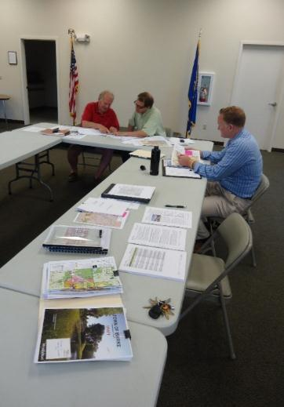
The Smart Growth legislation also outlines specific procedures for public participation that must be followed as part of the comprehensive planning process. Specifically, a municipality must hold at least one public hearing on the plan and notify the public at least 30 days in advance of this hearing. In an effort to foster meaningful public input, the Town of Burke provided additional opportunities for public involvement, as outlined in Chapter 1: Issues & Opportunities. A copy of the Town of Burke Public Participation Plan can be found in Appendix A.
The Town of Burke Comprehensive Plan Steering Committee compiles the original 2013 Plan. Image: Mead & Hunt, Inc.

The planning process set out to celebrate and protect the diversity of lifestyles and interests within community, build on the strengths of the community in achieving its goals, and guide the future of the town. The Steering Committee took seriously the process of engaging residents and businesses in the comprehensive planning process. The Steering Committee’s job was not merely to produce a report, but to reach out and collaborate with the community, to educate residents about planning, and to involve them in developing the plan. These goals stem from the fundamental aim of the planning process: to articulate Burke’s community vision for the future.

Throughout the process, the Town website was used to inform citizens of meeting dates and to summarize the developments of the planning process. This ensured that everyone in the town was at least aware of the process, even if they weren’t able to attend specific meetings.

Town of Burke Legacy__________________________________________________

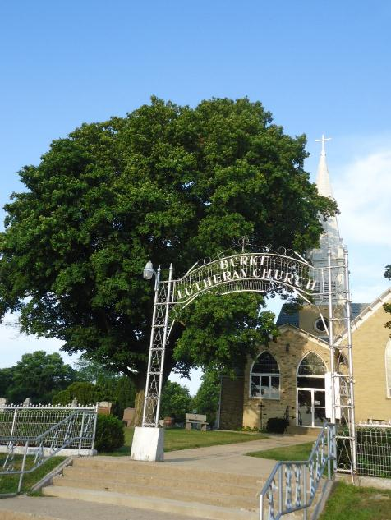
The impetus for this plan is twofold: meet the requirements of Wisconsin law and prepare a guide for making land use decisions within the Town. In carrying out the latter, Town leaders will be responsible for reassuring Town residents about the future, creating a positive environment for the municipalities absorbing the Town, and successfully transitioning the physical land and programs and policies of the Town.
Burke Lutheran Church is and will continue to be a recognizable place within the community, photo courtesy Mead & Hunt, Inc.

This document and the decisions resulting from its implementation aim to leave a legacy that transcends the Town and cements the contributions of its citizens and leaders to the growth and transformation of the community of northeast Dane County. How the Town plans for and operates over the next 12 years will have a lasting impact. As the term of influence grows shorter, Town decision makers must channel their energy, hopes, and fears toward helping their successors and the community they leave behind. This will help the next leaders be ready on Day 1.

Key factors that require attention for a successful transition include politics and practices. The Town decision makers must keep the greater good in mind and shape internal politics to be constructive and support outcomes beneficial to the community. Processes that draw groups in, build a shared vision of the future, create positive coalitions, and allow open expression of competing views will prepare the Town for the transition.

Within this document, the Town has laid out the elements of its shared vision that are critical to its legacy moving forward. This document is a host for that vision and is meant to communicate it to surrounding municipalities. The Town desires to create a strong relationship between the surrounding jurisdictions, which will ensure this legacy becomes reality.

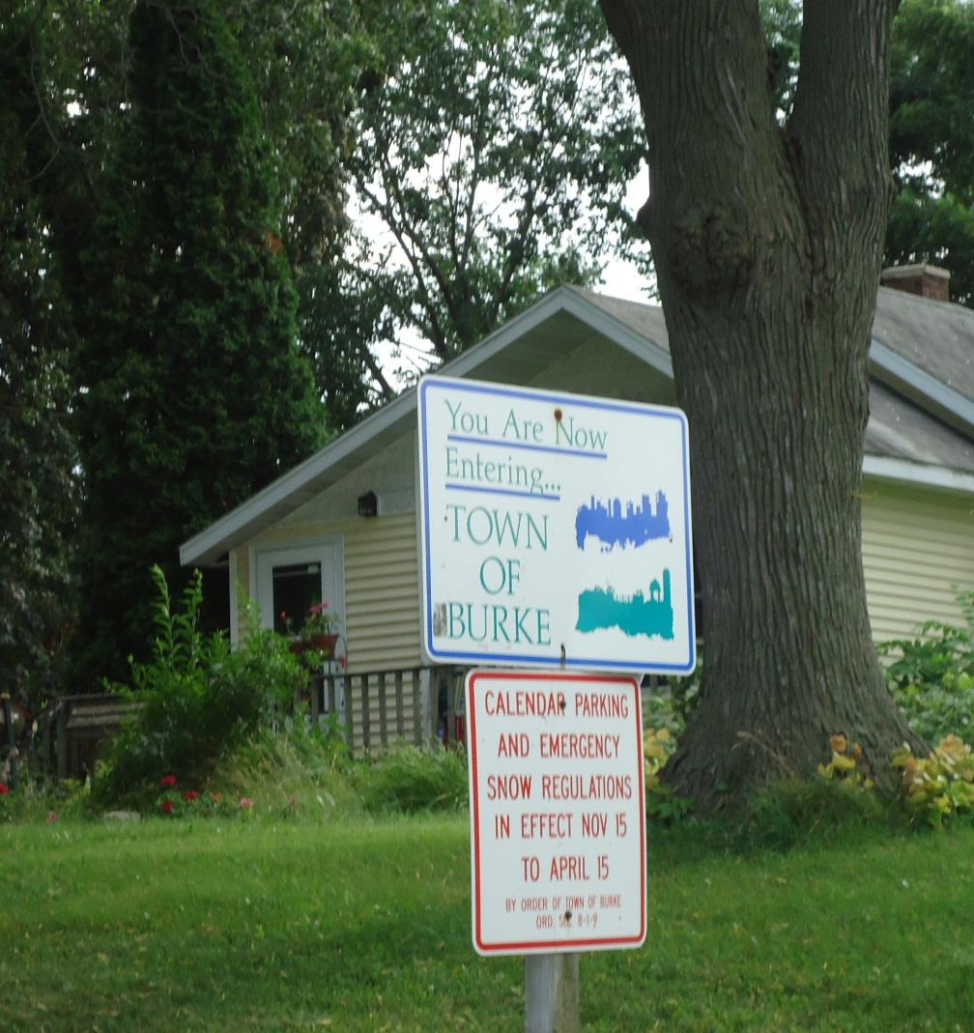

CHAPTER 1
ISSUES AND OPPORTUNITIES

I
SSUES AND OPPORTUNITIES

This chapter of the Plan provides demographic trends and background information for the Town. The demographic information provides an understanding of how the Town has changed over the last several decades and how that change relates to surrounding municipalities. The information provided here includes population, household and employment trends and forecasts, age distribution, and education level and income characteristics.

This chapter also includes a statement of overall objectives, policies, goals, and programs for the Town based on the present and forecasted demographic information. These recommendations will guide the preservation, development, and redevelopment of the Town over the 20-year planning period.

Population Trends and Forecasts_________________________________________

The Town of Burke has experienced modest population growth over the last 50 years. Table 1 shows the census populations of the Town from 1970 to 2020 compared to town and city and village populations for the same timeframe in Dane County. There was a steady population growth in the Town until around 2010 when the Town’s population declined. Around 2010 there was a shift to more urban housing in the County and the surrounding cities of Madison and Sun Prairie experienced population growth (Table 2).

Table 1: Historic Population, 1970 – 2020

Dane County | 1970 | 1980 | 1990 | 2000 | 2010 | 2020
Town of Burke | 1,742 | 2,967 | 3,000 | 2,990 | 3,284 | 3,265
Town Populations  (% of County) | 51,938 (22%) | 62,503 (24%) | 66,989 (22%) | 74,740 (21%) | 78,882 (19%) | 74,675 (15%)
Village and City Populations | 238,334 | 261,042 | 300,096 | 351,786 | 409,191 | 486,829
Source: Time Series Population Estimates (1970 – 2023), Wisconsin Department of Administration

The information in Table 1 paints the big picture of population distribution over the last five decades. The population trends show that recent growth in the County has been in the villages and cities and less so in the towns. The Town of Burke is no exception.

Table 2 provides a comparison of population trends for the last 50 years for the Town of Burke and surrounding municipalities. This comparison shows the leveling off of the Town’s population while surrounding cities and village have boomed. From 1980 to 2020 the Town experienced a 10.0 percent population growth. However, the City of Sun Prairie and Villages of DeForest, Waunakee, and Windsor, all northern suburbs of Madison, saw between a 129 and 285 percent increase in population, respectively, during this same time. The Town of Blooming Grove was the only municipality to lose population during the 40-year period.

Table 2: Population Trends, 1980 – 2020

 | 1980 | 1990 | 2000 | 2010 | 2020 | Population Change* | % Change*
Town of Burke | 2,967 | 3,000 | 2,990 | 3,284 | 3,265 | + 298 | 10.0
Town of Blooming Grove | 1,965 | 2,079 | 1,768 | 1,815 | 1,622 | (343) | (17.5)
Village of DeForest | 3,367 | 4,882 | 7,368 | 8,936 | 10,811 | + 7,444 | 221.1
City of Sun Prairie | 12,931 | 15,333 | 20,369 | 29,364 | 35,967 | + 23,036 | 178.1
Town of Sun Prairie | 1,990 | 1,839 | 2,308 | 2,326 | 2,391 | + 401 | 20.2
Village of Waunakee | 3,866 | 5,897 | 8,995 | 12,097 | 14,879 | + 11,013 | 284.9
Town of Westport | 2,748 | 2,732 | 3,586 | 3,950 | 4,191 | + 1,443 | 52.5
Village of Windsor** | 3,812 | 4,620 | 5,286 | 6,345 | 8,754 | + 4,942 | 129.6
City of Madison | 170,616 | 191,262 | 208,054 | 233,209 | 269,840 | + 99,224 | 58.2
Dane County | 323,545 | 367,085 | 426,526 | 488,073 | 561,504 | + 237,959 | 73.5
* 2000 to 2020 population change. **Village of Windsor voted to incorporate as a village in 2015.
Sources: U.S. Census Bureau 2020, U.S. Census of Population and Housing, 1980-2020

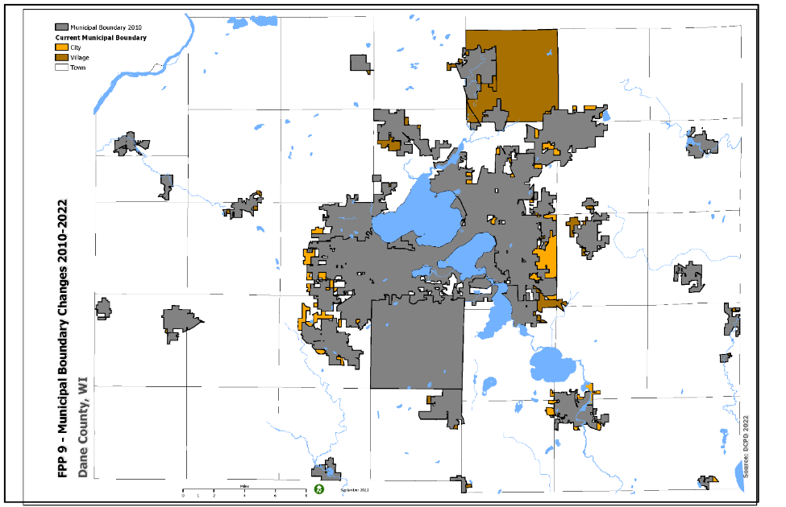
The significant growth of the villages and cities and the slower growth (and decline) of the surrounding towns in northeast Madison is one indication that the Town of Burke is experiencing heavy competition for land and resources from the increasing demands of cities and villages.
Municipal Boundary Changes, 2010 - 2022. Source: Dane County Farmland Preservation Plan 2022

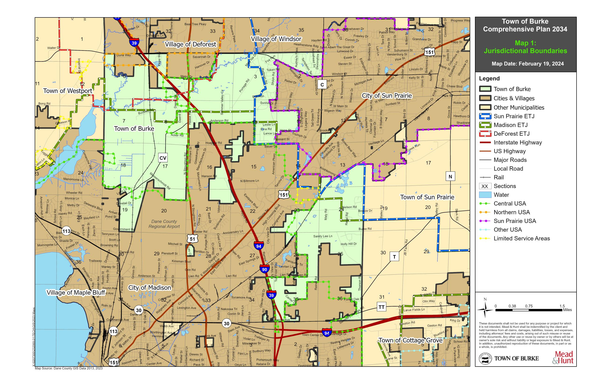

Map 1: Jurisdictional Boundaries

Map 1: Jurisdictional Boundaries shows the Town in relation to the surrounding municipalities that make up the northeast Madison Metropolitan Area. The map indicates the physical encroachment of the Village of DeForest and the Cities of Sun Prairie and Madison into the Town of Burke. As these cities and villages continue to increase in population, their demand for land and resources will also grow.

Table 3 provides population forecasts in five-year increments for the 20-year planning period for the Town of Burke as compared to surrounding municipalities. According to the U.S. Census, the population of the Town of Burke was 3,265 in 2020. Population forecasts indicate the Town is expected to continue to grow. The forecasted population, while positive, does increase at a slower rate than the previous 40-year period. Similarly, the villages and cities surrounding the Town are also forecasted to continue the growth trends experienced over the previous 40-year period.

Table 3: Population Forecasts, 2020 – 2040

 | Census 2020 | 2025 | 2030 | 2035 | 2040 | Projected Change %
Town of Burke | 3,265 | 3,625 | 3,740 | 3,815 | 3,875 | + 18.7
Town of Blooming Grove | 1,622 | 1,810 | 1,805 | 1,780 | 1,750 | + 7.9
Village of DeForest | 10,811 | 10,560 | 11,150 | 11,610 | 12,010 | + 11.1
City of Sun Prairie | 35,967 | 37,880 | 40,830 | 43,330 | 45,580 | + 26.7
Town of Sun Prairie | 2,391 | 2,470 | 2,520 | 2,545 | 2,560 | + 7.1
Village of Waunakee | 14,879 | 14,920 | 15,940 | 16,780 | 17,530 | + 17.8
Town of Westport | 4,191 | 4,390 | 4,555 | 4,660 | 4,745 | + 13.2
Village of Windsor* | 8,754 | 7,635 | 8,055 | 8,380 | 8,675 | (0.9)
City of Madison | 269,840 | 261,500 | 270,350 | 276,450 | 281,150 | + 4.2
Dane County | 561,504 | 555,100 | 577,300 | 593,440 | 606,620 | + 8.0
Source: Wisconsin Department of Administration, 2020
*Village of Windsor voted to incorporate as a village in 2015

The population forecasts are useful for the long-term planning efforts related to land use, housing, transportation, and community facility planning for the Town. However, the population forecasts are based on historical growth patterns and the composition of the current population. In order to be both accurate and reliable, the Town must continue the growth trends of the past. In a similar fashion, the Town must also consider the projected population growth (or decline) of surrounding municipalities in planning for its own long-term well-being.

Household Trends and Forecasts_________________________________________

According to the U.S. Census Bureau, a “household” consists of all people who occupy a “housing unit,” which is recognized as a house, apartment, or other group of rooms. Households include related family members and all unrelated people who share a housing unit. A person living alone in a housing unit, or a group of unrelated people sharing a housing unit, such as partners, is also counted as a household. Table 4 present’s household and housing unit characteristics for 2020 and compares the Town of Burke to the municipalities surrounding it. In 2020 the average household size for the Town (3.02), was slightly higher than the average for the surrounding communities (2.58), excluding the city of Madison and Dane County. This is also up from the 2010 average household size for the Town which was 2.60.

Table 4: Household Characteristic Comparisons, 2020

 | Total Housing Units (2020) | Total Households (2020) | Average Household Size (2020) | Median Value Owner Occupied Units | Median Rent (2020)
Town of Burke | 1,296 | 1,128 | 3.02 | $ 281,800 | $ 1,136
Town of Blooming Grove | 731 | 667 | 2.35 | $ 201,700 | $ 844
Village of DeForest | 4,294 | 3,892 | 2.69 | $ 249,400 | $ 1,000
City of Sun Prairie | 14,952 | 13,596 | 2.49 | $ 252,000 | $ 1,131
Town of Sun Prairie | 916 | 810 | 2.76 | $ 280,700 | $ 1,129
Village of Waunakee | 5,537 | 4,923 | 2.81 | $ 375,200 | $ 1,022
Town of Westport | 2,019 | 2,052 | 2.04 | $ 317,800 | $ 1,031
*Village of Windsor | 2,548 | 2,635 | 2.51 | $ 321,200 | $ 1,138
City of Madison | 126,070 | 111,832 | 2.20 | $ 257,700 | $ 1,147
Dane County | 248,795 | 226,600 | 2.33 | $ 278,700 | $ 1,118
Source: U.S. Census Bureau, 2020
*Village of Windsor voted to incorporate as a village in 2015

There are two major categories of households, "family" and "nonfamily." A family is a group of two or more people (one of whom is the “householder”) related by birth, marriage, or adoption and residing together. A family household is maintained by a householder who is in a family and includes any unrelated people who may be living there. A nonfamily household consists of a householder, or single person living alone or where the householder shares the home exclusively with people to whom he/she is not related. The Town had 1,296 housing units in 2020 with 1,128 total households. This indicates that approximately 87 percent of the total housing units were households, occupied by 2 to 3 people.

The median value of owner-occupied units in the Town of Burke in 2020 was $281,620. This was slightly below the average as compared to the surrounding municipalities and above both the City of Madison and Dane County’s median value.

Table 5 presents a housing occupancy characteristic comparison for the Town and surrounding municipalities. Within the Town, the number of single-family units (98.8%) and the percent of owner occupancy (85.4%) are the highest for all comparison municipalities. Alternatively, the City of Madison, which is home to a university enrolling more than 31,000 undergraduate students, contains fewer than 50 percent single-family units and twice as many single-person households than the Town. The number of single-family units and high owner occupancy, coupled with the vacancy rate (4.9%), is indicative of single-family-oriented, low-density development in the Town.

Table 5: Housing Occupancy Characteristics Comparison, 2020

 | % Single Person Household | % Vacant | % Owner Occupied* | % Single Family Units**
Town of Burke | 14.5 | 4.9 | 95.4 | 98.8
Town of Blooming Grove | 35.8 | 0.1 | 72.9 | 84.0
Village of DeForest | 21.8 | 5.4 | 75.8 | 77.2
City of Sun Prairie | 31.8 | 3.7 | 62.2 | 64.0
Town of Sun Prairie | 9.8 | 3.3 | 85.7 | 93.2
Village of Waunakee | 18.0 | 2.6 | 78.2 | 76.7
Town of Westport | 37.8 | 6.8 | 69.2 | 64.5
**Village of Windsor | 22.3 | 5.2 | 78.7 | 80.1
City of Madison | 37.3 | 4.3 | 47.7 | 47.9
Dane County | 31.7 | 4.2 | 59.0 | 59.9
* * Includes both 1-unit, detached and 1-unit, attached.
** Village of Windsor voted to incorporate as a village in 2015
Source: U.S. Census Bureau, 2020

Table 6 provides household projections for surrounding Dane County municipalities. Projections are used to estimate future demand for additional housing units. A 4.6 percent growth in households until 2030 indicates that the Town will need to plan for approximately 63 new households by 2030. Given the existing household and housing occupancy characteristics, there will also likely be demand for a wider range of household types based on various age, income, and lifestyle variables of future populations.

Table 6: Household Projections, 2020 – 2030

 | Census 2010 | 2015 | 2020 | 2025 | 2030 | Change 2020-2030 (%)
Town of Burke | 1,244 | 1,317 | 1,358 | 1,391 | 1,421 | +63 (4.6)
Town of Blooming Grove | 817 | 678 | 653 | 624 | 593 | -60 (-9.2)
Village of DeForest | 3,499 | 3,909 | 4,353 | 4,780 | 5,203 | +850 (19.5)
City of Sun Prairie | 12,413 | 12,358 | 13,799 | 15,187 | 16,559 | +2,760 (20.0)
Town of Sun Prairie | 861 | 943 | 993 | 1,037 | 1,080 | +87 (8.8)
Village of Waunakee | 4,516 | 4,941 | 5,545 | 6,127 | 6,704 | +1,159 (20.9)
Town of Westport | 1,929 | 1,918 | 2,056 | 2,184 | 2,308 | +252 (12.3)
Village of Windsor* | 2,548 | 2,386 | 2,557 | 2,718 | 2,874 | +317 (12.4)
City of Madison | 108,843 | 109,118 | 115,780 | 121,881 | 127,802 | +12,022 (10.4)
Dane County | 216,022 | 219,624 | 235,170 | 249,624 | 263,732 | +28,562 (12.1)
Source: U.S. Census Bureau, 2010 & Wisconsin Department of Administration, 2008
*Village of Windsor voted to incorporate as a village in 2015

Age and Gender Trends and Forecasts_____________________________________

The age and gender trends and forecasts for the Town and surrounding municipalities are helpful in understanding the demographic makeup of the population. This aids in determining what future needs the population might require from the Town and allows for long-term planning in order to address those needs. Table 7 provides the age and gender characteristics for the Town and surrounding area, while Table 8 presents age cohort forecasts through 2035. The Town’s median age is among the highest when compared to the surrounding municipalities, and significantly greater than the City of Madison and Dane County. The Town displays an average percent of the population over 65 years old (13.2%) and an average gender distribution (50.9%).

Table 7: Age and Gender Characteristics, 2020

 | Median Age | % under 18 | % over 65 | % Female
Town of Burke | 41.1 | 25.4 | 13.2 | 50.9
Town of Blooming Grove | 40.7 | 17.9 | 13.0 | 48.5
Village of DeForest | 37.9 | 27.3 | 12.1 | 53.4
City of Sun Prairie | 37.0 | 25.3 | 13.9 | 50.0
Town of Sun Prairie | 42.5 | 22.6 | 17.8 | 46.2
Village of Waunakee | 39.3 | 29.7 | 14.1 | 48.8
Town of Westport | 47.4 | 20.4 | 27.5 | 46.2
Village of Windsor* | 39.8 | 25.0 | 14.8 | 54.0
City of Madison | 31.2 | 16.1 | 12.0 | 50.5
Dane County | 35.2 | 20.4 | 13.7 | 50.3
Source: U.S. Census Bureau, 2020
*Village of Windsor voted to incorporate as a village in 2015

Table 8: Dane County Age Cohort Forecasts, 2010 - 2035

Dane County | Under 5 | 5 - 19 | 20 - 64 | 65 +
2010 | 30,809 | 91,777 | 316,897 | 50,229
2015 | 34,092 | 96,954 | 329,317 | 63,455
2020 | 36,871 | 106,213 | 335,280 | 80,641
2025 | 38,543 | 114,267 | 342,688 | 97,419
2030 | 39,904 | 121,844 | 350,110 | 112,642
2035 | 41,758 | 127,098 | 361,700 | 123,320
Source: Wisconsin Department of Administration, 2008

The age characteristics have important implications for education, service, housing, and transportation needs. The Town of Burke population is aging along with the surrounding towns, and more than surrounding villages and cities. This indicates a trend for younger populations to be located in more villages and cities than towns.

Employment Trends and Forecasts________________________________________

The Town’s labor force is the portion of the population age 16 and over that is employed or available for work. The labor force includes people who are in the armed forces, employed, unemployed, or actively seeking employment. Table 9 shows the percentage of the Town’s labor force employed by sector in 2020. A quarter of the Town’s labor force was employed in the educational, health care, and social services industries.

Table 9: Labor Force Characteristics, 2020

Occupational Group | Burke % of Labor Force | Dane County % of Labor Force
Agriculture, Forestry, Fishing, Hunting, & Mining | 0.0 | 1.0
Construction | 4.0 | 4.6
Manufacturing | 15.3 | 9.0
Wholesale Trade | 3.1 | 2.0
Retail Trade | 9.3 | 9.4
Transportation, Warehousing, & Utilities | 6.1 | 3.1
Information | 0.0 | 3.1
Financial & Insurance, Real Estate, Rental, & Leasing | 15.6 | 7.9
Professional, Scientific & Management, Administrative, & Waste Management Services | 2.8 | 14.1
Educational Services, Health Care, & Social Assistance | 25.8 | 28.5
Arts, Entertainment & Recreation, Accommodation, & Food Services | 8.2 | 8.1
Other Services, Except Public Administration | 3.6 | 4.2
Public Administration | 6.1 | 5.0
Source: 2020 American Community Survey

The Town’s labor force is fairly reflective of Dane County’s labor force. Commonalities exist in that the educational, health care, and social services are the highest percentage of both labor forces. This can likely be attributed to several factors, including the proximity of the University of Wisconsin, the Madison Area Technical College, and the culmination of the Madison Metropolitan, DeForest, and Sun Prairie school districts within the Town. Both the Town and the County’s primary economic activity is in employment groups related to educational services, health care, and social assistance.

The County has more of its labor force in the professional and management services than the Town. The Town has a higher percentage of its labor force in the transportation, warehousing, and utility sector, indicating that the Town might serve, socially and physically, as a support community for the central city of Madison. The higher percentage of labor force in transportation, warehousing, and utilities is also reflective of Burke’s location and proximity to several State Highways and the Interstate.

The top employers in Dane County include the University of Wisconsin – Madison, University of Wisconsin Hospitals, the State of Wisconsin, Epic Systems, and American Family Insurance.

Education and Income Levels_____________________________________________

Educational attainment is a variable used to measure a community’s labor force potential. According to the 2020 U.S. Census, 98.3 percent of the Town’s population age 25 and over attained a high school diploma or higher. The percent of the population who received a bachelor’s degree or higher is among the lowest compared to surrounding municipalities (39.0%). Table 10 presents education-related statistics for the Town and surrounding area.

Table 10: Educational Attainment, 2020

 | % High School Graduate or Higher | Bachelor's Degree or Higher
Town of Burke | 98.3 | 39.0
Town of Blooming Grove | 93.4 | 34.2
Village of DeForest | 98.5 | 39.3
City of Sun Prairie | 96.5 | 47.0
Town of Sun Prairie | 94.7 | 31.0
Village of Waunakee | 98.6 | 57.2
Town of Westport | 97.6 | 59.4
Village of Windsor* | 96.6 | 47.5
City of Madison | 95.9 | 58.5
Dane County | 96.2 | 52.4
Source: U.S. Census Bureau, 2020
*Village of Windsor voted to incorporate as a village in 2015

Table 11 presents the income characteristics for the Town and surrounding municipalities. According to the 2020 U.S. Census, the Town’s median household income was significantly higher than Dane County. Additionally, this Town’s median household income was higher than all but three neighboring municipalities: the Village of Waunakee and the Towns of Westport and Sun Prairie. This is comparable to the 2013 data.

The per capita income for the Town is higher than most surrounding communities. This is a change from the 2013 data where the Town was amongst the lowest compared to surrounding municipalities. The per capita income is defined as the total personal income, divided by the total population. This is used as a measure of the wealth of the Town’s population.

Table 11: Income Comparison, 2020

 | Median Household Income 2010 | Median Household Income 2020 | Per Capita Income 2010 | Per Capita Income 2020
Town of Burke | $ 74,500 | $91,543 | $ 30,990 | $48,438
Town of Blooming Grove | $ 60,682 | $67,837 | $ 32,692 | $34,392
Village of DeForest | $ 66,673 | $84,282 | $ 29,625 | $45,980
City of Sun Prairie | $ 66,395 | $79,566 | $ 32,091 | $45,801
Town of Sun Prairie | $ 69,375 | $96,000 | $ 30,503 | $46,332
Village of Waunakee | $ 82,099 | $114,983 | $ 37,073 | $55,489
Town of Westport | $ 80,588 | $80,174 | $ 45,811 | $44,800
Village of Windsor* | $ 73,023 | $98,789 | $ 32,500 | $52,127
City of Madison | $ 54,093 | $67,565 | $ 30,595 | $34,462
Dane County | $ 61,913 | $75,179 | $ 33,118 | $40,808
Source: U.S. Census Bureau, 2020
*Village of Windsor voted to incorporate as a village in 2015

Public Involvement _____________________________________________________

Several techniques were used to involve the public in the preparation of the 2013 Plan and this update.

Selected Techniques to Involve the Public
- Smart Growth Steering Committee Meetings
Monthly Smart Growth Steering Committee meetings were held. All Committee meetings were noticed and held as open public meetings and provided for a public comment period. Some Committee meetings were specifically intended to solicit public input, while others were Committee work sessions with a limited public comment period.

- Use of Internet
The Town shared information and materials on its website (www.townofburke.com) throughout the planning process. In addition to legal posting and publishing requirements, the Town also publicized and promoted the planning process, provided information on upcoming meetings, and supplied the results of meetings, along with draft plan documents and maps.

- Intergovernmental Cooperation
As the Town is completely surrounded by other incorporated municipalities and there is a significant amount of infrastructure that is the responsibility of other agencies, the Town will incorporate the 2007 Cooperative Plan with the City of Madison, City of Sun Prairie, and Village of DeForest without change. As required by statute, the Town will provide draft plan materials to adjacent and overlapping governments for review and comment.

- Public Comment at Plan Commission Meeting
The Plan Commission formally acted on the completed draft Comprehensive Plan near the end of the planning process. This was done through a public meeting and provided an opportunity for written public comment to be reviewed by the Plan Commissioners.

- Formal Public Hearing
The Town held one formal public hearing on the draft Comprehensive Plan and the adopting ordinance prior to adoption. All members of the public had an opportunity to present testimony and offer comments at that public hearing. The public hearing was noticed and held per the requirements of Wisconsin Statutes, Section 66.1001.

Town Board and Plan Commission Key Planning Issues Survey
In 2013, a survey on key planning issues was provided to members of the Town Board and Plan Commission. The survey asked Town officials to answer a series of questions related to existing conditions in the Town and the growth, development, or redevelopment potential for the Town. Responses are summarized below.

In 2023, the Town Plan Commission reviewed these results and agreed that the overall goals and objectives of these issues remained the same today as in 2013.

The key planning issues survey has provided the Town an opportunity to develop a comprehensive guide for its future. The lack of a comprehensive plan has been an issue in Burke because the existing adopted plans lack the guidance the Town needs to make joint planning decisions with surrounding municipalities. This manifests itself when development proposals are brought to Town officials and County zoning is changed to reflect desired development instead of aligning with the long-term plan.

The Burke – DeForest Extraterritorial Zoning Committee has been a model of intergovernmental cooperation and development, but thus far has not prompted the Cities of Sun Prairie or Madison to work with the Town on development efforts. Because of its juxtaposition to surrounding municipalities, the Town does directly benefit from shared services like Fire/EMS and snow plowing, which are outlined by the Cooperative Plan.

The community character is derived from its agricultural heritage. The influence of agriculture is reflected in the Town by its small, isolated pockets of development, low density, and rural nature. The character of the community is slow paced and exurban, although all the services and benefits of the larger City of Madison are at the Towns doorstep. The Town favors the single-family housing typology currently prevalent in the community. This single-family, low-density development creates an auto dependency that the Town acknowledges and embraces. The pace of development in the Town has generally been slow. While development, both residential and non-residential, seems in large part to be driven by developers, the location and type of development has been generally compatible with the County’s land use plan.

The key planning issue associated with transportation is the increase in traffic volume resulting from development related to the Extraterritorial Jurisdiction (ETJ) areas of Madison and Sun Prairie. Specifically, Reiner Road near Nelson was mentioned as an intersection that has increased in traffic since the development around the American Family Insurance Company site. Burke has not been aggressive to plan for its transportation infrastructure, but rather embraced the benefits of being located adjacent to the City of Madison and within Dane County, and adjacent to several state and federal highways. Highway development within ETJ areas has made it necessary for the Town to react to increasing traffic demands, often before intergovernmental planning has occurred.

Development and transportation go hand in hand. The results of surrounding municipalities exercising extraterritorial jurisdiction has provided opportunities for Burke to develop and redevelop portions of its community. Areas with the most potential for development include vacant parcels adjacent to existing development. Some redevelopment of older business parks is also possible. The Town prefers the agglomeration type development to help preserve the natural and scenic assets and exurban character.

The Town’s key environmental features are its wetlands and the Token Creek and associated parks. Stormwater and flooding issues have arisen because of development patterns, driven by the Cooperative Plan, which seem to bypass Town review until late in the development process. The Town emphasizes protection and preservation of its park system and feels like the Parks and Open Space Plan is an adequate mechanism for this.

Key Planning Issues
- Community character and feel is exurban
- Extraterritorial jurisdiction putting the squeeze on Burke
- Intergovernmental relationships could be better
- Development is slow, scattered, and mostly in ETJ areas
- Token Creek and community parks/wetlands are key environmental assets
- Low-density, single-family housing is prevalent and preferred
- Auto dependent community is reactive to ETJ development and WisDOT

Regional and County Opportunities_______________________________________

According to the 2020 US Census of Population and Housing, Dane County was Wisconsin County which grew the most in terms of population between 2010 and 2020, increasing by 15 percent. The Town of Burke is situated in central Dane County in the Madison Metropolitan Area. This location in the State’s capital city offers unique regional opportunities based on proximity to a growing urban area like transportation accessibility, abundant, and unspoiled natural resources for recreation, and pockets of regional tourist destinations.

Madison Metropolitan Area
The City of Madison is the second largest city by population in the State of Wisconsin. Madison lies within a one- to three-hour drive of Wisconsin’s other largest cities including Milwaukee, Eau Claire, Green Bay, La Crosse, and Wausau. Additionally, the cities of Chicago and Rockford, Illinois, and Dubuque, Iowa, are all within this same driving timeframe. Proximity to the major population and employment centers in the southern Wisconsin/northern Illinois region is a critical asset for the Town from both an urban and a rural perspective. The Town is likely to benefit from the exchange of people, money, commodities, and information found in urban areas.

Transportation
Interstates 39, 90, and 94 all converge on the eastern side of the City of Madison along the southern boundary line of the Town. These highways connect Madison to the major urban areas of Milwaukee, Chicago, Minneapolis, and Rockford, and various others, as mentioned above. U.S. Highways 51 and 151 also provide access to and from adjacent municipalities and regional markets such as the Fox Valley area. Access to regional markets supports traditional forms of economic development and continued tourism growth. The Town of Burke also sits adjacent to the Dane County Regional Airport.

Outdoor Recreation Areas
Dane County Parks welcomes nearly 4 million visitors annually and manages over 17,000 acres of land. The park system uses a classification system to divide county park lands into five categories: recreation parks, natural resource areas, forests, historical/cultural sites, and wildlife areas. As a whole, this system provides active and passive recreation areas, protection of valuable natural habitats and greenbelt corridors, land management and economic resources, and protection and preservation of historically or culturally significant sites. Dane County Parks provide excellent economic and health benefits and improves the general quality of life for the regions residents.

Locally, the 170-acre Token Creek Natural Resource Area, the 9.9 acre Token Creek Wildlife Area, and 427-acre Token Creek County Park provide key environmental assets for the Town. These are explored in more detail in Chapters 3 and 6.

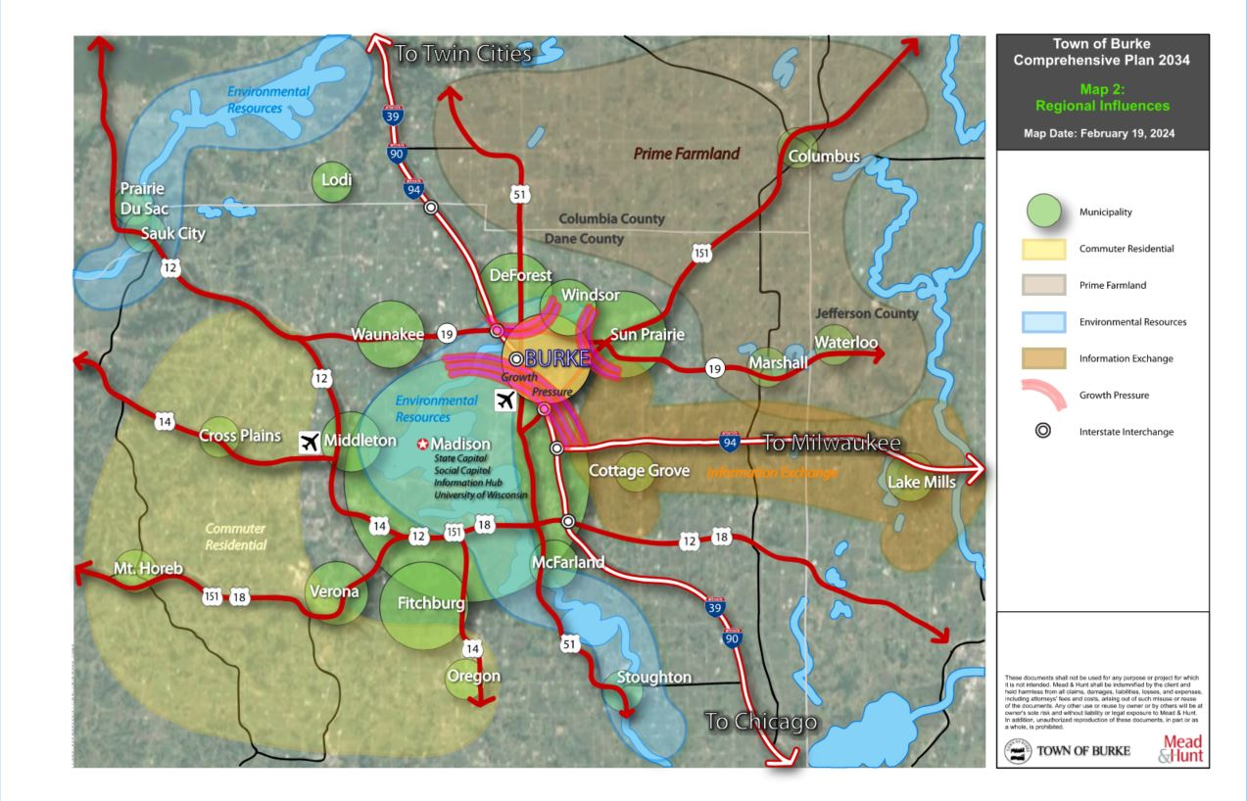

Map 2: Regional Influences

Tourism
Opportunities for tourism in the County and Region are centered on two things: natural and recreational opportunities and the City of Madison and the amenities associated with being a state capital. As discussed above, Dane County is flush with outdoor recreational opportunities including regional attractions like Devil’s Lake State Park, the Ice Age National Scenic Trail, and Token Creek County Park, which offers camping, disc golf and equestrian. The City of Madison is no exception when it comes to outdoor recreational opportunities. Centered between Lake Mendota and Lake Monona, Madison is home to 270 public parks and responsible for over 6,000 acres of public lands.
Significant tourist attractions within an hour drive of Burke include Devil’s Lake, the Wisconsin Dells, Frank Lloyd’s Taliesin, House on the Rock, the Fireside Dinner Theatre, and the Kettle Moraine State Forest Southern Unit.

Madison is also home to a variety of urban based tourist attractions including a collegiate summer league baseball team, the University of Wisconsin – Madison, State Street, the Henry Vilas Zoo, the Monona Terrace Convention Center, the UW-Madison Arboretum, Olbrich Gardens, the Overture Center, the Speckled Hen Inn, and many more. Being a state capital, Madison also provides tourism opportunities for sightseeing the Capitol building and grounds and the governor’s mansion. The IRONMAN Wisconsin triathlon and Dane County Fair are yearly events which support the region and boast Madison as a major tourism destination.

Overall Goals, Objectives, Policies, Programs and Recommendations__________

Each chapter of this Comprehensive Plan includes goals, objectives, policies, programs, and recommendations that will provide a framework and policy guidance for the Town Board and Plan Commission members, town residents and staff members, and other stakeholder groups for the next 12 years. Goals, objectives, policies, programs, and recommendations are defined as follows:

Goals are broad and general expressions of the Town’s aspirations, towards which this Comprehensive Plan is directed. Goals tend to be ends rather than means.

Objectives are more specific targets, derived from goals and necessary actions to achieve those goals. While still general in nature, objectives are more precise, concrete, and measurable than goals.

Policies are rules or courses of action necessary to achieve the goals and objectives they are derived from. Policies are precise and measurable.

Programs are a system of projects or services necessary to achieve plan goals, objectives, and policies.

Recommendations provide detailed information regarding how to implement objectives policies, and programs.

Town of Burke Vision Statement
The Town of Burke envisions that it will sustain the exurban town character of the community by prudent planning and intergovernmental cooperation. The Town will preserve its natural environmental features and housing stock by guiding new development towards planned and existing development areas. By recognizing and utilizing community resources, the Town aims to foster sense of place and leave a legacy of responsibility and community service.

- Maintain the Protected Areas of Burke through the Towns existence.
- Protect the Town’s natural and environmentally sensitive areas from future development.
- Preserve the low-density, single-family housing majority in Burke.
- Guide new development through intergovernmental and stakeholder collaboration.
- Maintain and expand efficient transportation networks that meet the needs of multiple users.
- Preserve an abundance of commercial and business services located in the Town’s backyard.

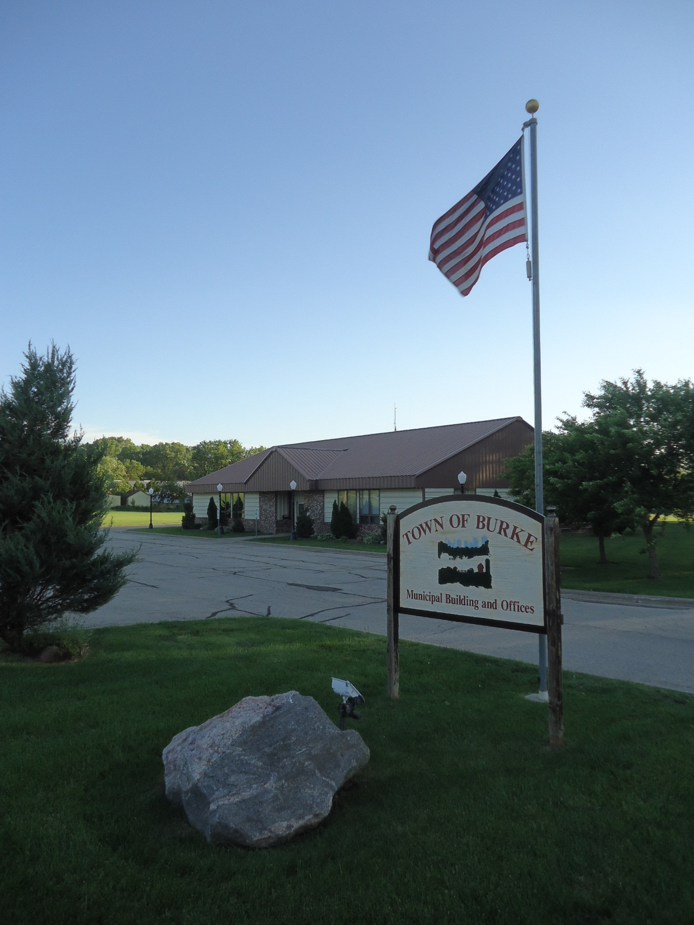

CHAPTER 2
INTERGOVERNMENTAL COOPERATION

I
NTERGOVERNMENTAL COOPERATION
This chapter analyzes the Town of Burke in relation to adjacent local governmental units, the region, the state, and other governmental agencies and proposes policies, programs, and recommendations for public facilities and sharing of public services.

This chapter incorporates plans or agreements that the Town is a party under, including Comprehensive Plans from the Village of DeForest, the Cities of Sun Prairie and Madison, Dane County, the Madison Area Metropolitan Planning Organization, the Capital Area Regional Planning Commission (CARPC), and the state of Wisconsin. It is intended to promote consistency between this Plan and plans for neighboring and overlapping jurisdictions. Finally, this chapter identifies existing or potential conflicts between the Town and surrounding municipalities that may arise over this plan’s remaining planning period and strives to resolve those conflicts.

In 2007 the Town of Burke, in cooperation with the Village of DeForest and the Cities of Sun Prairie and Madison, completed a Cooperative Plan for the long-range dissolution of the Town. The Cooperative Plan provides an orderly, planned transition for the current Town of Burke territory to DeForest, Sun Prairie, and Madison municipal jurisdiction over the Cooperative Plan’s 30-year planning period and maintains the fiscal viability and operational efficiency of the Town of Burke during the transition period.

The Cooperative Plan provides that all Town territory will be attached to the designed Village or City no later than October 2036. In the interim, owners of property not located within a designated “Protected Area,” may attach their property to the designated Village or City if that jurisdiction approves the attachment request. Residential property in a protected area will remain in the Town of Burke until October 27, 2036.

Boundary Adjustment Area
The territory subject to the Cooperative Plan is all of the existing Burke territory shown on Map 1. The Boundary Adjustment Area (BAA) is all of the same Burke territory to be governed by this Plan until it is ultimately transferred to DeForest, Sun Prairie or Madison, shown on Map 3: Final Boundary Adjustment Areas.

The BAA is the physical area in which the Village of DeForest and Cities of Sun Prairie and Madison may plan and develop. Extraterritorial Jurisdiction, as described below, allows the municipalities the authority to plan and develop, within the BAAs. In addition to BAAs, the Cooperative Plan outlined Protected Areas, mostly consisting of existing development, which will remain in the Town through 2036. These areas are shown on Map 4: Town of Burke Protected Areas.

With the dissolution of Burke, the Village of DeForest and Cities of Sun Prairie and Madison’s boundaries will meet. In total, the City of Madison will share a boundary with the Towns of Westport, and Sun Prairie, the Villages of DeForest and Windsor, and the City of Sun Prairie. Final Boundary Lines are shown on Maps 3 and 4.

Extraterritorial Jurisdiction
Extraterritorial jurisdiction is the extension of cities and villages beyond their municipal boundaries into unincorporated areas of towns. Under Wisconsin Statutes, cities and villages have the authority, by right, to exercise extraterritorial land use planning, subdivision review, official mapping, and, with town approval, zoning outside their incorporated boundaries. In order to exercise extraterritorial zoning, cities and villages must work cooperatively with adjoining towns. The Village of DeForest and Cities of Sun Prairie and Madison have extraterritorial jurisdiction over different portions of the Town of Burke as defined by the BAAs established in the Cooperative Plan. Map 3 shows the respective BAAs within which the respective municipalities can exercise extraterritorial jurisdiction in order to make land use decisions for their futures. Intergovernmental cooperation is critical to addressing mutual land use concerns within each extraterritorial area and to avoiding potential conflicts.

Urban Service Areas
Urban Service Areas (USA) are those areas in and around existing communities that are most suitable for urban development and capable of being provided with a full range of urban services (e.g., municipal sewer and water). USA boundaries represent the outer limits of planned urban growth over a long-term planning period. Because these boundaries are drawn on the basis of a long-term planning period, typically 20 years, they can change over time. The area of the USA is typically within the extraterritorial jurisdiction boundaries of a city or village, and essentially reserves land for future urban development by discouraging premature development on private water and sewer systems in those areas. USAs are also included in area wide plans so that local, regional, and state agency decisions can be coordinated, consistent, and capable of achieving desired growth and development patterns.

Currently, several main USAs serve residents and businesses of the Town of Burke. These include the Central Area USA, the Sun Prairie USA (serving the far northeastern portion of the Town), and the Northern USA serving a portion of the Town adjacent to Wisconsin State Highway (WIS) 19. Map 1: Jurisdictional Boundaries shows these boundaries. More details about Town utilities is provided in Chapter 6.

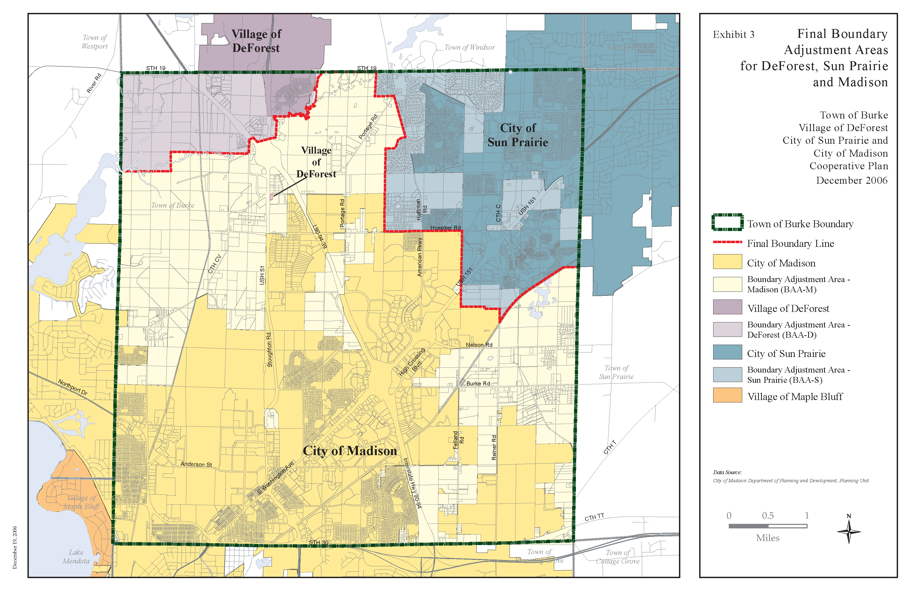

Map 3: Final Boundary Adjustment Areas (Cooperative Plan)

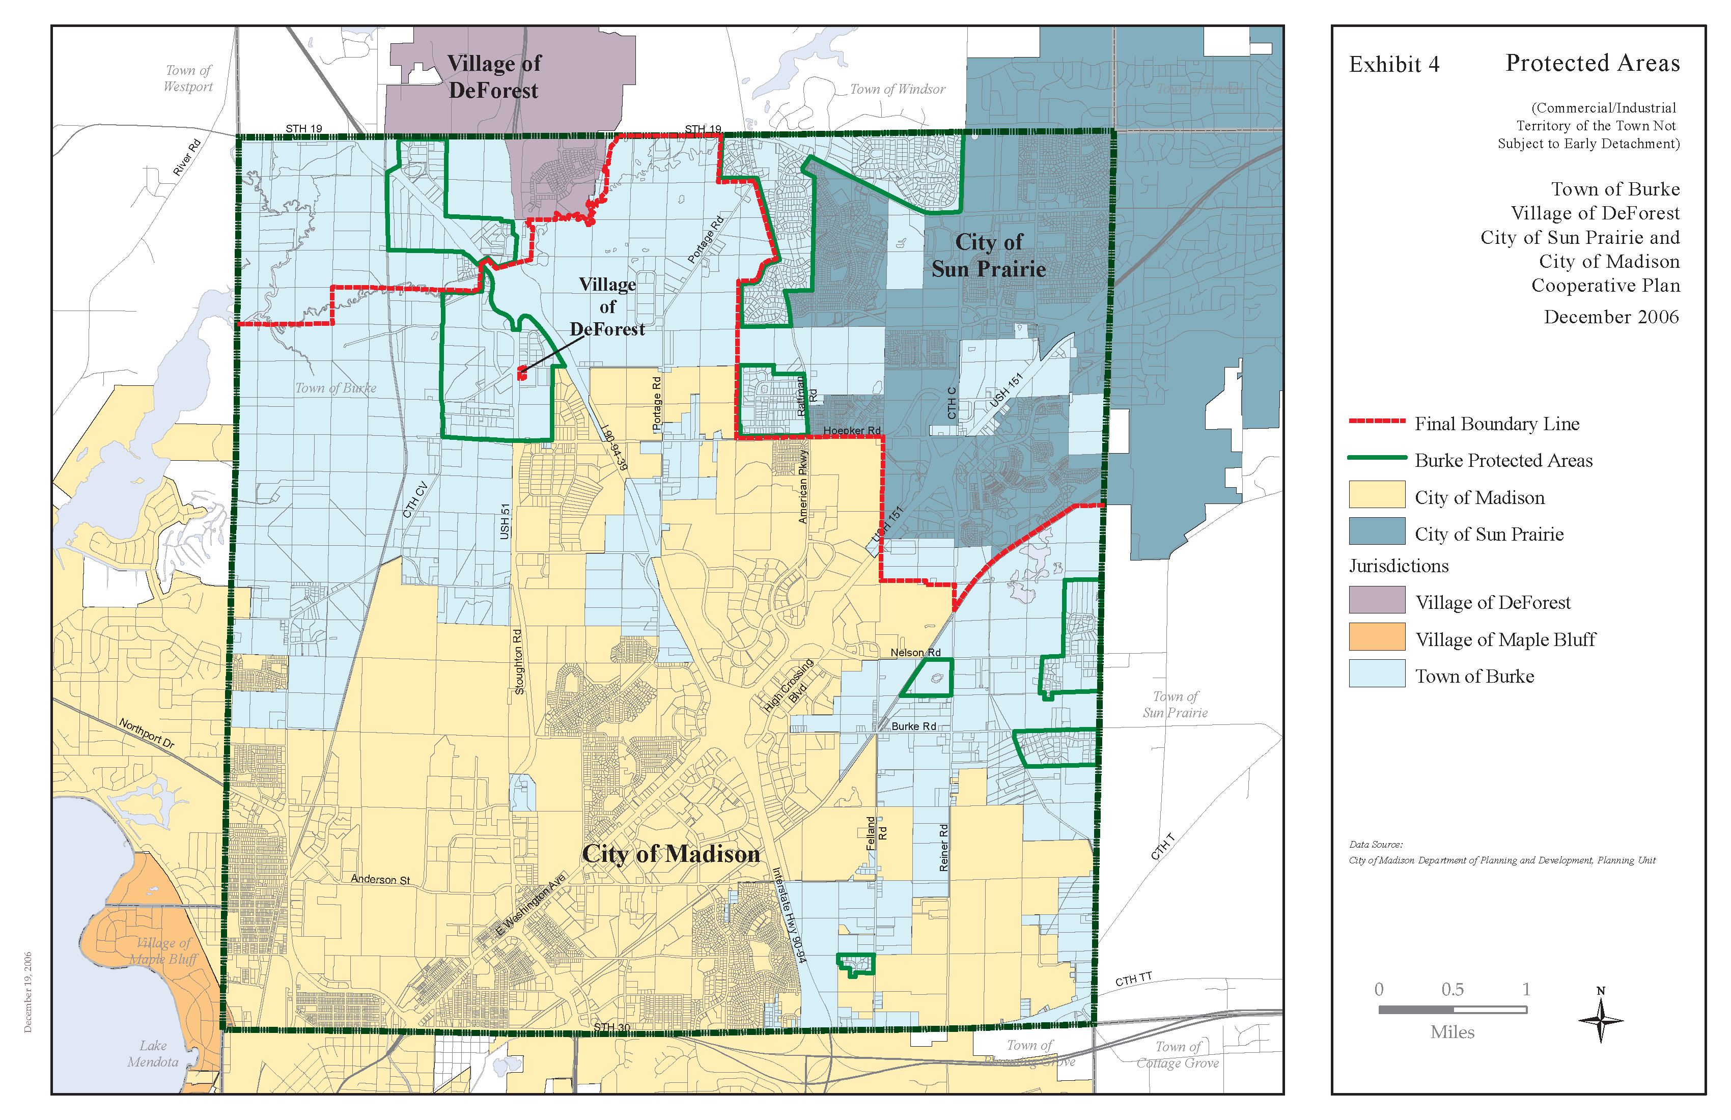

Map 4: Town of Burke Protected Areas (Cooperative Plan)

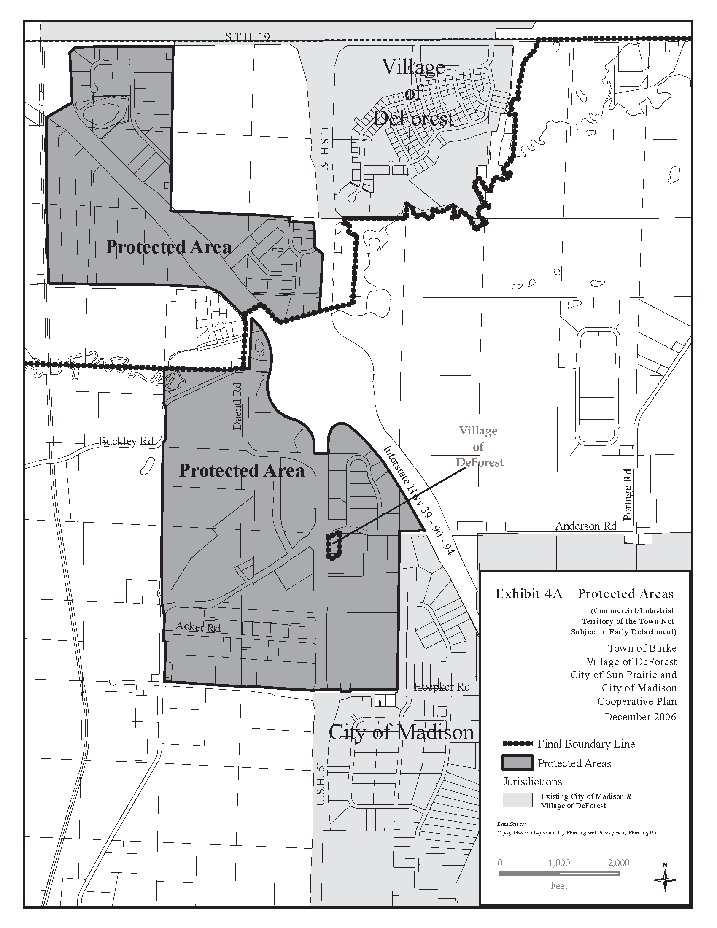

Map 4a: Protected Areas in Detail (Cooperative Plan)

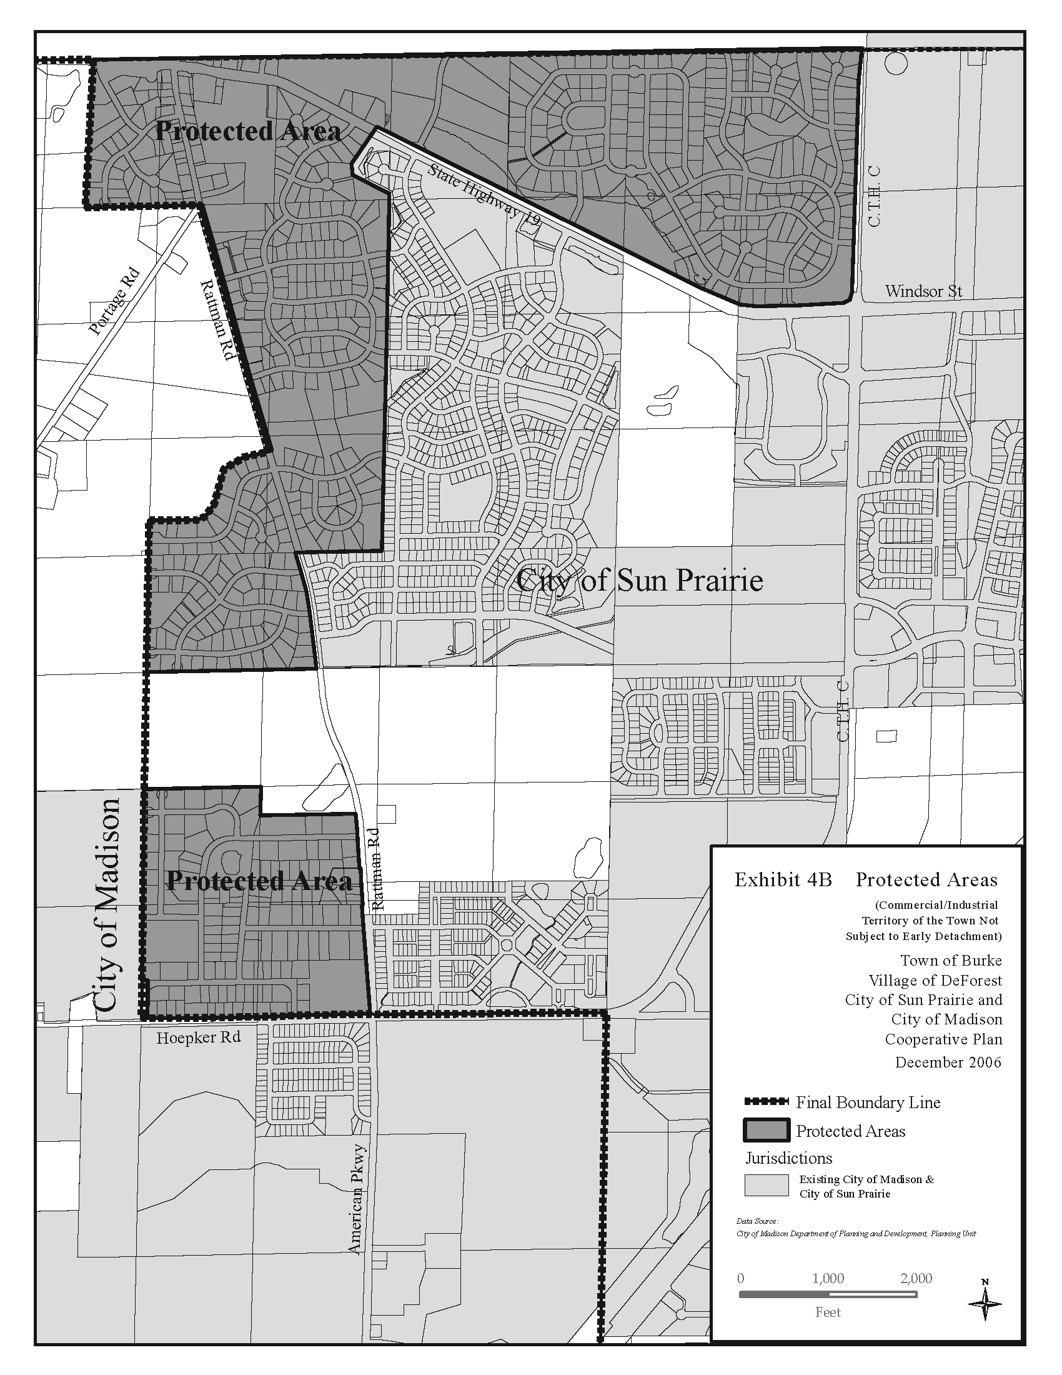

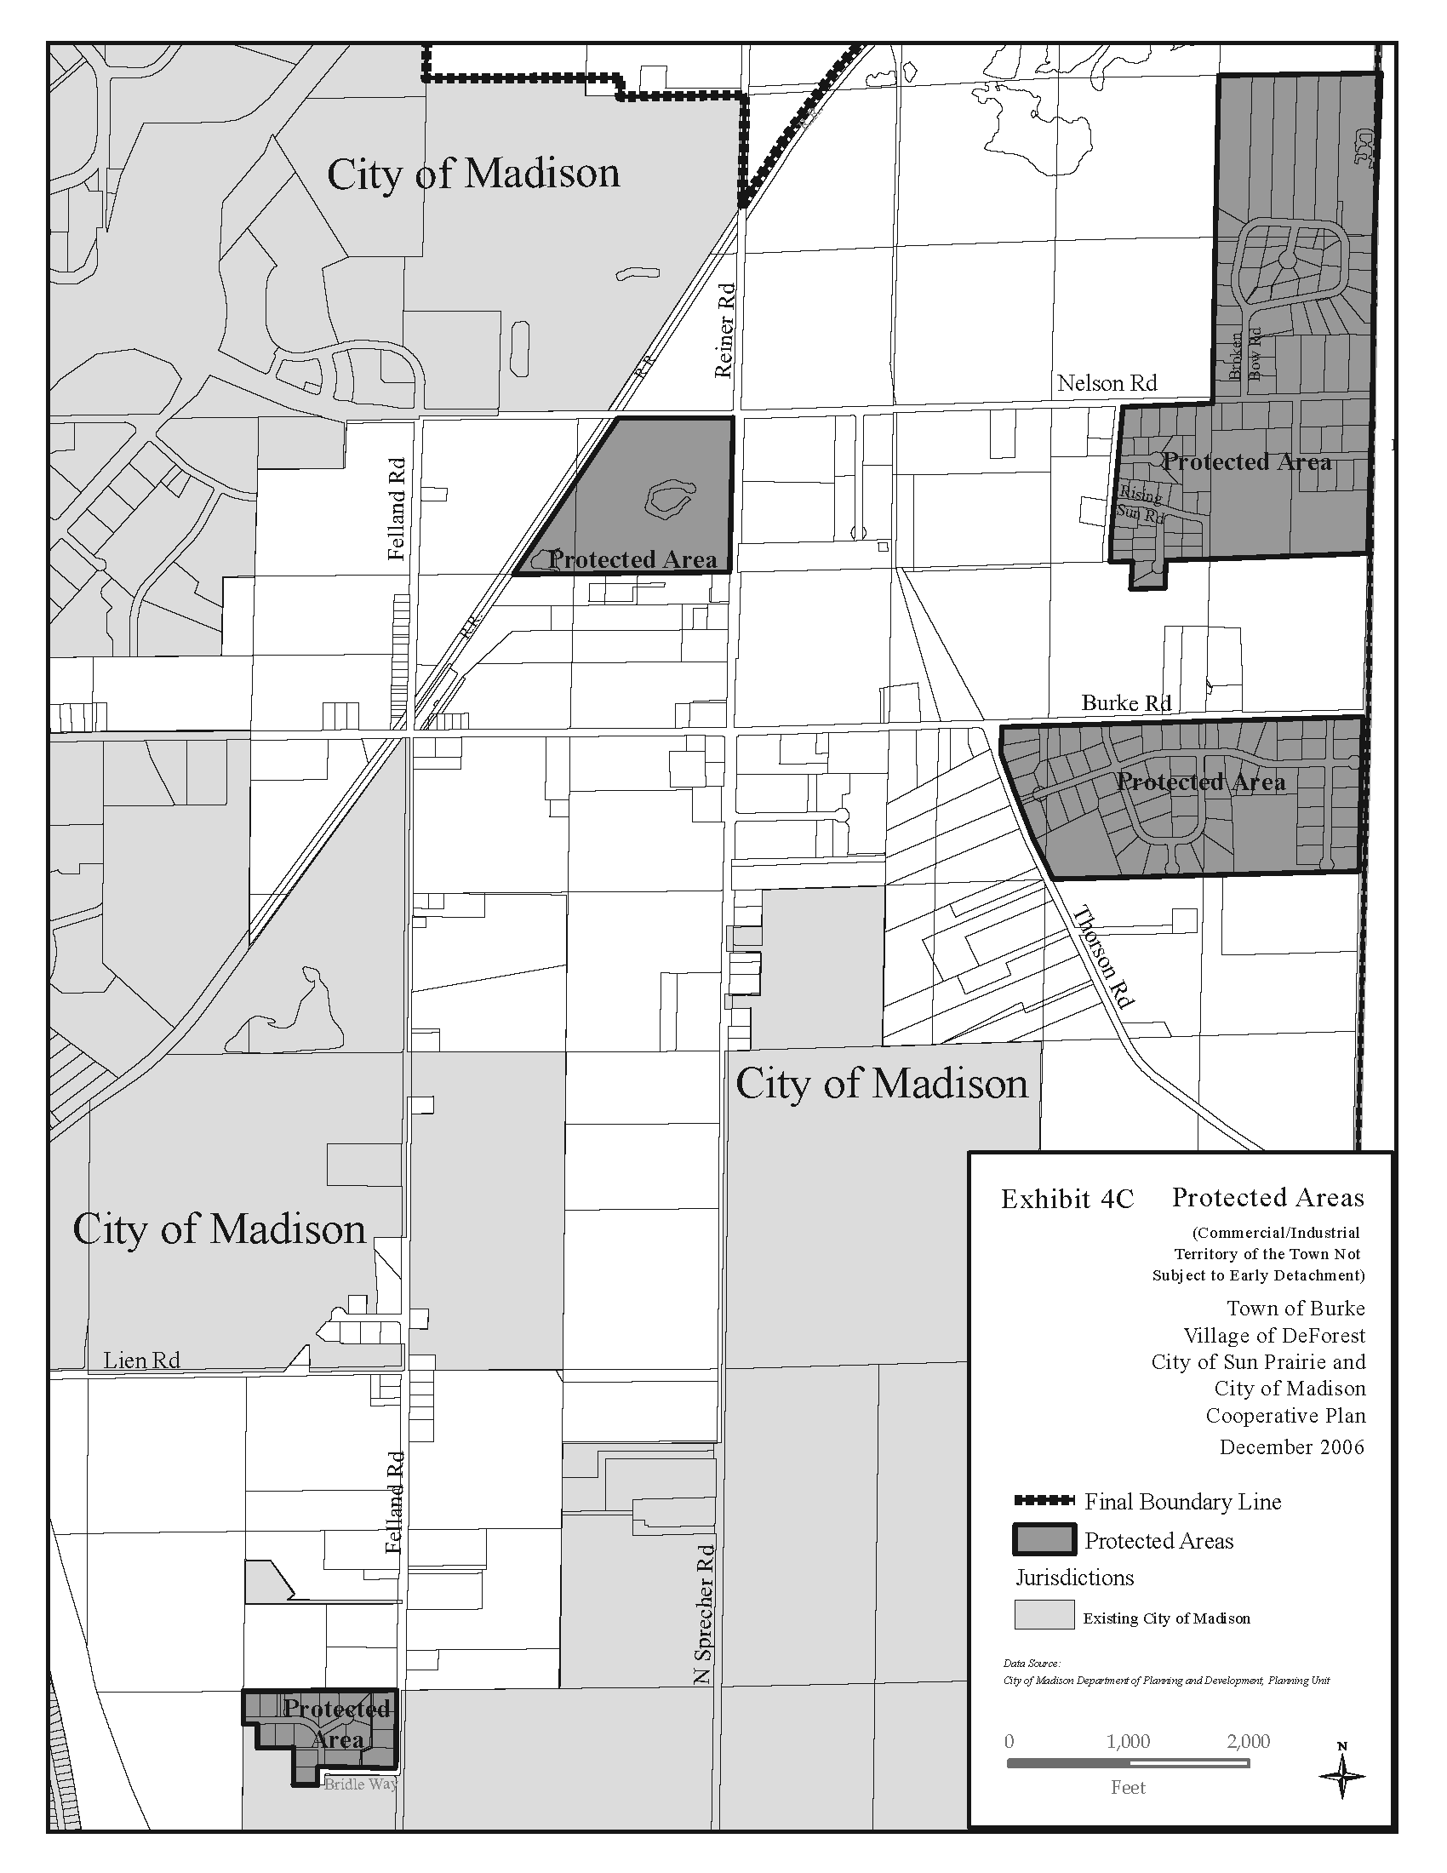

Existing Regional Framework____________________________________________

The following is a brief description of the local units of government that surround the Town of Burke, as well as a description of other regional and state jurisdictions operating within or adjacent to Dane County. Map 1 depicts the existing municipal boundaries of Burke’s neighboring and overlapping jurisdictions.

City of Madison
The City of Madison is located to the south and west of the Town of Burke’s remaining land area. The city’s 2021 population was 269,196, which makes it the second largest city in the state after Milwaukee. In order to effectively plan for the needs of a large population base, the city has clustered development around distinct neighborhoods, which provide convenient access to basic services, shopping, and a variety of housing choices.

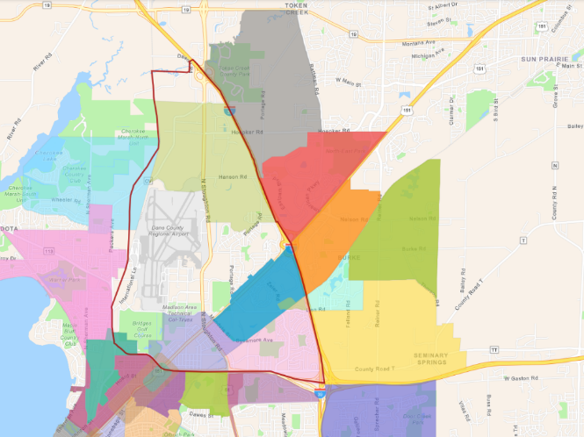
Near the Town of Burke, the City’s peripheral area is very large and extends to the northern boundary with Windsor and to the Town of Sun Prairie. The future development areas, depicted in the graphic at right, includes areas for permanent open space, urban expansion, and several distinct neighborhood plans.
City of Madison Neighborhood Planning Areas, 2023. https://www.cityofmadison.com/dpced/planning/plans/440/
Reiner Plans - Planning - DPCED - City of Madison, Wisconsin
Northeast
Nelson
Felland
Rattman
Pumpkin Hollow
Hanson
Road

Each of the respective neighborhood development plans includes a description of recommended land uses, transportation facilities and services, urban services, and public improvements specific to that neighborhood, but also relative to one another and the surrounding municipalities. Implementation of the neighborhood plans will occur in stages over several years, but is planned for well in advance, allowing for joint planning and decision making with surrounding municipalities.

The Hanson Road, Pumpkin Hollow, Rattman, Nelson, Felland, Northeast, and 2023 Reiner future neighborhoods are shown above. All of these plan areas, as well as others, are described in more detail in Chapter 7, Housing and Neighborhood Development.

City of Sun Prairie
The City of Sun Prairie is located adjacent to the northeast corner of the Town of Burke. The City’s extraterritorial land area is also in the northeast of the Town and shares a boundary with the City of Madison. Land within the City of Sun Prairie Boundary Adjustment Area will be guided by the City of Sun Prairie Comprehensive Plan, adopted in 2019.

There are three separate sub-areas within the city’s Boundary Adjustment Area: the western area, southern area, and central area, which is already encircled by the city and has seen a number of annexations. The western area, generally along Rattman Road, is shown in the City of Sun Prairie Future Land Use Map 9-3 as having low-density residential land uses including pockets of open space and parks. The southern sub-area, which will eventually share a boundary with the City of Madison is located adjacent to US Highway 151 and has also seen a number of annexations. This area is planned for by the city as primarily business and employment centers. The central sub-area is also located along US Highway 151 and is planned for a mix of uses containing denser commercial, office, and residential.

In 2023, the City also partnered with the Madison Metro to join the Bus Rapid Transit system which will bring bus service through areas of the town and to the city.

Village of Windsor
Incorporating as a village in 2015 to protect its boundaries and rural character, the Village of Windsor adopted its Comprehensive Plan in 2016. It is currently in the process of updating its Comprehensive Plan to planning horizon 2050.

While Windsor currently shares a boundary with portion of the Town along WIS 19, the lands within what would be the Windsor ETJ are currently to be incorporated into DeForest and Sun Prairie by the Cooperative Plan.

Village of DeForest
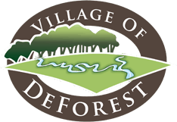
The Village of DeForest is located to the north and west of the Town of Burke. The Village updated their Comprehensive Plan in 2023.

The 2023 Plan provides a Conceptual Development Plan for area around the WIS 19 and US 51 interchange, referred to as the Highway 19 /51 District. This plan is organized around supporting a current and future job center and corporate headquarters; creating a new gathering place for southern DeForest (“DeFoSo Center”); thoughtful transitions between industry and low-density housing and zoning for compatibility, performance, and design; road and path connections and safe non-motorized crossings; and a welcoming highway experience into and through the community.

Dane County
Dane County has an adopted Emergency Management Natural Hazard Mitigation Plan, Land Use and Transportation Plan, Parks and Open Space Plan, Farmland Preservation Plan, Consolidated Plan, and many other, specialized plans. In 2012 the County, in cooperation with other local units of government, adopted an updated Comprehensive Plan. There are no existing or potential conflicts between the long-range plans of Dane County and the Town of Burke.

Token Creek
Token Creek is an unincorporated area located at the intersection of WIS 19 and Portage Road. The area is bordered by the Town of Burke on the south and the Village of Windsor on the north of WIS 19. The citizen-driven community groups in the Token Creek area are responsible for many of the Town of Burke’s annual events, as described in more detail in Chapter 3.

Capital Area Regional Planning Commissions
The Town of Burke is located within the jurisdiction of the Capital Area Regional Planning Commission (CARPC). The territory of the CARPC is Dane County and the incorporated cities and villages within the County. CARPC serves as the regional planning body responsible for preparing and adopting a master plan for the physical development of the region. CARPC is also responsible for maintaining an area-wide water quality management planning process in order to manage, protect, and enhance the water resources of the region.

The Community and Regional Planning division of CARPC provides intergovernmental planning and coordination for the physical, social, and economic development of the County and the municipalities that comprise Dane County. The CARPC provides research, data, and mapping services and makes and adopts plans that are all available to the municipalities within the region for planning at the local level. The Regional Plan Commission’s clearinghouse of information and regional resources provide the basis for intergovernmental cooperation within Dane County. This proactive, long-range collaborative planning process, adopted by Governor Jim Doyle when CARPC was created, is named Future Urban Development Area Planning (FUDA).

Madison Area Metropolitan Planning Organization
The Madison Area Metropolitan Planning Organization (MPO) is the designated transportation planning agency for the Madison metropolitan area. The MPO is responsible for planning and decision making related to regional transportation. The goal of the MPO is to build regional agreement on transportation investments that balance roadway, public transit, bicycle, pedestrian, and other transportation needs and support regional land use, economic, and environmental goals.

The current 2050 Connect Greater Madison Regional Transportation Plan (RTP) provides recommended improvements and studies for areas within the Town of Burke and surrounding municipalities. Major recommended studies and improvements include the Interstate 39/90/94, US 51, and WIS 19 corridors. capacity improvements and study for US Highway 51, regional transit corridors for bus and rail, and an improved bicycle network. The Town of Burke Cooperative Plan and Land Use plan are compatible with the long-range recommendations of the MPO plan.
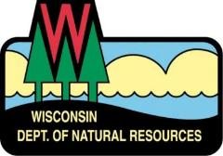
Department of Natural Resources
The WDNR provides service to all Dane County residents out of two Dane County offices located in Fitchburg and Madison. The WDNR south central region manages key environmental assets like land, wildlife, and water through six departmental divisions. Natural features in the Town and Dane County are discussed in Chapter 3.

Department of Transportation (WisDOT)
The Wisconsin Department of Transportation is comprised of three executive offices and five divisions responsible for overseeing, planning, building and maintaining Wisconsin’s network of state highways and Interstate highway system. Included in that system are US 151 and 51, and Interstates 39, 90, and 94 which all run through the Town of Burke. The department shares the cost of maintaining those systems and county and local systems including highways, public transit, and bicycle and pedestrian facilities. The WisDOT southwest region includes Dane County and has several projects under or scheduled for construction in the Town which are described further in the Transportation Chapter of this Plan.

School Districts
The Town of Burke is served by three separate school districts: the Madison Metropolitan School District, the Sun Prairie School District, and the DeForest School District. The Town is within the Madison Area Technical College (MATC) District, which offers education in liberal studies and over 100 other fields. Details regarding the School Districts can be found in Chapter 6: Utilities and Community Facilities.
Intergovernmental Conflicts and Resolution_______________________________

It is important for future planning efforts to attempt to resolve current conflicts between neighboring and overlapping jurisdictions, and to attempt resolution as future conflicts may arise.

Areas depicted on the Future Land Use Map for future development are generally identified in the Cooperative Plan. The Cooperative Plan provides an orderly, planned transition for the current Town of Burke territory to DeForest, Sun Prairie, and Madison municipal jurisdiction over the Cooperative Plan's 30-year planning period and maintains the fiscal viability and operational efficiency of the Town of Burke during the transition period. The Town will continue to work with the adjacent communities to ensure that future development that occurs is reasonably respectful of existing land uses.

There are no known conflicts between the Town of Burke Comprehensive Plan and the various adopted plans and policies of Dane County, the CARPC, WisDOT, or the area School Districts. The Town desires a collaborative, working relationship with these entities on future planning efforts.

Intergovernmental Cooperation Goals, Objectives and Policies_______________

Goal:
Maintain the community character by providing timely service delivery and compatible land development through cooperation with surrounding and overlapping units of government.

Objectives:
- Develop and maintain mechanisms for ongoing communication between the Town and surrounding and overlapping units of government.
- Collaborate on service delivery and examine the need for future opportunities for service consolidation.
- Maintain a relationship with WisDOT regarding future projects and facility improvements.

Policies:
- Continue to pursue intergovernmental joint committees (e.g., DeForest – Burke ETZ) with surrounding local governments, particularly the Cities of Sun Prairie and Madison, to address extraterritorial jurisdiction issues.
- In coordination with the Village of DeForest and the Cities of Sun Prairie and Madison, review proposals for land development to ensure coordinated and compatible development.
- Share equipment, facilities, and service with surrounding jurisdictions to create efficiencies and minimize cost.
- Encourage the timely reconstruction of transportation facilities (e.g., US Highway 51).

Intergovernmental Cooperation Programs and Recommendations______________

Intergovernmental cooperation is a crucial element of the Town of Burke local plan process. The Town is impacted by decisions of a number of adjacent or overlapping jurisdictions. This following listing of programs and recommendations is to promote joint planning and decision making between the Town and the other jurisdictions.

Implement the Cooperative Plan with Madison, Sun Prairie, and DeForest
Because many of the Town’s goals and objectives relate to issues that transcend municipal boundaries (e.g., transportation, natural resource, farmland preservation, land use), the Town intends to maintain an active and open dialogue with surrounding communities and Dane County. The Cooperative Plan adopted in 2007 will continue to serve as a guiding document for the orderly, planned transition for the current Town of Burke territory to DeForest, Sun Prairie, and Madison municipal jurisdiction over the remaining term. The Town will encourage regular meetings be held among the communities in the Cooperative Plan to discuss and evaluate issues of comment interest or concern.

Adopt and Implement Extraterritorial Zoning Committees with Madison and Sun Prairie
Under Wisconsin Statutes, cities and villages have the authority, by right, to exercise extraterritorial land
use planning, subdivision review, official mapping, and, with town approval, zoning outside their incorporated boundaries. In order to exercise this zoning, cities and villages must work cooperatively with adjoining towns. The Town should continue to pursue joint extraterritorial zoning (ETZ) committees with both the City of Madison and the City of Sun Prairie to review new proposals for development. Extraterritorial zoning has the benefit of providing for smoother transitions between rural and urban land uses, reducing conflicting land uses (which lessens citizen complaints and protects property values), and promoting intergovernmental cooperation and communication.

Adopt the County Scenic Roads Program
The Town contains a number of scenic viewsheds that exemplify the natural beauty that attracted many to the area. The County Scenic Roads Program is an initiative of the Dane County Park and Open Space Plan that could link local, county, and state park facilities and include pull-off areas that offer scenic views and interpretive signage within the Town. The Town will work with the County to identify roadways to include in the county-wide program.

Advocate for the Timely Improvement of the US Highway 51 and the I-39/90/94 Corridors
Town officials should continue to coordinate and communicate with WisDOT officials on transportation issues, such as US 51 and I-39/90/94 improvements. See Chapter Five: Transportation for detailed recommendations.

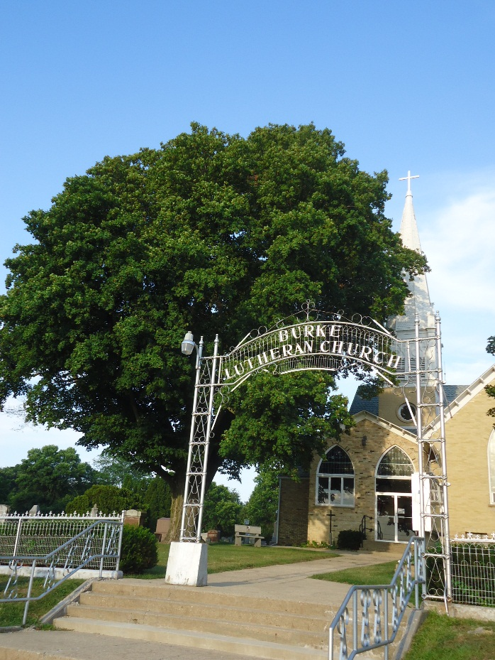

CHAPTER 3
AGRICULTURAL, NATURAL, AND CULTURAL RESOURCES

A
GRICULTURAL, NATURAL, & CULTURAL RESOURCES

This chapter contains a compilation of goals, objectives, policies, programs, maps, and recommendations for the conservation, and promotion of the effective management, of natural and cultural resources. These resources include productive agricultural areas, metallic and nonmetallic mineral resources, groundwater, forests, environmentally sensitive areas, threatened and endangered species, stream corridors, surface water, floodplains, wetlands, wildlife habitat, parks, open spaces, historical and cultural resources, community design, recreational resources, and other natural resources.

Agricultural Resources________________________________________________

The following is an overview of the character, location, and viability of farming activity in the Town of Burke. Since there is a large amount of agricultural land within the community as it exists today, there are important influences on economic and development policies associated with that land that will affect the future of the Town and landowners within and surrounding the Town.

Character of Farming
The 2022 Dane County Farmland Preservation Plan indicates that agricultural lands in Dane County declined by 1.7% (6,346 acres) between 2010 and 2020. During the same decade, residential development grew by 4.6% (2,836 acres) as strong demand for housing has driven the conversion of agricultural lands for suburban and urban development. Figure 1 shows this change.

Figure 1: Land Use Trends in Dane County, 2010 - 2020
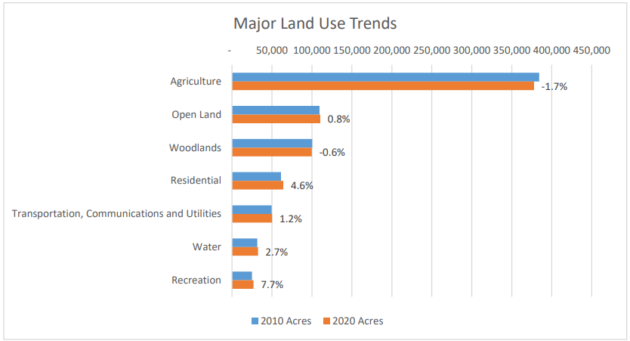
2022 Dane County Farmland Preservation Plan. Volume II: Agricultural Inventory & Trends. https://danecountyplanning.com/documents/pdf/Projects/Farmland-Preservation/Farmland-Preservation-Plan-2022-FINAL-Volume-II-AG-INVENTORY.pdf
When this data is explored further, it indicates that across Wisconsin, the nature of farming has changed over the past two decades. Dane County has seen a trend toward consolidation of agricultural production as there has been an increase in large farms (over 500 acres) and a decline in smaller farms. Additionally, agricultural production continues to be located in the outer portions of the county while those farms closest to Madison are facing significant growth pressure.
According to the Capital Area RPC’s 2010 report Farmland Loss in Dane County, half of Dane County towns with prime soils are located where growth pressure is the greatest, including the towns of Bristol, Burke, Middleton, Westport, and Windsor.

The Town of Burke contains lands that are cropped, but a vast majority, over 75 percent, of the cropped lands (as defined by Dane County) is not farmed in the traditional sense of the word. Rather, the majority of this land that raises a crop is cropped by people other than the owner. It is probable that the owner is holding the land for development. Absentee owners have not been known to “hold” land for farmland preservation.

Assessment of Farmland Viability
The Natural Resource Conservation Service ranks soil suitability for different uses into eight capability classes, with Class I soils considered prime farmland and Class VIII soils being useful for recreational purposes or natural habitat areas. The classifications are based on the soils capability to produce cultivated crops and pasture plants without deteriorating over a long period of time. Map 5: Soils shows the composition of soils within the Town.

Class I soils have slight limitations that limit their use and are prime soils for agricultural production. Class II soils have moderate limitations that reduce the choice of plants or require moderate conservation practices. Class III soils have severe limitations that reduce the choice of plants or require special conservation practices, or both. Class IV – Class VIII soils have very severe limitations that limit their agricultural use to mainly pasture, range, or grazing. Land use in these areas commonly consists of little crop production and more forestland, wildlife, and recreation area with a high esthetic value.

Generally, Class I soils are located in small, isolated groups throughout the Town. Class I soils comprise a relatively small percentage of the total land area. Class II soils are located throughout the Town and make up the largest percentage of total land area. There is a massive area of Class III soil located in the western area of the Town, adjacent to the Cherokee Marsh and Token Creek areas. Class III soils are found throughout the Town, make up the largest percentage of soils within the Town, and tend to be more contiguous.
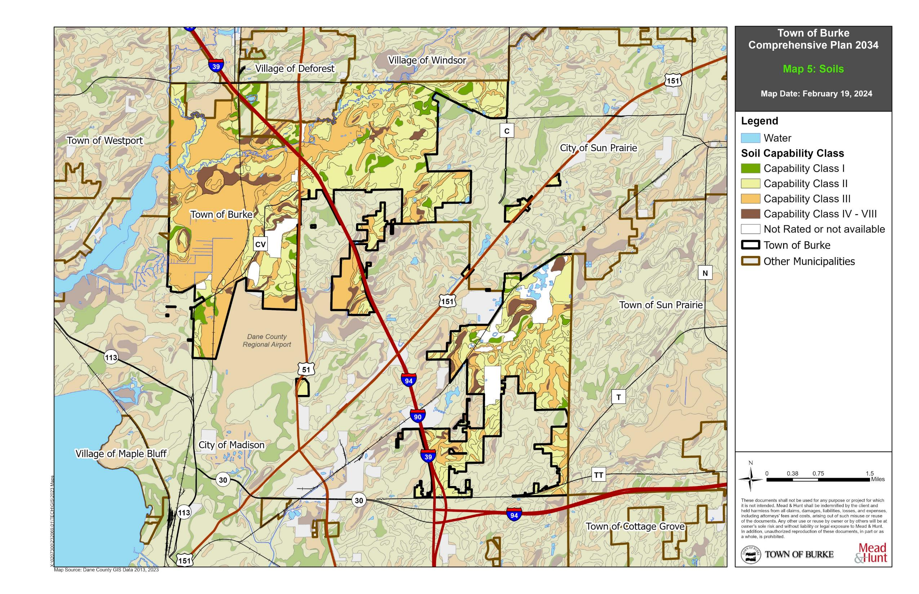

Map 5: Soils

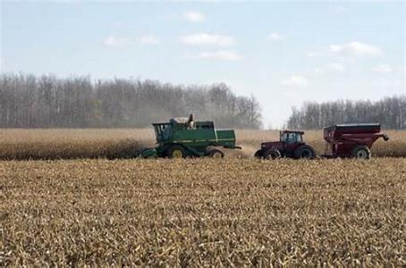
State and County Farmland Preservation Efforts
Wisconsin Working Lands Initiative.
The Working Lands Initiative, a Wisconsin Department of Agriculture, Trade, and Consumer Protection (DATCP) initiative signed into law in 2009 (Chapter 91, Wisconsin Statutes), is comprised of the Farmland Preservation Plan, the Agricultural Enterprise Area (AEA) Program, and the Purchase of Agricultural Conservation Easement (PACE) Program. Through these programs, the initiative strives to address the rapidly increasing loss of forest and farms, often in a fragmented fashion, that increases urban-rural conflicts, and deprives Wisconsin of the land base and infrastructure necessary for agricultural development and profitability.

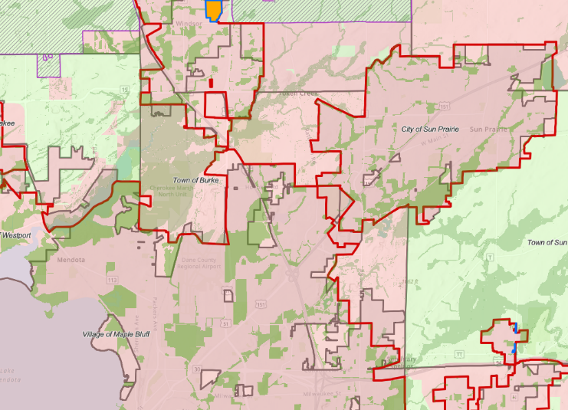
In 2022 Dane County Farmland Preservation Plan, certified by the DATCP, provides a basis for farmland preservation in Dane County and allows farmers to be eligible for state benefits and tax credits as long as they agree to keep their land in agricultural use.
Areas in pink are Not Farmland Preservation Areas. This encompasses the entire Town of Butke. Dane County Farmland Preservation Plan 2022.

The image at right shows the areas and municipalities actively engaged in farmland preservation. The Town of Burke is entirely Not Farmland Preservation. These Not Farmland Preservation Areas include insufficient regulatory or other policy mechanisms in place to effectively limit nonfarm development over the next 20 years. Similarly, the future areas of the Town to be incorporated into the Village of DeForest and cities of Sun Prairie and Madison are not planned for future agricultural uses.
Agricultural Resource Goals, Objectives, and Policies______________________

Goal:
Preserve and redevelop farmland and agriculture related areas as open space to preserve the exurban character and natural beauty of the Town.

Objectives:
- The Town does not intend to seek exclusive agriculture zoning as a means to preserve farmland.
- Recognize the eventual transition of farmland to urban usage.
- Encourage more compact development in areas of existing development.
- Conserve present agricultural land as open space.
- Work with neighboring communities to encourage orderly, efficient development patterns that minimize conflicts between urban and rural uses.

Policies:
- Utilize the Village of DeForest extraterritorial zoning authority to ensure development occurs only in urban expansion areas and not in agricultural preservation areas.
- Utilize the City of Sun Prairie extraterritorial zoning authority to ensure development occurs only in urban expansion areas and not in agricultural preservation areas.
- Prioritize the Madison – Sun Prairie Community Separation Agreement Area to conserve agricultural areas as open space.
- Utilize the City of Madison extraterritorial zoning authority to ensure development occurs only in urban expansion areas and not in agricultural preservation areas.

Agricultural Resource Programs and Recommendations_____________________

Direct Intensive Development into the Village of DeForest and Cities of Sun Prairie and Madison
Large-scale residential and commercial development projects, which have the greatest opportunity for conflicts with agricultural uses and detract from open space and natural corridors, should be directed away from existing farms, areas of farm operations, and environmentally sensitive areas. The Town of Burke intends to direct intensive development into the Cities of Sun Prairie and Madison and the Village of DeForest. Specific development areas and criteria will be guided by the comprehensive plans and ordinances of each respective municipality.

Transfer of Development Rights (TDR) Program
Transfers of development rights programs allow landowners to transfer the right to develop one parcel of land to a different parcel of land. TDR is used to shift development from agricultural or environmentally sensitive areas to designated growth areas closer to municipal services and existing development. When a landowner sells property, generally all the rights (develop, lease, sell, mine, etc.) are transferred to the buyer. TDR programs enable landowners to separate and sell the right to develop land from their property rights. In this way, TDR programs can be utilized to protect prime farmland, conserve environmentally sensitive areas, protect scenic views, and preserve historic landmarks. In 2010 the Dane County Board of Supervisors adopted a TDR ordinance that gives towns the choice of whether or not to participate in the County’s TDR program. The program is intended to reduce sprawl and protect farmland, natural resources, open space, and rural lands.

Natural Resource Inventory_____________________________________________

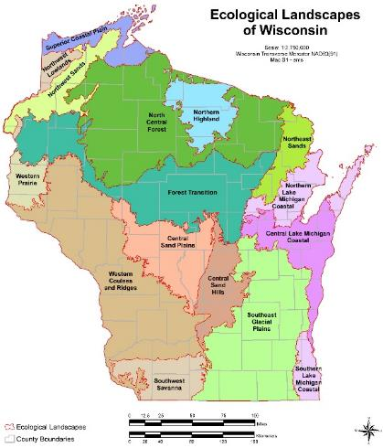
The area around the Town of Burke is heavily developed and highly populated. Pressure on natural resources is high and unlikely to diminish in the short-term. Isolation or fragmentation of native habitats is a major concern for planning and management at a state, county, and local level. A comprehensive approach to understanding the natural resources within Dane County and in and around the Town will have many benefits to best ensure long-term viability of the resources present.
Source: Ecological Landscapes Handbook. WDNR. http://dnr.wi.gov/topic/landscapes/documents/18051Intro.pdf

Landforms/Topography
In order efficiently and effectively plan and manage natural resources in Wisconsin, the WDNR created an eco-region map to divide the state into ecological landscapes. Ecological landscapes are a combination of physical and biological factors, such as climate, geology, topography, soils, water, and vegetation. While the ecological landscapes share characteristics, each offers distinct differences which allow for a number of management opportunities.

The Town of Burke lies entirely in the Southeast Glacial Plains Ecological Landscape (seen in light green on the previous page). This landscape is characterized by rolling topography and an outstanding array of glacial landforms like the Kettle Moraine and Devil’s Lake area. Underlying bedrock is primarily limestone and dolomite with some sandstone and shale. The productive silt loam soils support a dominant agricultural land use (58%). There are numerous wetlands including large fertile marshes, diverse warm water rivers and streams, and marl lakes. The tallgrass prairie and oak savanna are two globally rare communities found in this ecological landscape.

One Significant Ecological Place and several areas of Protected Land are currently within the Town of Burke. Protected Lands include most state, federal, and county ownership or easements as well as lands owned or managed by land trusts and NGOs such as The Nature Conservancy and others. Both the significant ecological place and protected lands are associated with the Cherokee Marsh, which is explored in more detail below.

Metallic and Nonmetallic Mineral Resources
The miner on the Wisconsin state flag is testament to the fact that mining has always been a large part of the economic and industrial base of the state. There are no closed, existing, or proposed metallic mining sites within Dane County.

Nonmetallic mining, or the extraction of stone, sand, rock, or similar materials, is most common in quarry and pit mines. Under State Statutes (295.20), landowners who want to register their property as nonmetallic mining deposits are required to notify each county, city, village, and/or town that has zoning authority over their property. Registrations must be recorded at the County Register of Deeds in the County where the mineral deposit is located. State law limits the ability of a municipality or county to rezone or otherwise interfere with the future extraction of a mineral resource from a registered nonmetallic mineral deposit. It is important to note that zoning changes prohibiting mining on land registered as a marketable nonmetallic mining deposit cannot take effect during the registration period. Registration is effective for 10 years and renewable for an additional 10 years. In addition, registration on property with active mining operations can be renewed for as long as mining is ongoing. Zoning changes may take effect after the registration has expired.

Dane County and the local zoning bodies are responsible for all mine siting requirements and regulation. County zoning allows mineral extraction operations as a conditional use within the following zoning districts: Farmland Preservation district FP-35 and FP-B, Transitional / Rural Mixed Use districts AT-35, AT-B, AT-5, RM-8 and RM-16, and Processing, Manufacturing, and Industrial districts RI and CI.

In addition, the County has developed Special Requirements for Particular Uses under Chapter 10.103(15) Mineral Extraction. Currently, several mineral extraction sites exist within the Town of Burke.

Groundwater Resources
Groundwater is made up of the portion of rainfall that does not run off to streams or rivers and does not evaporate or transpire from plants. This water percolates down through the soil until it reaches the saturated zone of an aquifer. Groundwater quality and quantity is important because it supplies nearly all of Dane County’s water demands. Additionally, the streams, rivers, and wetlands in and around the Town are recharged by groundwater.

According to the Dane County Farmland Preservation Plan 2022, Over 60 million gallons per day of groundwater is withdrawn and used for public and private water supply, translating to about 140 gallons per person per day. Public water supplies account for about 75 percent of total groundwater use. And, urban areas account for 80 percent of groundwater use. Two distinct groundwater sources supply Dane County’s water demands. Shallow sandstone aquifers serve private domestic wells in rural areas, while the deep Mt. Simon aquifer serves municipal wells. Most groundwater in Dane County is replenished from precipitation falling within county boundaries.

The Town of Burke sits atop the Mt. Simon aquifer. As part of the 1999 Land Use Plan, the Town developed Groundwater Hazard maps that indicate the relative susceptibility for groundwater pollution that could originate from various industrial, municipal, and agricultural sources. Much of the town lies in what are considered moderate to greatest groundwater pollution hazard areas. In addition, a four-mile diameter protection zone surrounds the well located in Section 5 near the Village of DeForest, and the Town has adopted a wellhead protection plan and ordinance. Community utilities and facilities are discussed in Chapter 6.

In rural areas of Dane County, nitrates are considered the most common and widespread contaminate for groundwater. While high nitrate levels have been associated with certain rural subdivisions, the high area wide concentration may be the result of nitrogen fertilizer use in the Town’s agricultural past.
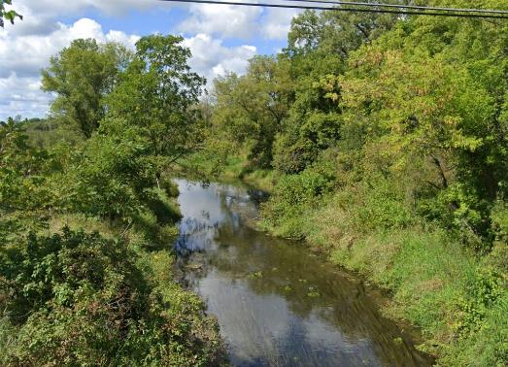
Token Creek at Portage Road, September 2021.
Watersheds and Surface Waters
The Town of Burke is located in the Lower Rock River Basin, which covers over 3,700 square miles in south-central Wisconsin. Water from the Lower Rock River Basin enters the Mississippi River via the Rock River and eventually ends up in the Gulf of Mexico. Within the Rock River Basin, the Town is split by the Yahara River and Lake Monona and Yahara River and Lake Mendota Watersheds. The Yahara River and Lake Mendota Watershed covers 85 square miles and contains portions of the Yahara River, Token Creek, Lake Mendota, and the Cherokee Marsh. The Capital Area Regional Planning Commission (CARPC) ranked this watershed as a high priority candidate for a nonpoint source priority watershed project, primarily because of the rapidly urbanizing areas of DeForest, Sun Prairie, and Madison. Within the Yahara River and Lake Mendota Watershed is the Token Creek Watershed.

The major body of water that runs through the Town is Token Creek. Token Creek is an important tributary of the Yahara River, joining it just before entering Cherokee Lake and ultimately Lake Mendota. In fact, Token Creek generally contributes more water to Lake Mendota than the Yahara River itself. Token Creek is a cold water, spring-fed Class III trout stream that passes through residential agricultural, and parkland areas. Because of the substantial inflow of groundwater to Token Creek, nonpoint source pollution is an ongoing issue. Class III streams are streams where the level of development has overwhelmed the biological integrity and function of the stream. Remediation strategies are directed more to the aesthetic and cultural amenities associated with these streams.

Stormwater management in Burke is a collaborative effort between the Town, County, and CARPC, and involves the use of best management practices (BMPs) to address adverse water quality and quantity impacts generated by uncontrolled stormwater runoff. Chapter 14 of the Dane County Code includes county-wide stormwater management standards used by landowners and developers to address the unique characteristics of their land. It is CARPC policy that stormwater management measures should be aimed at mitigating to the maximum extent practicable the cumulative and incremental adverse impacts of development on surface water and groundwater quality and quantity and associated ecological functions.

Dane County Drainage Districts
Drainage districts are local government entities organized to drain land for agriculture or other purposes. Most Midwestern farmland has too much water, and farmers rely on surface and subsurface drainage systems to produce crops. Land is drained using ditches that cross individual property boundaries and can span several hundred acres. Landowners in a district benefit from drainage because it removes standing water from productive agriculture fields without compromising adjacent properties. The drainage systems also protect structures built below grade that are subject to periodic flooding. Landowners who benefit from drainage are required to pay special assessments to cover the cost of constructing, maintaining, and repairing the drainage system.

Floodplains
In Wisconsin, floods are one of the most common types of natural disasters, and each year communities suffer millions of dollars in flood damages. The Federal Emergency Management Agency (FEMA) designates floodplain areas in the state. These are areas predicted to be inundated with flood waters in a 100-year storm event (i.e., a storm that has a 1 percent chance of happening in any given year). The State requires County regulation of development in floodplains within the Town of Burke.

The National Flood Insurance Program maps produced by the FEMA should be referenced for official delineation and elevations of floodplain boundaries. Development is strongly discouraged in floodplains to avoid both on-site and up and downstream property damage. In the Town of Burke, floodplains are associated with Token Creek and Cherokee Marsh, primarily in the area west of County CV, and the north and western parts of the Town. See Map 6 for more information.
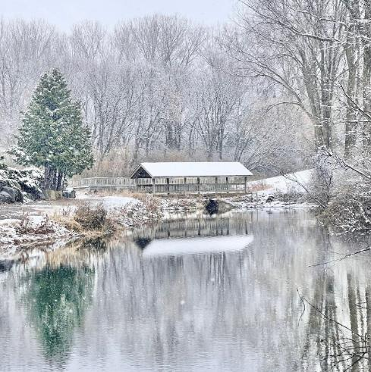
Image courtesy PJ Lenz
Wetlands
Wetlands are ecosystems typically found where land and water meet, transitional areas between dry upland and wet aquatic environments. Wetlands play a significant role in maintaining the quality of groundwater and surface water and provide valuable habitat for fish, birds, and other species.

Additionally, wetlands affect both flooding and water quality because they store large amounts of water as well as stabilize sediments, nutrients, and other pollutants, keeping them from impacting areas located farther downstream. Wetlands provide a critical buffer in the chain of events between cause and effect. Using air photos and original public land survey records, the City of Madison has documented a loss of over 640 acres of wetlands along the Upper Yahara River in the past 160 years.

A significant amount of wetland is present in the Town. The largest section lies in the northwestern portion and is part of Dane County’s largest wetland, Cherokee Marsh. The other significant wetland areas identified within the Town are associated with the Token Creek, which feeds the marsh.
Dane County has adopted shoreland, shoreland/wetland, and floodplain zoning ordinances (unincorporated areas only) that control the use and development of wetlands. Ordinances include a specific listing of permitted uses in the shoreland/wetland district, as well as list other allowed uses requiring a conditional-use permit. The ordinance specifies that all uses not listed are prohibited unless a rezoning should occur, which shall not have a significant impact on any of the wetland functions. Final approval of the zoning amendment must be made by the WDNR, whose authority supersedes that of the County.

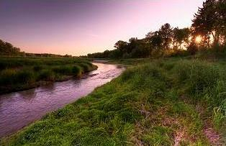
In addition to zoning, communities may use subdivision regulations to protect wetland resources. Subdivision ordinances apply when a parcel of land is divided into lots for sale or development. Many communities use subdivision regulations to protect wetland resources by imposing site restrictions, design standards, and open space dedication requirements. Subdivision regulations often include specific design standards for width and alignment of parkways and drainage ways, and public easements adjacent to streams to anticipate potential flow volumes. Besides easements, the regulation may require dedication of land to the public for resource protection and open space or recreation purposes. Plat approval is often conditioned upon compliance with design standards for critical areas, or adequate protection or preservation of certain environmental features in the site development plan.
Token Creek. Image courtesy Rich Armstrong, 2012.

Woodlands and Natural Vegetation
Much of the woodland and natural vegetation areas within the town and county have been significantly changed due to agricultural and urban land use practices. Prior to development in the area, much of Dane County was covered with prairies, wetlands, oak savanna, and contiguous forests. Isolated remnants of these native plant communities remain in several locations in the area, but the majority of the land use has been converted to agricultural and urban land uses.

Environmental Corridors
Environmental corridors are continuous systems of open space in urban and urbanizing areas that include environmentally sensitive lands and natural resources requiring protection from disturbance and development. Corridors are located mainly along stream channels, floodplains, wetlands, steep slopes and other resource features and are managed at a county level. The WDNR has also identified resource protection corridors, specifically designated to protect a particular natural resource found in that area. In

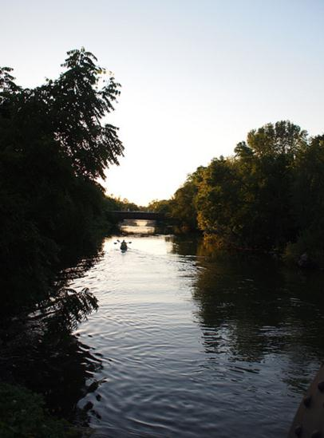
Dane County, there are thousands of acres of environmental and resource protection corridors. Within the Town of Burke, the major resource protection corridor is associated with the Cherokee Marsh and Token Creek areas. There are several areas of environmental corridors within the jurisdictions of the cities of Madison and Sun Prairie, adjacent to the Town.
The Yahara River. Image courtesy Keith Dotson. http://www.flickr.com/photos/keith_dotson/4778994544/in/photostream/

Furthermore, in 2006, the WDNR published the Wisconsin Land Legacy Report which identified 229 Legacy Places and 8 statewide Needs and Resources that are considered highest priority areas for conservation in the state. While the publication is an educational resource rather than a regulatory document, it provides a basis for conservation initiatives throughout the state. The Upper Yahara River and Lakes area, associated with the Cherokee Marsh and the Town of Burke, is the only area classified as a Legacy Place within the Madison Metropolitan Area. Map 6: Natural Features documents the environmental corridors in and adjacent to the Town.

Rare Species Occurrences
The Wisconsin Natural Heritage (NHI) Working List, maintained by the WDNR, contains species known or suspected to be rare in the state and natural communities native to Wisconsin. It includes species legally designated as “Endangered” or “Threatened” as well as species in the advisory “Special Concern” category. There are 14 environmentally sensitive elements identified in the Town of Burke. Sensitive elements are those species or communities particularly vulnerable to collection or disturbance. Table 12 indicates two state-listed threatened animal species and one butterfly. Six plant species and five communities are also present on the NHI Working List.
Regal Fritillary Butterfly. Image courtesy Eric Preston. http://ericpreston.com/p76404109/h172F3246#h172f3246

Table 12: Threatened, Endangered and Special Concern Species in Burke

Group Name | Scientific Name | Common Name | State Status* | State rank**
Bird | Ammodramus henslowii | Henslow’s Sparrow | THR | S2,S3B
 | Tyto alba | Barn Owl | END | SNA
Plant | Agastache nepetoides | Yellow Giant Hyssop | THR | S3
 | Cuscuta glomerata | Rope Dodder | SC | S1
 | Cuscuta polygonorum | Knotweed Dodder | SC | S1
 | Cypripedium candidum | Small White Lady’s-slipper | THR | S3
 | Polytaenia nuttallii | Prairie Parsley | THR | S2
 | Scirpus cespitosus | Tufted Bulrush | THR | S2
 | Hydrastis canadensis | Golden-seal | SC | S2, S3
 | Spiranthes magnicamporum | Great Plains Lady's-tresses | SC | S3
 | Spiranthes ovalis var. erostellata | October Lady's-tresses | SC | S1
 | Nothocalais cuspidata | Prairie False-dandelion | SC | S2
 | Napaea dioica | Glade Mallow | SC | S3
 | Ranunculus cymbalaria | Seaside Crowfoot | THR | S2
Community | Calcareous fen | Calcareous Fen | NA | S3
 | Northern wet forest | Northern Wet Forest | NA | S4
 | Shrub-carr | Shrub-carr | NA | S4
 | Southern sedge meadow | Southern Sedge Meadow | NA | S3
 | Wet prairie | Wet Prairie | NA | SU
Butterfly | Speyeria idalia | Regal Fritillary | END | S1
Frog | Acris blanchardi | Blanchard's Cricket Frog | END | S1
Turtle | Emydoidea blandingii | Blanding's Turtle | SC/P | S3, S4
* State Status: Protection category designated by the Wisconsin DNR. END = Endangered; THR = Threatened; SC = Special Concern.

**State Rank: State element rank.
    - S1 Critically imperiled in Wisconsin because of extreme rarity, typically 5 or fewer occurrences and/or very few (<1000) remaining individuals or acres, or due to some factor(s) making it especially vulnerable to extirpation from the state.
    - S2 Imperiled in Wisconsin because of rarity, typically 6 to 20 occurrences and/or few (1000-3000) remaining individuals or acres, or due to some factor(s) making it very vulnerable to extirpation from the state.
    - S3 Rare or uncommon in Wisconsin, typically 21-100 occurrences and/or 3000-10,000 individuals.
    - S4 Apparently secure in Wisconsin, usually with >100 occurrences and >10,000 individuals.
    - S5 Demonstrably secure in Wisconsin and essentially ineradicable under present conditions.
    - SNA Accidental, non-native, reported, but unconfirmed, or falsely reported.
    - SH Of historical occurrence in Wisconsin, perhaps having not been verified in the past 20 years and suspected to be still extant. Naturally, an element would become SH without such a 20-year delay if the only known occurrence were destroyed or if it had been extensively and unsuccessfully looked for.
    - SNR Not Ranked, a state rank has not yet been assessed.
    - SU Cannot currently rank. Possibly in peril in the state, but status is uncertain due to lack of information or substantially conflicting data on status or trends.
    - SX Apparently extirpated from the state.

Ranking long distance aerial migrant animals presents special problems relating to the fact that their non-breeding status (rank) may be quite different from their breeding status, if any, in Wisconsin. In other words, the conservation needs of these taxa may vary between seasons. In order to present a less ambiguous picture of a migrant's status, it is necessary to specify whether the rank refers to the breeding (B) or non-breeding (N) status of the taxon in question. (e.g. S2B, S5N).

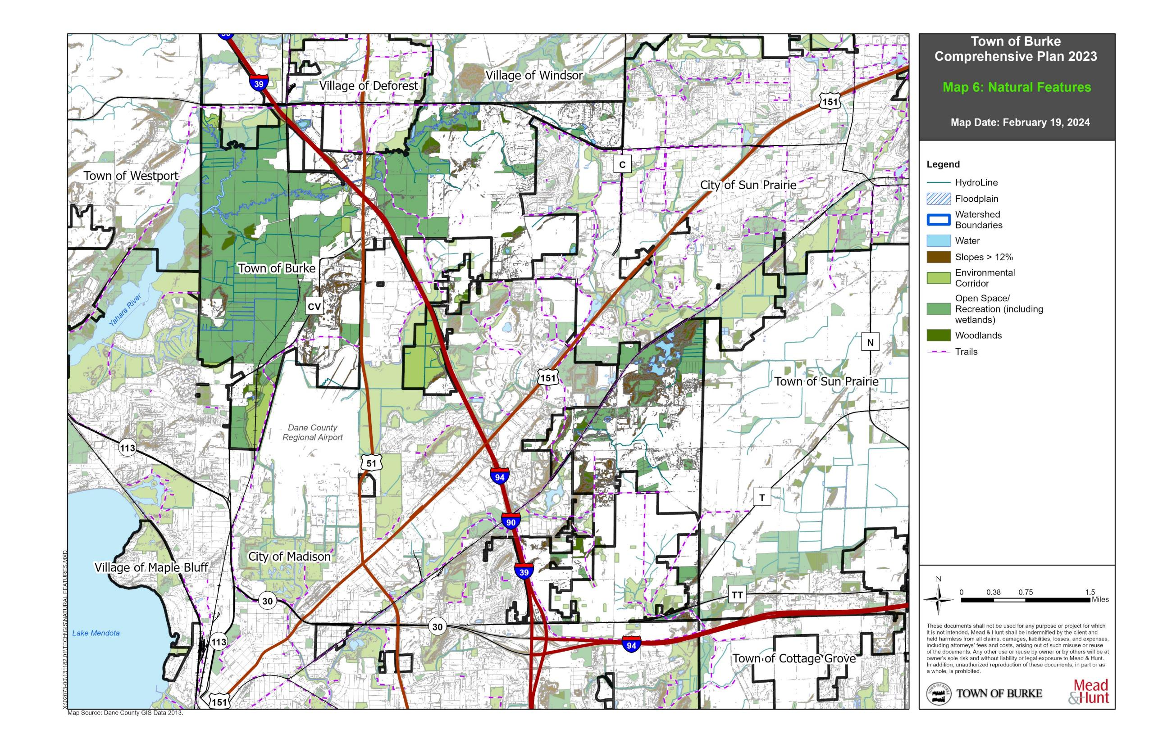

Map 6: Natural Features

State Parks and Natural/Wildlife Areas
The Cherokee Marsh State Natural Area, designated a state natural area in 1976, is part of an extensive wetland complex of more than 2,000 acres. The Marsh represents a gradient of habitat types ranging from open water to hardwood forest and warm season grass fields. The banks of the Yahara River and Token Creek which feeds the Marsh, are typical emergent wetland vegetation consisting of cattail and wetland plants. Because of its size and differentiating characteristics, the Marsh has been divided into a northern and southern unit. The northern unit, the part which lies within and adjacent to the Town, has been classified as a fen and is home to many species of mammals, amphibians, reptiles, and birds. State Natural Areas have very few public facilities like picnic areas or restrooms, but provide a variety of recreational activities like hiking, fishing, outdoor education, and wildlife viewing, amongst others.

Immediately adjacent to the north of the Cherokee Marsh is the Cherokee Marsh State Fisheries Area. WDNR Fisheries Areas are located along stream, rivers, and lakes and are designated to protect and restore water quality by improving habitat and fishing opportunities. Fisheries help replenish native fish populations that have diminished from over-harvesting and deteriorating habitat. In conjunction with State Natural Areas, Forest, Trails, and Wildlife Areas, fisheries often include lands adjacent to streams and lakes and help protect a larger watershed and provide for compatible recreational uses.

Additional information about the Cherokee Marsh can be found through the Wisconsin Wetland Association (http://www.wisconsinwetlands.org/), Friends of Cherokee Marsh (http://cherokeemarsh.org/) and the WDNR (https://dnr.wisconsin.gov/topic/statenaturalareas/CherokeeMarsh).

County and Local Parks
County and Local Parks will be discussed in detail in Chapter 6: Utilities & Community Facilities.

Natural Resource Goals, Objectives, and Policies___________________________

Goal:
To preserve, protect and improve environmental resources in the Town and surrounding area.

Objectives:
- Protect environmentally sensitive areas such as floodplains and wetlands from urban encroachment, specifically Token Creek and Cherokee Marsh.
- Support management options that mitigate the effects of urban development on the Token Creek watershed.
- Support open space preservation to protect outstanding scenic resources.
- Encourage land use development were soil capability, slope and other physical factors are most suitable.
- Coincide with the County’s Park Plan for trails, land acquisition, and development.
- Ensure future development does not disrupt natural drainage ways and is consistent with area storm drainage planning.

Policies:
- Protect environmental corridors as a composite of the Town’s most sensitive natural areas, including wetlands and floodplains, especially adjacent to future development areas.
- Work with the WDNR, County, and surrounding municipalities to link natural resources preservation with recreational and economic opportunities.
- Protect surface water quality and groundwater quality by supporting stream bank management, natural shoreline restoration, erosion control, river and creek clean-up initiatives, proper agricultural practices, stormwater management, and the use of vegetative buffers.
- Carefully review proposals for mineral extraction operations, and the reclamation of existing mineral extraction sites.
- Encourage landowner participation in programs that provide financial assistance and technical assistance for land management activities and land preservation efforts, particularly in flood prone areas, such as the Conservation Reserve Program and the Nature Conservancy.
- Pursue alternative stormwater management techniques to prevent and reduce flooding within the Town.
- Pursue state and federal programs to help protect natural resource from non-point pollution and offset the costs of implementing best management practices.

Natural Resource Programs and Recommendations__________________________

Protect Environmental Corridors and Preserve Open Space
Environmental corridors are present within and adjacent to the Town, but truly do not adhere to administrative boundaries. Environmental corridors provide habitat areas, recreation, scenic views, and flood mitigation, amongst many other things, in a linear (corridor) pattern on the landscape that ties jurisdictions together for management and protection purposes. The social, economic, and environmental value associated with natural features is immeasurable and provides significant value for the community.

New development should be discouraged in environmental corridors and in areas associated with scenic
open space. Development types should be limited to those which will not impair the resource and are generally compatible with existing and proposed uses on surrounding lands. Protection of natural resources should be paramount in reviewing proposed development within and adjacent to environmental corridors. An example of this is the Town Parks Committees plan to convert approximately 7.5 acres of mowed lawn into natural prairie beginning in 2024.

The Town should conduct or require viewshed analysis before approving new development. A viewshed analysis would identify the places from where new development could be seen from other locations, and the impact of view that would result from the proposed development. New development should be designed and located in a manner that does not detract from the Town’s scenic views associated with open spaces.

Protect Rare Species and Wildlife Habitat Areas
Protection of rare species and wildlife habitat has many benefits. It preserves open spaces and natural areas, which often produce the scenic beauty of a place; it increases stewardship and awareness; it enhances recreational experiences; and it creates a sense of pride within the Town. Protecting habitat and rare species may also minimize the potential of a species becoming “threatened” or “endangered,” thereby requiring federal intervention under the Endangered Species Act. Protection and management of rare species and wildlife habitat will help the Town develop a legacy over the next 20 years, which recognizes the importance of preserving environmentally sensitive areas.

Expand Nature-based Tourism
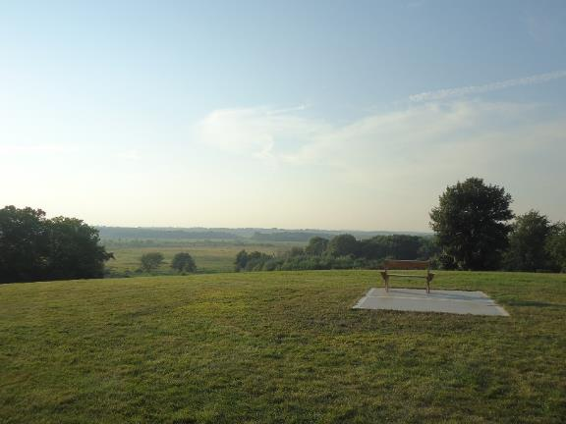
Nature-based tourism centered on the Token Creek provides the Town an opportunity to enjoy the financial benefits of increased economic development while simultaneously preserving the area’s environment and sensitive areas. The area’s abundant natural resources make the Town particularly well-suited to attract growth in nature-based activities like fishing, boating, and wildlife watching. The Town may work with the State and the Department of Natural Resources to promote the enhancement and possible expansion of the Token Creek environmental corridor as it ties in to state-owned and maintained facilities like Cherokee Marsh State Natural Area and State Fishery.
Token Creek County Park as seen from atop a hill off CTH CV. Photo courtesy Mead & Hunt, Inc. 2013

Review Proposals for Mineral Extraction Sites and Enforce Reclamation and Remediation
Three non-metallic mineral extraction sites are currently located within the Town. Over the remaining years, the Town will increasingly lose acreage as it transitions land to the jurisdictions of the surrounding municipalities. During this time, the Town should carefully review any proposals for new extraction sites to manage and prevent any land use conflicts which may arise from the potential impacts associated with mineral resource extraction. The Town will work to assure that applications for approval of extraction operations present a clear picture of proposed activities and support those activities with a detailed reclamation plan and map. Applicants will also be required to submit plans for post reclamation operations once the mine becomes inactive. The Town will work with the County to ensure notification for surrounding land owners is proper and just.

Protect and Enhance the Token Creek Watershed (Cooperative Plan)
To minimize reduction of water table levels, particularly in the Token Creek Watershed, the Town of Burke
should implement mitigation measures outlined in the 1999 Land Use Plan. These mitigation measures include stormwater management and erosion control, habitat restoration, groundwater management, impoundments, and management of agricultural lands.

Stormwater Management and Erosion Control
The Town should ensure the construction of stormwater mitigation structures for minimizing stormwater peak flow, volumes, and water resource degradation for future development. This is a proactive measure to mitigate the effects of flooding. These structures are also used to increase groundwater recharge, enhance water quality, and improve recreation.

- Three major types of stormwater mitigation structures can be construction:
  - Detention basins
  - Infiltration structures (permeable pavement, infiltration basins, infiltration trenches, buffer strips and filter strips, and grassed swales)
  - Artificial wetlands

- Development of non-structural measures to protect the areas within the watershed from potential stormwater runoff and erosion problems associated with urbanization include:
  - Adoption and Implementation of Stormwater and Erosion Control Ordinances
  - Adoptions and Implementation of Stormwater Management Plans
  - Establishment of Stormwater Public Utilities
  - Education of citizens about protection practices

Habitat Restoration
Take steps to stop habitat degradation that is currently occurring within areas of the watershed and then implement strategies to restore degraded or destroyed habitats.
- Remediate stream bank erosion.
  - Riprapping
  - Installation of deflectors.
  - Artificial seeding with riparian plants.
- Increase wetland acreage.
  - Enhance existing wetland areas.
  - Restore former wetland areas.
  - Create new wetlands.

Groundwater Management
Develop local and regional groundwater management strategies that address concerns of both quality and quantity.
- Quality strategies
  - Municipality Well-Head Protection Plan.
  - Implementation of farm management groundwater pollution preservation techniques.
  - Proposer sitting and maintenance of septic systems.
  - Road salt use limits.
  - Individual household measures.
- Quantity strategies
  - Avoid sensitive areas for municipal well locations.
  - Educate citizens on the importance of conserving water.
  - Artificially recharge water levels by using imported water or re-infiltration of treated wastewater.

Impoundments
Impoundments, also known as reservoirs, are artificially created standing water bodies produced by dams on streams or rivers. The removal of impoundments within the watershed area is a desirable strategy because it would allow streams within the area to become deeper, colder, and healthier.

Management of Agricultural Lands
The Town should promote the implementation of agricultural management strategies that control non-point sources of pollution, such as the prevention of soil erosion and limitations on fertilizer, manure, and pesticide applications.

Cultural Resources____________________________________________________

Historic, archeological, and cultural resources contribute to a community’s quality of life and provide a feeling of social and cultural continuity between the past, present, and future. For instance, the Town of Burke derived its name from Rt. Hon. Edmund Burke, Irish patriot, orator, and poet. Preservation of resources helps to foster a sense of pride and place and often provides economic benefits to property owners and communities through tourism and increases in property values.

As with many areas throughout Dane County, most Native American and original European settlement occurred around sources of water. In 1984 the Dane County Historical Society recognized the Token Creek area as historically significant place and placed an informational sign near the creek. The sign reads:
Attracted by abundant water, early Indian inhabitants erected effigy mounds in the area. George Spaulding was the first white settler in 1841. The Town of Windsor’s first election was held in 1847 at Charles Lawrence’s Prairie House Inn. A post office was established in that year but discontinued in 1902. The name Token was derived from Tokaunee, a minor Indian chief. Completed in 1844, the Fort Winnebago Road from Madison passed through Token Creek. Guided by the landmark Big Hill, homesteaders and lumberman journeyed through on their way to northern pineries. Token Creek had a school, Congregational church, two mills and an early fish hatchery. Veterans of five wars, including the Revolutionary War, rest in the cemetery. Until destroyed by fire in 1881, the Token Creek Tavern was the area’s social center. Under the glow of tallow candles, couples danced to the fiddle music of Marcus Wheeler, father of poetess Ella Wheeler Wilcox. Token Creek declined after the railroads bypassed it.

In addition, an Indian trail once passed through what is now the Town of Burke. The trail led from Koshkonong and Lake Monona, to Fort Winnebago at the portage of the Wisconsin and Fox Rivers, and on to the timber mines in northern Wisconsin. The trail was used as a trade route from Madison to Portage.

Historic Sites
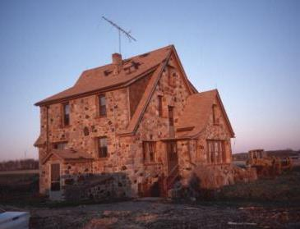
The Wisconsin Historical Society’s Architecture and History Inventory (AHI) contains data on a wide range of historic properties throughout the state. A 1934 Capital Times article indicates the first house and first barn in Burke were built by William Lawrence in 1837, who later built the Prairie house. According to the AHI, more than 50 documented properties are in the Town of Burke. These properties include the S.W. and Sarah Thompson Farm, Lucinda and Samuel Messerschmidt House, the Hillside Barn, and the Hanchett-Spaulding House. The S.W. and Sarah Thompson Farm and the Lucinda and Samuel Messerschmidt House have both been determined eligible and the Hillside Barn, although demolished, is listed as potentially eligible for the National Register of Historic Places (National Register). Additional information about these and other properties may be found at the Wisconsin Historical Society Website at: www.wisconsinhistory.org/ahi
The Lucinda and Samuel Messerschmidt House, built in 1930 is a Tudor Revival style and has been determined eligible for the National Register of Historic Places. Source: Wisconsin Architecture and History Inventory

Archeological Sites
The Wisconsin Historical Society also contains information on archaeological sites within the state. According to the Archaeological Sites Inventory, current Town lands contain 37 archeological sites, 11 of which are burial sites. One area contains Native American burial mounds. Although the surface of the mounds has been destroyed by cultivation or development, the site is still subject to Wisconsin State Statute 157.70, protecting human burial sites. Other burial sites include at least four Euro-American cemeteries, some of which are still used. There are also a number of Town sites containing evidence of early habitation by Native Americans between 1,000 BC and 1,000 AD and one much earlier site (to 9,000 BC). All the archeological sites are on private lands and none is listed on, or eligible for, the National Register.

Cultural Resource Goals, Objectives, and Policies__________________________

Goal:
Preserve and enhance the Town’s cultural resources.

Objectives:
- Identify and promote preservation of the Town’s cultural, historic, and archaeological resources.
- Support community special events.
- Increase research and documentation of Native American settlement and activity areas.

Policies:
- Support local festivals, fairs, tours, community breakfasts, and markets that celebrate the Town’s farming heritage, exurban character, and history.
- Encourage the preservation and rehabilitation of identified cultural, historic and archeological resources when specific sites are proposed for development.
- Participate in updating or records and mapping to fully document cultural, historical, and archeological resources.
- Prohibit incompatible land uses (e.g., high traffic generators, noisy uses, or unattractive uses) from locating within or next to cultural and historic resources and residential areas.
- Conduct additional research/study to create interpretive information regarding the history of settlement within the Token Creek watershed and how the Big Hill, stream and springs influenced settlement.
- Partner with Dane County Parks to develop interpretive signs and exhibitions of former Native American settlement and activity sites.
- Preserve and protect the scenic landscape of the Town.
- Engage the Town Board early in the calendar year to plan, schedule, and publicize community special events.
- Regularly update the Town website to include community special events.

Cultural Resource Programs and Recommendations_________________________

Encourage Cultural Heritage Tourism
The Town should work to encourage tourism opportunities that celebrate the area’s cultural, historic, and archeological resources and bring economic vitality to the community. The National Trust for Historic Preservation defines heritage tourism as “travelling to experience the places, artifacts, and activities that authentically represent the stories and people of the past.” Cultural heritage tourism helps make historic preservation economically viable by using historic sites and landscapes to attract travelers. The National Trust for Historic Preservation also indicates that studies have shown that heritage travels stay longer and spend more money than any other kind of travelers and a good heritage tourism program can improve the quality of life for local residents as well as serve visitors. Celebration of the Towns past through tourism will help its social and economic future.

Protect and Rehabilitate Known Historic and Archeological Sites
The Town of Burke has a number of historic and archeological resources. Under Wisconsin law, Native American burial mounds, unmarked burials, and all marked and unmarked cemeteries are protected from intentional disturbance. In situations where development is proposed in areas where historical and archeological resources exist, the Town will require developers to demonstrate how historical and archeological features will be preserved and recognized.

The Town should also explore the availability of State Historical Society grant money and state and federal tax credits to rehabilitate, restore, or relocate historic structures threatened by demolition or disrepair.

Preserve and Celebrate the Scenic Landscape
Scenic vistas are a very important resource in the Town of Burke, and this region of the state offers a diverse landscape of wetlands, prairies, forested areas, and agricultural lands. A number of local areas are also present that offer beautiful views of the landscape, key natural landmarks, and water bodies.
Within these potential areas of scenic beauty, the Town can require viewshed analysis before approving new development. A viewshed analysis would identify the places from where new development could be seen from other locations, and the impact of view that would result from the proposed development. New development should be designed and located such that it does not detract from scenic views in the Town.
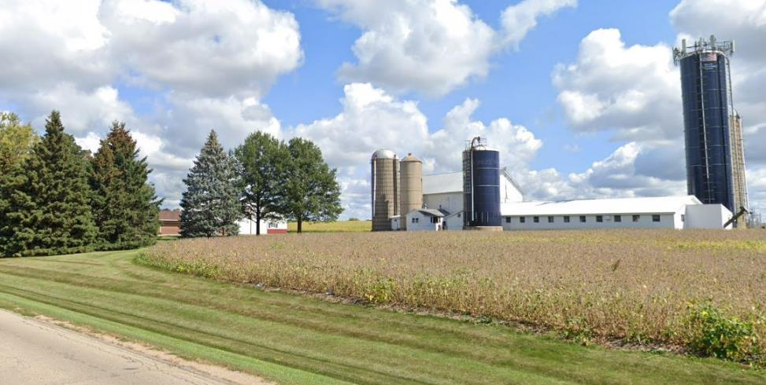
View along Rattman Road.

Cooperate on a Comprehensive Survey of Historic and Archeological Resources
The historical and archeological sites outlined above include only those sites that have been identified and reported to the State Historical Society. Very little of Dane County and the Town of Burke land areas have been surveyed for the presence of archeological sites, cemeteries, or other historically significant areas. The presence of some Native American burial sites within the Town suggests that there may be other, currently undocumented sites in close proximity.

The Town of Burke is open to partnering with Dane County, the Wisconsin Historical Society, UWEX, local historical societies, and other government agencies to complete a comprehensive, countywide survey of historic and archeological resources. The survey would involve both research and field work and should be conducted by trained archeologists or students under professional supervision.

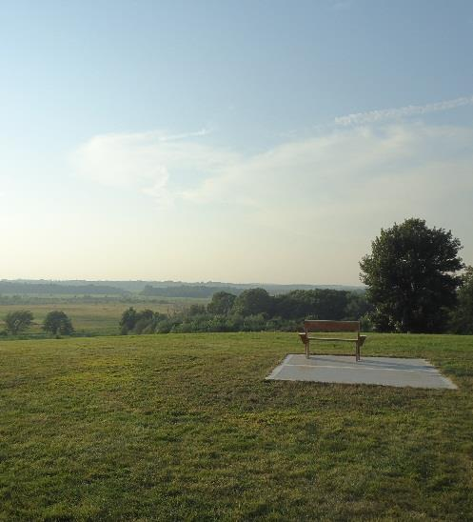

CHAPTER 4
LAND USE

L
AND USE

The land use element is a compilation of goals, objectives, policies, recommendations, programs, and maps intended to guide the future development and redevelopment of public and private property. This chapter contains a listing of the amount, type, intensity, and net density of existing uses of land in the Town including agricultural, residential, commercial, industrial, and several other public and private uses. Based on the background information, this chapter also analyzes trends in the supply, demand, and price of land; makes projections of future demands; and outlines opportunities for redevelopment and existing and potential land-use conflicts.

According to the 2010 CARPC Farmland Loss in Dane County report, annexation by cities and villages totaled 24,000 acres between 1980 and 2000. Cities annexed twice as much land, roughly 16,000 acres, as villages which annexed about 8,000 acres. While some annexed land remains under cultivation, typically annexed land is intended for eventual development, unless preserved as urban agriculture.

Further, according to the 2022 Dane County Farmland Preservation Plan, between 2010 and 2020, cities and villages in Dane County annexed a total of 26,987 acres. Cities annexed over 6,000 acres while villages annexed about 21,000 acres.

According to the 1999 Land Use Plan, the total area in the Town of Burke in 1970 was 17,513 acres. This total has steadily declined to 17,269 acres in 1980, 15,777 acres in 1990 and 10,450 acres in 2013. Today, the Town of Burke is 8,908 acres.

Existing Land Use Map Categories_________________________________________

Map 7: Existing Land Use organizes existing land uses by the land use categories listed below. These categories indicate how land is currently being used, which does not necessarily reflect the current zoning designations or desired future used. Some categories of use are not present within the Town but are found in neighboring communities and elsewhere in the County.

Agriculture uses include cropland/pasture (including cultivated farm fields, livestock grazing areas and farm primary farm residence and farm building, animal husbandry (including buildings), farm building/ accessories (located separate from primary farmstead), commercial forest, fishing, and related other agriculture. Of these uses, the Town only contains cropland/pasture and farm building/accessories.

Single-Family Residential uses include single-family detached residential development.

Multi-Family Residential includes two-family residential development and multi-family residential with three or more units per building.

Mixed Residential includes mobile homes, mobile home parks, farm units (separate from cropland/pasture), group quarters (dormitories, retirement facilities), and seasonal residential uses, occupied less than six months of the year. There are no mixed residential parcels within the Town.

Industrial uses include food and kindred; textile and mills; apparel and related uses; lumber and wood products manufacturing; furniture and fixtures manufacturing; paper and allied products manufacturing; printing, publishing, and allied industries; scientific instruments; chemicals and allied products manufacturing; miscellaneous industrial; wholesale trade; rubber and miscellaneous plastic products manufacturing; stone, clay, and glass product manufacturing; and mineral extractive sites/quarries.

Transportation uses are both parcels and rights-of-way. They include railroad, aircraft transportation, marine craft transportation, street, road, highway rights-of-way, automobile parking (stand-alone parking lots or ramps), and non-motorized transportation (including trails).

Utilities include electric generating/processing, gas generating/processing, water generating/processing, electric, gas, and water transmission, sewage, solid waste, and other communication/utilities.

Commercial/Office uses contain a mix of retail sales and retail services. Commercial retail sales uses include shopping centers, hardware, and farm equipment, general merchandise, food (bakeries, grocery stores, liquor stores, butcher shops), apparel and accessories, furniture, home furnishings and equipment, eating and drinking establishments, general repair and maintenance, motor vehicles, tires, batteries and accessories stores, gasoline service stations, and other commercial retail sales including automotive, marine craft, aircraft and accessories. Commercial retail service uses include finance, insurance and real estate offices, personal services, business services, professional services, contract construction services, transient lodging, amusement, and miscellaneous services. There is no apparel retail within the Town. In addition, there are no grocery stores within the Town.

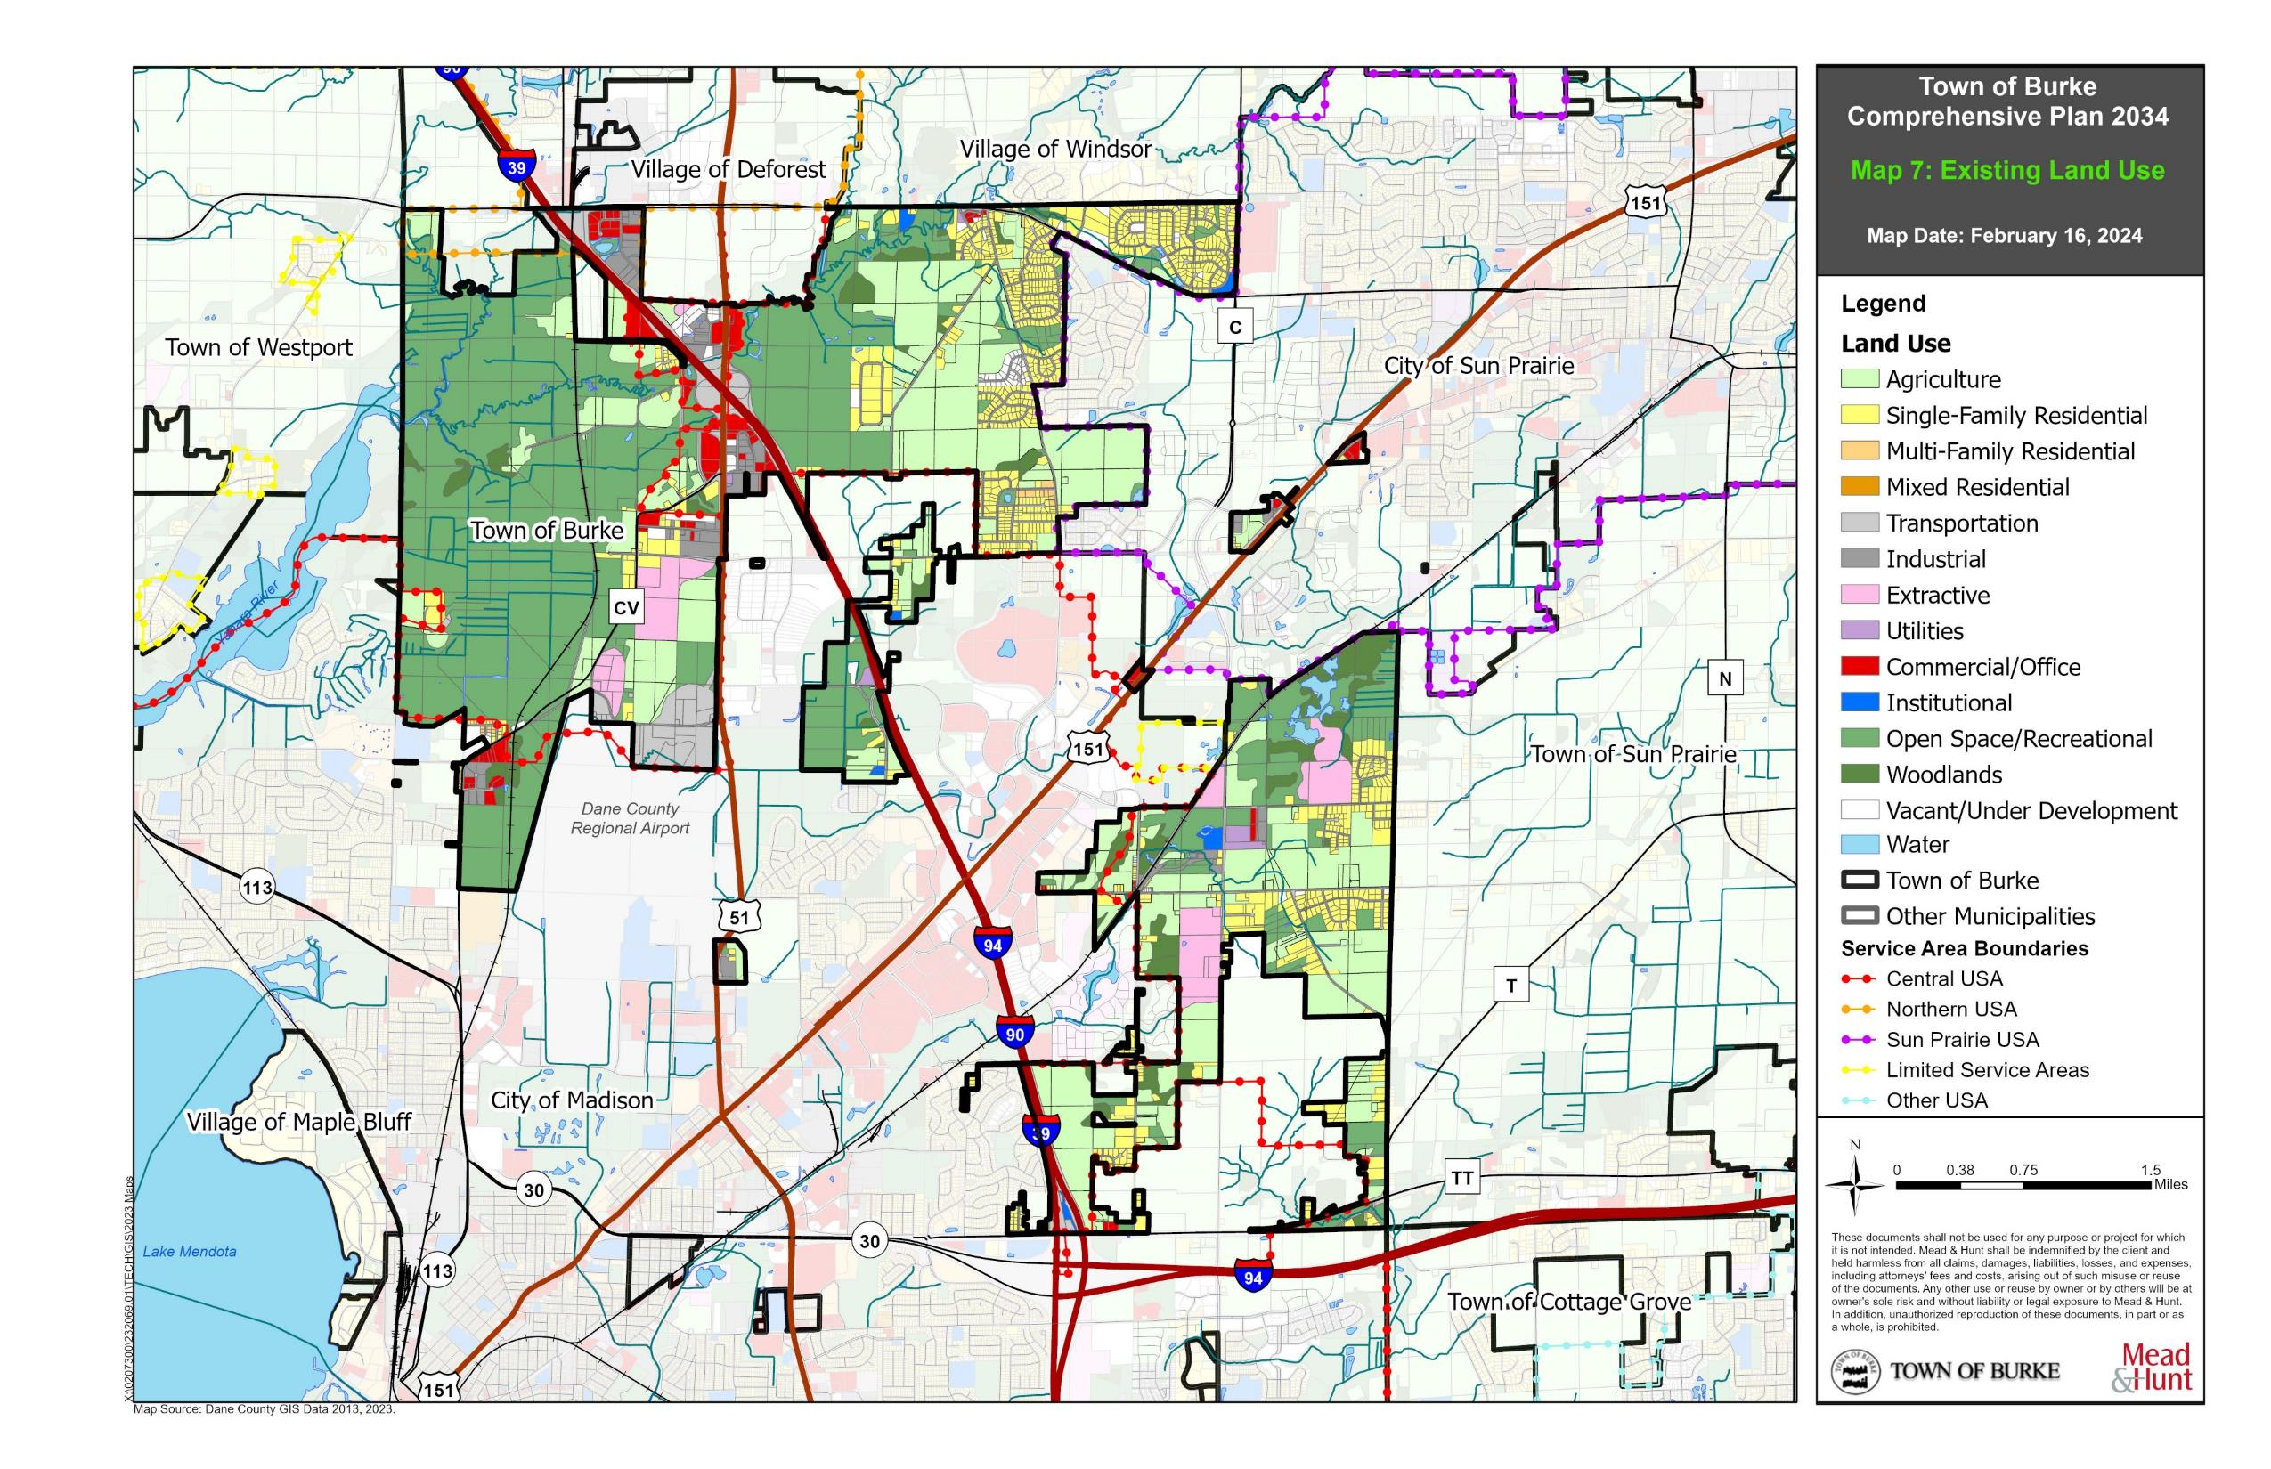

Map 7: Existing Land Use

Institutional uses include schools and universities, health care and administrative facilities, safety buildings like police and fire, places of assembly, cemeteries, and institutional/government facilities.

Open Space/Recreational uses include cultural activities exhibits, camp and picnic areas, land-based outdoor recreation areas like county or state parks including open land and woodlands, water-based recreation areas, and other open or vacant land including wetlands and farm fields not under cultivation.

Woodlands include areas of non-commercial forest which are groups of mature trees larger than 3 acres in size and being continuous in nature.

Vacant land includes lots within a subdivision that have not yet been built upon, are under construction, or buildings that are not yet occupied.

Existing Land Use Pattern_______________________________________________

Map 7 depicts the existing land use pattern within the Town of Burke. Table 13 summarizes the existing acreage within various land use categories in the Town, as presented on Map 7. Table 13 also provides a comparison of existing land use to historic land use trends within the Town.

Table 13: Existing Land Use Totals, Burke

Land Use Category | 1970 Acres* | 1980 Acres* | 1990 Acres* | 2013 Acres | 2023 Acres | 2023 % Acres
Agriculture | n/a | 11,418 (66%) | 9,141 (58%) | 3,321 (32%) | 2,462 | 28%
Single-Family Residential | 253 (1%) | 690 (4%) | 782 (5%) | 1,083 (10%) | 1,095 | 13%
Multi-Family Residential | 5 (<1%) | 8 (<1%) | 25 (<1%) | 14 (<1%) | 13 | <1%
Mixed Residential | 267 (2%) | 205 (1%) | 193 (1%) | 0 | 0 | 0%
Industrial | 66 (<1%) | 468 (3%) | 433 (3%) | 449 (4%) | 166 | 2%
Transportation | 964 (6%) | 1,144 (7%) | 1,043 (7%) | 1,015 (10%) | 912 | 10%
Utilities | 152 (1%) | 13 (<1%) | 151 (1%) | 27 (<1%) | 25 | <1%
Commercial/Office | 125 (1%) | 145 (1%) | 221 (1%) | 147 (1%) | 140 | 2%
Institutional | 16 (<1%) | 33 (<1%) | 44 (<1%) | 45 (<1%) | 31 | <1%
Open Space/Recreational | n/a | 1,702 (10%) | 2,737 (17%) | 3,725 (36%) | 3,468 | 3%
Woodlands | n/a | 491 (3%) | 444 (3%) | 415 (4%) | 367 | 4%
Vacant | n/a | 180 (1%) | 152 (1%) | 209 (2%) | 102 | 1%
Total | 17,513 | 17,269 | 15,777 | 10,450 | 8,781 | 100%
Source: Dane County, 2023. County “Extractive” land use layer acreage included in Agriculture Land Use Category above.
*1970-1990 data obtained from 1999 Land Use Plan and Dane County RPC Land Use Inventories. Total acreage calculation discrepancies are due to rounding errors and alternative classifications of data between 1970 and 1990.

The largest portion of existing land within the Town of Burke is classified as open space/recreational uses (39 percent). Open space and recreational uses include all areas of county and state parks, water and wetland areas, and natural environmental areas. Also included in the open space/recreational land use classification are farm fields not under cultivation, the majority of which are located on the west side of the Town adjacent to the Cherokee Marsh. Open space and recreational uses have historically been one of the highest percentages land uses within the Town and will continue to be as they are largely undevelopable.

Within the Town, approximately one-third (28 percent) of the total land area is for agricultural purposes. Agricultural land uses are located largely in contiguous areas in the north-central and eastern parts of the Town. Agricultural parcels, like open space and recreational land use parcels, tend to be large, undivided quarter- and quarter-quarter sections. Agricultural uses have historically been the highest percentage of land use in Burke. Residential land uses in the Town, which account for roughly 12 percent of the existing land uses, are almost entirely single-family and located in contiguous, planned development areas.

Land Development and Market Trends_____________________________________

According to the Wisconsin Department of Revenue, the change in equalized value within the Town between 2012 and 2022 was $223,147,600. During the past 10 years, the Town has seen an overall 51 percent increase in total equalized value. The percent change by year for total equalized value within the Town of Burke was steady between 2014 and 2021, ranging between zero and five percent any given year. However, since 2020, the total equalized value has increased 10 to 15 percent per year. This was almost exclusively a result of the increase in real estate value of residential and commercial lands.

Table 14: Total Equalized Values

 | 2012 | 2022 | % Change, 2012-2022
Town of Burke | $ 437,455,400 | $ 660,603,000 | 51.0
Town of Blooming Grove | $ 184,680,800 | $ 221,293,300 | 19.8
Village of DeForest | $ 790,689,800 | $ 1,828,925,000 | 131.3
City of Sun Prairie | $ 2,353,842,900 | $ 4,767,506,600 | 102.5
Town of Sun Prairie | $ 249,567,000 | $ 388,037,300 | 55.5
Village of Waunakee | $ 1,286,376,700 | $ 2,638,409,300 | 105.1
Town of Westport | $ 757,604,200 | $ 1,215,453,900 | 60.4
Village of Windsor | $ 553,643,100 | $ 1,305,644,600 | 135.8
City of Madison | $ 21,697,080,900 | $ 38,606,699,100 | 77.9
Source: Wisconsin Department of Revenue, 2022

Compared to surrounding municipalities, the Town’s 51 percent increase over the past 10 years is the second lowest. Only the Town of Blooming Grove saw a lower percent change while other communities saw upwards of 100 percent increases. In short, value has remained and grown in the developing portions of villages and cities in Dane County more so than the towns.

The trends in the land market in the Town of Burke are indicative of the recent US market trends. The Towns value increase has been attributed mostly to improvement value increases derived from pre-existing housing. Little residential development and even less commercial and manufacturing land development leaves ample room for future opportunities, where the Town is not landlocked by environmental features.

Land Supply___________________________________________________________

As previously mentioned, the majority of land use within the Town is comprised of open space/ recreational and agricultural uses. Chapter 3 outlined the Town’s goals to preserve open space and realize the transition of agricultural land to other types of uses, consistent with the future land use plans of surrounding municipalities. Knowing the location and availability of agricultural land for transition, the Town can begin to understand where demand will occur.

The Town of Burke has adopted the county’s zoning ordinance (Chapter 10, Dane County Code) as of March 20, 2019. The Dane County Zoning Ordinance divides the unincorporated areas of Dane County into 27 base, two special use, and five overlay zoning districts, each with a different combination of permitted and conditional uses, lot sizes, and area and setback requirements. In the Town of Burke, there are large groups of lands classified as Natural Resource Conservancy (at the Cherokee Marsh), and Agricultural Transition as well as Rural Residential and Rural Mixed Use. The latter two districts are well-suited for the Town because they are geared toward agricultural practices and low density housing, much of what the Town already contains.

Landowners, town boards, or county board supervisors may petition the county board to rezone property from one zoning district to another. Affected town boards, the county board and county executive must all approve any rezone petition or ordinance text amendment before it can go into effect. Areas lying within extraterritorial zoning areas must be coordinated with the respective municipality. In addition, the Dane County Land Division and Subdivision Ordinance (Chapter 75, Dane County Code) regulates the division of land in unincorporated areas of Dane County.

Projected Land Use Demand______________________________________________

Wisconsin Statutes require comprehensive plans to include projections, in five-year increments, for future residential uses in a community over the planning period. This Comprehensive Plan includes projections of residential land use demand between 2015 and 2030, using 2010 data discussed in Chapter 1 as a baseline.

In 1990, the average household size in the Town of Burke was 2.86. In 2000, this number decreased to 2.60 and remained the same in 2010. However, in 2020, this number increased to 3.02. A declining trend is found within Dane County and the State of Wisconsin, which have seen a decline from 2.46 (County) and 2.61 (State) in 1990, 2.37 (County) and 2.50 (State) in 2000, 2.33 (County) and 2.43 (State) in 2010, and 2.33 (County) and 2.36 (State), respectively. In addition, the average household size of the comparable municipalities surrounding the Town, excluding the City of Madison but including the Town, was 2.55 in 2010 and 2.58 in 2020. Knowing this information, an average of 2.50 was used for average household size for projecting land use demand rather than the Town’s current 3.02.

Dane County has several residential zoning districts in its zoning ordinance. The majority of residential land use within the Town is within the SFR-08 Single-Family Residential (small lots) district which requires that sewered lots have a minimum area of 8,000 square feet while unsewered lots have a minimum area of 20,000 square feet. For projecting the residential land use demand, one-half acre lot size was used (21,780 square feet).

Table 15: Projected Residential Land Use Demand

Town of Burke | 2025 | 2030 | 2035 | 2040 | Totals
Number of New Residents | + 200 | + 115 | + 75 | + 60 | + 450
Household Size | 2.50 | 2.50 | 2.50 | 2.50 | 2.50
Number of New Housing Units | + 80 | + 46 | + 30 | + 24 | + 115
Residential Acreage Demand* | + 40 | + 23 | + 15 | + 12 | + 90
*Existing acreage in the Town of Burke, 2023: 8,908 acres
Source: Wisconsin Department of Administration, Mead & Hunt, Inc.

The data in Table 15 shows the additional amount which will be added to the Town for the number of new residents, number of new housing units and number of acres that will need to be reserved for residential land use. The projections shown above are a calculation of a perfect scenario. However, because of several variables that are not considered in the calculation and trends and fluctuations in the development market, the totals shown above should be increased by a factor of two or three to ensure sufficient land is available. The land use demand forecasts suggest that the Town will require approximately 90 acres of land for residential land uses until it dissolves. Within this development, the Town could experience around 100 new housing units, with more than 400 new residents.

Planning for residential land use demand is a balance between other related land uses and preserving the open space and environmental corridors that help define the character of the Town. A large portion of the existing land in the Town is currently zoned Agricultural Transition, which will require a zoning change for any substantial development to occur.

Potential Land Use Conflicts____________________________________________

The Town of Burke has entered into a cooperative agreement with Madison, Sun Prairie, and De Forest, and because of this, the areas of annexation by these jurisdictions have already been established. As the Town of Burke loses developable land and potentially residents and businesses to surrounding jurisdictions, it will lose population and tax base. This, in turn, negatively affects the Town’s ability to provide services to residents and lessens relative political strength. If the Town attempts to rebuild their tax base by encouraging low-density development, in particular ETJ areas adjacent to Madison, Sun Prairie, or DeForest boundaries, they may frustrate planned urban growth and complicate urban service delivery. ETJ areas are particularly susceptible to this type of conflict. The Cooperative Plan is in place to aid in minimizing conflicts and provide for the eventual transition of Town land to the surrounding municipalities.

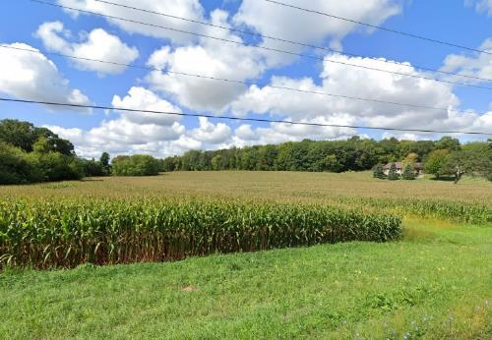
The Town of Burke has a desire to cultivate a stronger working relationship with surrounding municipalities and regional and state agencies to make land use decisions for the betterment of all stakeholders. Token Creek Park, although county-owned and maintained, is entirely within the Town of Burke. The Town was not part of the park master planning team for this park and was not consulted about the process. The Town desires to be involved in the planning process for amenities like this because they can be a catalyst for economic development and aid in attracting tourists to the Town.
While the preservation of farmland within the Town is not a recommendation of this plan, the preservation of the scenic vistas afforded by farmland, which define the community character of the Town, is a recommendation.

Land Use Goals, Objectives, and Policies___________________________________

Goal:
Manage the extent, location, and pace of new growth to promote future land use patterns consistent with the town’s exurban character.

Objectives:
- Direct new residential development into Single-Family Residential land use areas.
- Minimize the visual impact of new development on the landscape.
- Plan for a sufficient supply of land uses to meet Town objectives.
- Promote the conservation and preservation of the Town’s natural resources including woodlands, wetlands, lakes, rivers, creeks, and streams.
- Work in partnership with the City of Sun Prairie and Madison and the Village of DeForest to achieve the Town’s land use objectives.
- Direct new non-residential development to areas of compatible use.
- Update and maintain accurate land use data.

Policies:
- Follow the land use recommendations mapped and described in this plan (Maps 7 and 8) when making and advising on detailed land use decisions.
- Maintain low density, single-family development as the primary residential land use category.
- Preserve the Town’s Protected Areas until 2036, as outlined in the Cooperative Plan.
- Promote compatible and complementary land uses around the Town Hall Park and similar park facilities.
- Build a relationship with Madison, Sun Prairie, and DeForest to ensure development is compatible and desirable.
- Work to ensure greater input and flexibility in County zoning and ETJ decisions, staying within the overall framework laid out in County plans and ordinances.
- Ensure that incompatible land uses are not located close to one another, or are buffered through screening where nearby locations are unavoidable.

Land Use Programs and Recommendations__________________________________

Update Existing Land Use Map/Land Use Inventory
The Town of Burke should work with Dane County, the Regional and Metropolitan planning organizations, and surrounding jurisdictions to update and maintain accurate land use data. The existing land use map shown in this document is a reflection of data originally created in 2005 and updated as needed over time. Given the layering of municipal interests in the Town, this leaves room for error and can lead to generalizations and incorrect categorization. Every five years, the Town should collaborate with CARPC, the County, and surrounding municipalities to compile and verify the existing and future land use maps.

Update and Implement Design Guidelines
The 1999 Land Use Plan provides a Design Review Guideline Checklist for Site Plans and Design Review and Site Plan and Landscaping Guidelines for the Town. This recommendation proposes to update those guidelines to reflect current needs and objectives of the Town. Design guidelines are a tool a community can use in review of development to direct designers and developers to look closely at a community’s character to design within the context of a particular community, neighborhood, or site.

Design guidelines can also aid community staff and administrators by supplementing the link between Town residents and developers who can be seen as too “outside the box” or “over the top.” Having guidelines in place provides an expectation to the developer for what the Town desires and how to achieve the Town’s goals, set forth by public input and citizen involvement. Similarly, guidelines provide an example and explanation to residents of how and why development proposals look the way do. Design Guidelines should be prepared and implemented in conjunction with the Village of DeForest and Cities of Madison and Sun Prairie as they may affect the ETJ areas and overlapping neighborhood plans.

Future Land Use Map Categories
The Future Land Use Map (Map 8) indicates recommended future land uses over long-range planning horizons and their location within the Town. This map incorporates the future land uses of Madison, Sun Prairie, and DeForest and their ETJ areas. Discrepancies exist between the land use categories of this Plan and the Comprehensive Plans of DeForest, Sun Prairie and Madison because the planning horizon year for local plans varies depending on when the plan was prepared.

Map 8 will be used to guide Town decision-making on future land use changes and prevent or minimize potential conflicts between overlapping jurisdictions. The Comprehensive Plans, neighborhood and special area plans, and other local land use plans of the DeForest, Sun Prairie and Madison should be consulted for specific future land use recommendations. All future development should comply with the local jurisdictions development requirements as outlined by their local plans and ordinances.

Below is a description and recommended zoning, policies and programs for each planned land use category depicted on Map 8. The Burke – DeForest Extraterritorial Zoning Committee allows the Village the authority to zone within the DeForest ETJ. County zoning does not apply in this area. For all areas of Burke outside the DeForest ETJ, county zoning does still apply.

Agriculture
Description: The agriculture land use category is established to preserve productive agricultural lands, open space, and natural areas in the long-term. This land use category focuses on lands actively used for farming and/or with productive agricultural soils and topography conditions for farming. This category may also include cropland/pasture, farm buildings and accessories, and commercial forests or woodlands. The Town is located in the Non-Farm Planning Area of the Farmland Preservation Plan and does not intend to seek agriculture as a future land use. However, this land use category is present throughout the county and is heavily active in neighboring jurisdictions.

Recommended Zoning: Most of the land within the agriculture category will be zoned AT-35 (Agricultural Transition, 35 acres) Zoning or AT-5 (Agricultural Transition, 5 acres) by the Dane County Zoning Ordinance. The AT-35 district is generally for agricultural production and related uses on larger tracts of land with a minimum area of 35 acres. AT-5 reduces the minimum to 5 acres and allows more non-farm related use. Both districts are geared toward farmlands which are transitioning to non-farmlands near urban developing areas.
Rural Residential
Description: The rural residential land use category is intended to accommodate large-lot and estate single-family residential development with rural character. These areas include the majority of the existing residential neighborhoods in the Town. Residential net densities in this land use district should range from approximately one to two dwelling units per acre. New single-family residential should possess a similar character and density of the surrounding neighborhoods.

Recommended Zoning: Future land uses in the rural residential category will generally fall into the RR-1 (1 to 2 acres), RR-2 (2 to 4 acres), RR-4 (4 to 8 acres), RR-8 (8 to 16 acres), and RR-16 (16 to 35 acres) Rural Residence Districts and RM-8 (8 to 16 acres) and RM-16 (16 to 35 acres) Rural Mixed Use Zoning Districts.

Low-density Residential
Description: The low-density residential land use district includes areas for planned residential development in and around areas of existing single-family development. Recommended residential net densities in this land use district should range from one to four dwelling units per acre. The land use district is intended to include single family detached and attached dwellings.

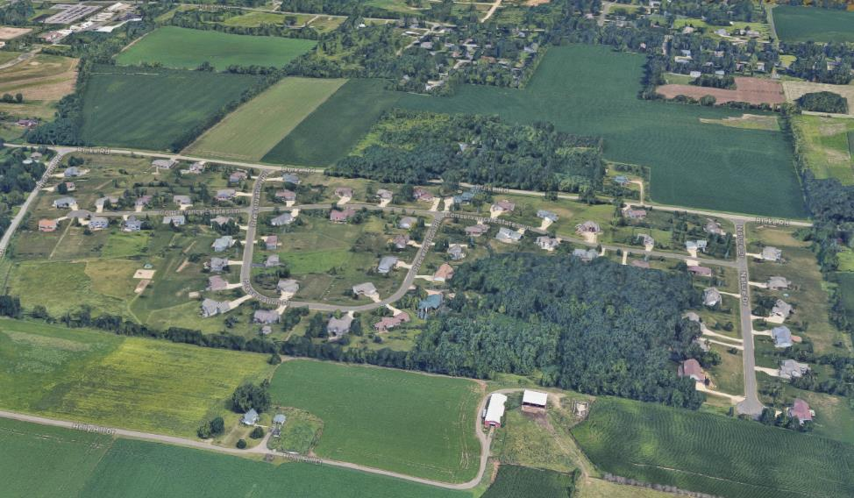
Recommended Zoning: The recommended zoning district in these areas are RR-1, RR-2, and SFR-08 Residence Districts.
Burke Conservancy Estates contains low-density residential on 0.5 to 1 acre lots off of Burke Road.

Medium-density Residential
Description: The medium-density residential land use classification will be generally similar to the low density category but include two flats, duplexes, townhouses, and apartments. Recommended residential net densities in this land use district should range from approximately four to 10 dwelling units per acre.

Recommended Zoning: Recommended zoning includes the TFR-08 (Two-Family Residential) and MFR-08 (Multi-Family Residential) Zoning Districts.

High-density Residential
Description: High-density residential should consist of areas of planned residential development mostly adjacent to commercial areas and act as a buffer between intense, non-residential land uses and lower intensity, low and medium density and rural residential land uses. High density land uses will be multi-family in nature and contain a net density in the range of eight to twenty dwelling units per acre.

Recommended Zoning: Future land uses in this category will be in the MFR-08 Residential District, which allows single-family residential uses, duplex or multi-family residential uses on relatively small parcels between 8,000 and 20,000 square feet depending on the presence of utilities. The HAM-R (Hamlet Residential) and HAM-M (Hamlet – Mixed-Use) may also be appropriate districts.

Planned Neighborhood / Development
Description: This land use category will include a carefully planned mix of single-family residential development including some single-family, two-family, and multi-family residential and a mix of non-residential uses such as neighborhood scale commercial, office, parks, and institutional uses. This district is to function primarily as a residential district but provide access to neighborhood commercial within a half mile of the majority of residents within the district.

Recommended Zoning: Planned neighborhood / development land uses will fall under the PUD, Planned Unit Development District of the Dane County Code. The PUD district promotes improved development design by allowing greater flexibility and imagination in urban and rural development. The district allows variations in uses, structures, densities, setbacks and yard requirements, building heights, landscaping, and other provisions for developments which are cohesively planned and implemented.

Mixed Commercial / Residential
Description: The mixed commercial / residential land use category will contain a mix of commercial retail and services uses and residential uses. The mixed commercial / residential future land use category differs from the planned neighborhood / Development category because mixed commercial and residential areas are typically either areas of existing development or will become buffer areas between commercial and residential uses once either of those land uses is developed. These areas are not planned and are typically organic transition areas between uses.

Recommended Zoning: An appropriate zoning district for mixed commercial and residential would be the HAM-M (Hamlet – Mixed-Use) District. Within the HAM-M district, the predominant land and building use is commercial, but may include residential and workplace uses in deference to the purpose and character of local commercial activities.

Commercial Retail and Services
Description: The commercial land use district is recommended to include large and small-scale commercial and professional office development. A wide range of indoor retail, service, lodging uses, and offices are appropriate in this land use district. Landscaping is recommended in these areas to foster high quality development and to minimize disruption to adjacent residential development where applicable.

Recommended Zoning: The Dane County Code provides LC (Limited Commercial), GC (General Commercial), and HC (Heavy Commercial) for commercial retail and service uses.

Institutional / Government
Description: This category includes large scale public buildings, hospitals, and special-care facilities and clinics. Small scale, existing institutional uses such as churches, cemeteries, open spaces, and schools are included in this category, but may also be permitted in other land use categories. This future land use category is intended to accommodate new institutional facilities including churches and schools as well as future sites for public services and utilities. There are currently no schools in the Town. The Town Hall is currently one of two existing institutional uses in the Town.

Recommended Zoning: Institutional and government future land uses are permitted uses in a number of base zoning districts and may also be conditional uses in many of the County’s zoning districts. For instance, the Town of Burke Town Hall is located in the Recreational Zoning District.

Transportation
Description: The transportation future land use district includes those areas dedicated for transportation services such as existing airports and Interstate interchanges. The Dane County Regional Airport and the airport clear zone is included in this category.

Recommended Zoning: Transportation land uses can fall into any zoning district because their use typically involves vacant land areas associated with interchanges. However, the UTR (Utility, Transportation and Right-of-Way) Zoning District is appropriate as a base district.

Communication / Utilities
Description: The communication / utilities future land use category includes uses like communication towers and power stations. These uses are scattered throughout the Town. There are distribution substations located just east of the Burke Town Hall, off WIS 19 on Steven Road just west of Portage Road, and west of Interstate 39/90/94 on Hanson Road. There is one communication tower located east of Burke Town Hall on Maly Road and one on Pepsi Way, off WIS 19. There is also a pump station on Wheeler Road, off County CV.

Recommended Zoning: Communication / utilities may generally fit into the UTR (Utility, Transportation and Right-of-Way) Zoning District or are allowed as accessory uses in a number of districts.

Industrial / Business
Description: This future land use category includes indoor manufacturing, warehousing, distribution, and office uses, with outdoor storage areas. Also included in this category or uses like retail sales or service businesses, medical, dental and veterinary clinics, banks, and office buildings, to list a few. Future industrial areas will be planned around and adjacent to existing industrial areas. These areas are concentrated north of the Dane County Regional Airport, adjacent to I-39/90/94 near the Village of DeForest, and on Maly Road, east of Burke Town Hall.

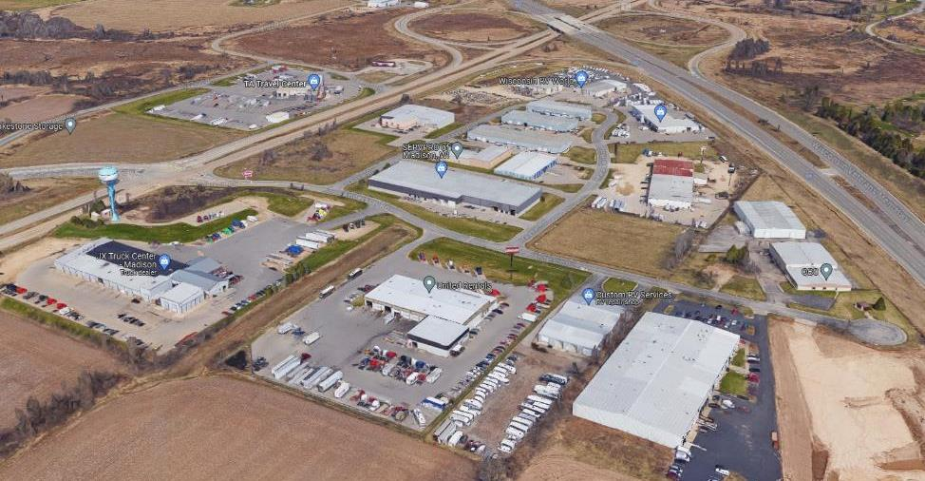
Recommended Zoning: Future land uses in this category will generally fall into the RI (Rural Industry) or MI (Manufacturing and Industrial) Zoning Districts or may be appropriate in other commercial or special use districts depending on the intensity.
Haese Road has a number of industrial businesses and warehouses.
Natural Area
Description: Natural areas consist of undeveloped areas including non-productive farms, areas with unique natural features, steep slopes, and environmental corridors. These continuous systems require protection from disturbance and development and consist of wetlands, stream channels, floodplains, stormwater management areas, and other resource lands and features.

Recommended Zoning: The Dane County Code provides a NR-C (Natural Resource Conservation) Zoning District which is appropriate for natural areas.

Parks / Outdoor Recreation
Description: This future land use category includes park and open space facilities devoted to both active and passive recreation, such as golf courses, playgrounds, play fields, play courts, trails, picnic areas, some natural areas, and related recreational activities. Programmed parks like Token Creek County Park are included in this district.

Recommended Zoning: Parks and outdoor recreation uses are appropriate in the NR-C (Natural resource Conservation) or RE (Recreational) Zoning Districts.
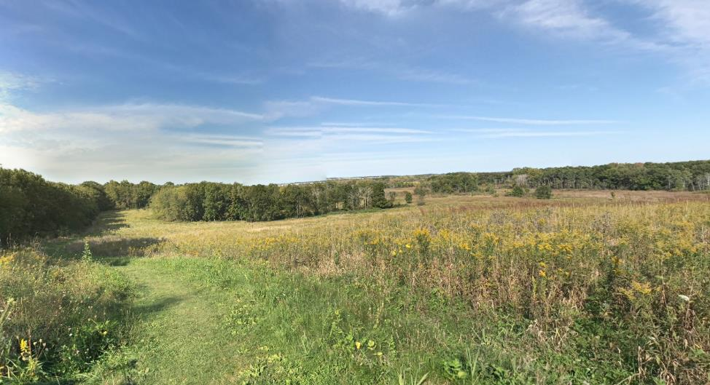
View within the Cherokee Marsh Conservation Park.

Woodland
Description: The woodland future land use category includes areas of dense woodlands greater than three acres in size and non-commercial forests.
Recommended Zoning: The woodland land use category can fall into a number of zoning districts including the agricultural districts, some residential districts, and conservancy and recreational districts.

Extractive
Description: This future land use category is intended for nonmetallic mine sites including quarries, gravel pits, clay extraction, waste disposal sites and related land uses. Lands within this category may be converted to recreational and open space uses in the long-term or other land uses if detailed reclamation plans have been approved by the Town and WDNR. There are three extractive site within the Town, outlined in Chapter 3.

Recommended Zoning: The extractive use is commonly a conditional use in any number of districts.

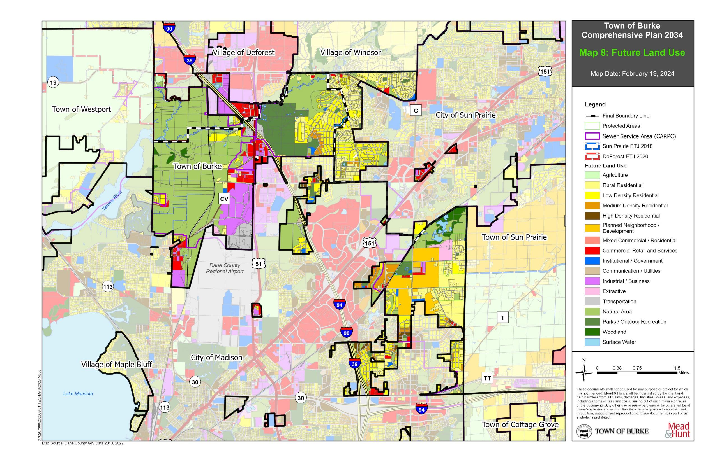

Map 8: Future Land Use

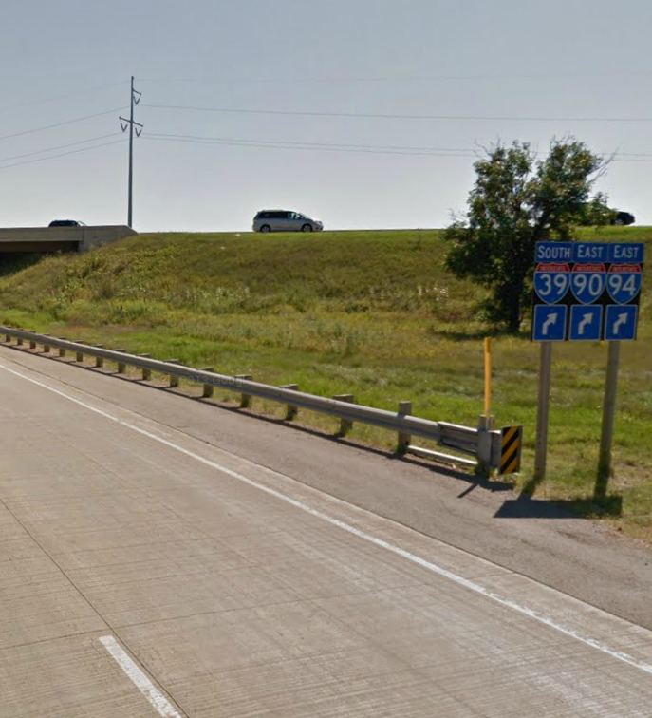

CHAPTER 5
TRANSPORTATION

T
RANSPORTATION

The transportation chapter contains a compilation of goals, objectives, policies, programs, recommendations, and maps to guide the future development of the various modes of transportation, including highways, transit, transportation systems for persons with disabilities, bicycles, walking, railroads, air transportation, trucking, and water transportation. The chapter provides a comparison of the Town’s policies and recommendations to the state and regional transportation plans. This chapter also identifies existing highways within the Town by function and incorporates state, regional, and other applicable transportation plans, including transportation corridor plans, county highway functional and jurisdictional studies, urban area and rural area transportation plans, airport master plans, and rail plans that apply within and adjacent to the Town.

Existing Transportation Network_________________________________________

The Town of Burke is well connected to Dane County and the region through the existing roadway network. Other transportation facilities, such as airport service, freight rail, and bicycle and recreational trails are located in or near the Town. This section describes the Town’s existing transportation facilities, which are also depicted on Map 9: Planned Transportation Facilities.

Roadways
Interstates
The Town of Burke is served by a combination of Interstates 39, 90, and 94 (39/90/94), which run north to south through the center of the Town’s geographic area. According to the Wisconsin Department of Transportation interactive average annual daily traffic (AADT) website, which records average daily traffic volumes (number of cars) for major state roadways, traffic on Interstate 39/90/94 between US 151 and Hoepker Road is 72,200.

US Highways
US Highways 151 and 51 (N. Stoughton Road) are the main Highway routes serving the Town. US 151 runs from Interstate 39/90/94 northeast through the City of Sun Prairie. US 51 runs north and south entirely through Burke in the western central area of the Town. Both routes serve as regional arterials connecting regional cities and villages to the Town of Burke and beyond. US 151 is also designated a freeway by Dane County north of Interstate 39/90/94 to the Columbia County line.

State Trunk Highways
State Trunk Highways serve as minor arterial roadways which function in a similar fashion as principal arterials but usually have less traffic, slower speeds, and more frequent stops. WIS 19 provides east-west service along the Town’s northern boundary through the Village of DeForest and to the City of Sun Prairie. AADT on WIS 19 between Portage Road and US 51 is 14,300 (an increase of 200 vehicles since 2013) and between US 51 and Interstate 39/90/94 is 15,000 (a decrease of more than 3,100 vehicles since 2013).

County Highways
County Highways (County) are collector roads that serve the outlying areas and distribute traffic to the regional arterial system. County C (Reiner Road extended) on the northeast and County CV on the west, are both north-south routes which serve the Town and bordering jurisdictions. County T and County TT provide service along the Town’s southern boundary. County CV, south of Hoepker Road consistently has an AADT around 10,700 vehicles and is an important artery between the Interstate, Dane County Regional Airport, City of Madison, and the Town.

Local Roads
Local, or Town, roads are an important component of the county-wide transportation system. Local roads serve local development and provide access to many of the Town’s neighborhoods. Most of these roads are maintained by the Town, but the Town also contracts some services when necessary. Important local roads include Hoepker Road, Reiner Road, Felland Road, Portage Road, Rattman Road, Burke Road, Nelson Road, and Lien Road.

Bridges
The bridges in the Town of Burke are concentrated along Interstate 39/90/94. Specifically, bridges are located at Hoepker Road, Hanson Road, Lien Road, and County T/Commercial Avenue and interchanges are located at US 51 and WIS 19. There are also two bridges that cross the Token Creek along WIS 19 and Daentl Road. The State maintains jurisdiction over the interchanges, and State roads. Dane County maintain county roads and the Town maintains town bridges on Town roads.

Truck Transportation
Semi-truck transportation is concentrated along the Interstate, US Highways 51 and 151, and WIS 19.

Public Transportation
Madison Metro Transit System
The Madison Metro Transit System, or city bus, serves residential neighborhoods, business parks, downtown Madison, schools and universities, and shopping centers in the Madison area. Routes A, L, P, G, S, and W serve the northeast portion of Madison and run into the town, running primarily along US 151. The transit system is accessible from the southern areas of Burke. In addition, all Metro buses are equipped with bike racks.

In 2024, the city will open a new Bus Rapid Transit (BRT), or a system of high-quality bus-based transit that delivers fast, comfortable, and cost-effective service with a high-level of capacity. This is done through specialized lanes, dedicated boarding stations, off-board fare collection, and fast and frequent operations. The new BRT will largely follow US 151 and provide service into the City of Sun Prairie.
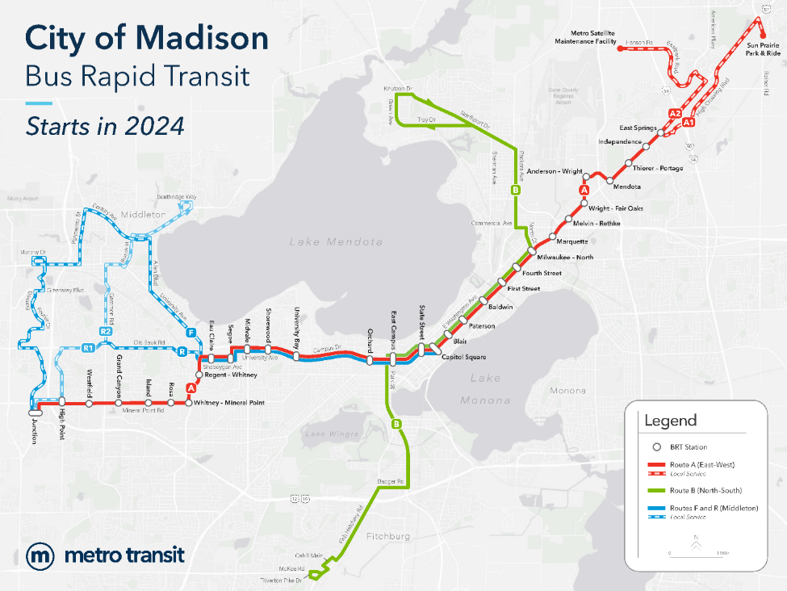

Paratransit
Paratransit services are provided by the Madison Metro Transit System to persons with disabilities who cannot access the public transit system. Paratransit service complements the same areas and hours as the Madison Metro Transit System. More detailed information can be found at www.cityofmadison.com/metro/paratransit.

RIDESHARE
The State of Wisconsin provides a free RIDESHARE program to all Wisconsin residents and some bordering counties (IA, IL, MI, MN) to serve individual commuters who drive, ride, or bike to work. The program brings commuters together for carpooling and bicycle commuting with the intent to improve air quality, reduce congestion, and provide “green” alternative commuting options and programs. https://wisconsindot.gov/pages/travel/road/rideshare/default.aspx

Regional Bus
Regional transportation service providing motorcoach, trolley, school bus, escorted tour, paratransit and other services.

Park-and-Rides
No park-and-ride facilities are currently located within the Town of Burke. A park-and-ride facility is located on Eastpark Boulevard near American Parkway within the City of Madison and another at Cremer and O’Keefe in the City of Sun Prairie.

Bicycle Transportation
The Bicycle Transportation Plan for the Madison Metropolitan Area and Dane County is a comprehensive plan to serve as a blueprint for improving bicycling conditions and safety in the County. The plan provides guidelines for planning, designing, and maintaining bicycle facilities throughout the County and provides an inventory of existing and planned future routes, connections, and trails, both on-road and off-road. These trails and routes are depicted on Map 9: Planned Transportation Facilities. The Town of Burke is supportive of Dane County’s Bicycle Transportation Plan.

Railroads
Two railroads cross the Town of Burke, the Wisconsin Southern and the Canadian Pacific railroads. Both rail lines carry freight traffic and there is no commercial or passenger access to these railroads within the Town. There are no railroad depots within the Town.

Airport
The Dane County Regional Airport is located adjacent to the Town within the City of Madison and provides both commercial and cargo flights.

Water Transportation
There are no water transportation services within the Town of Burke.
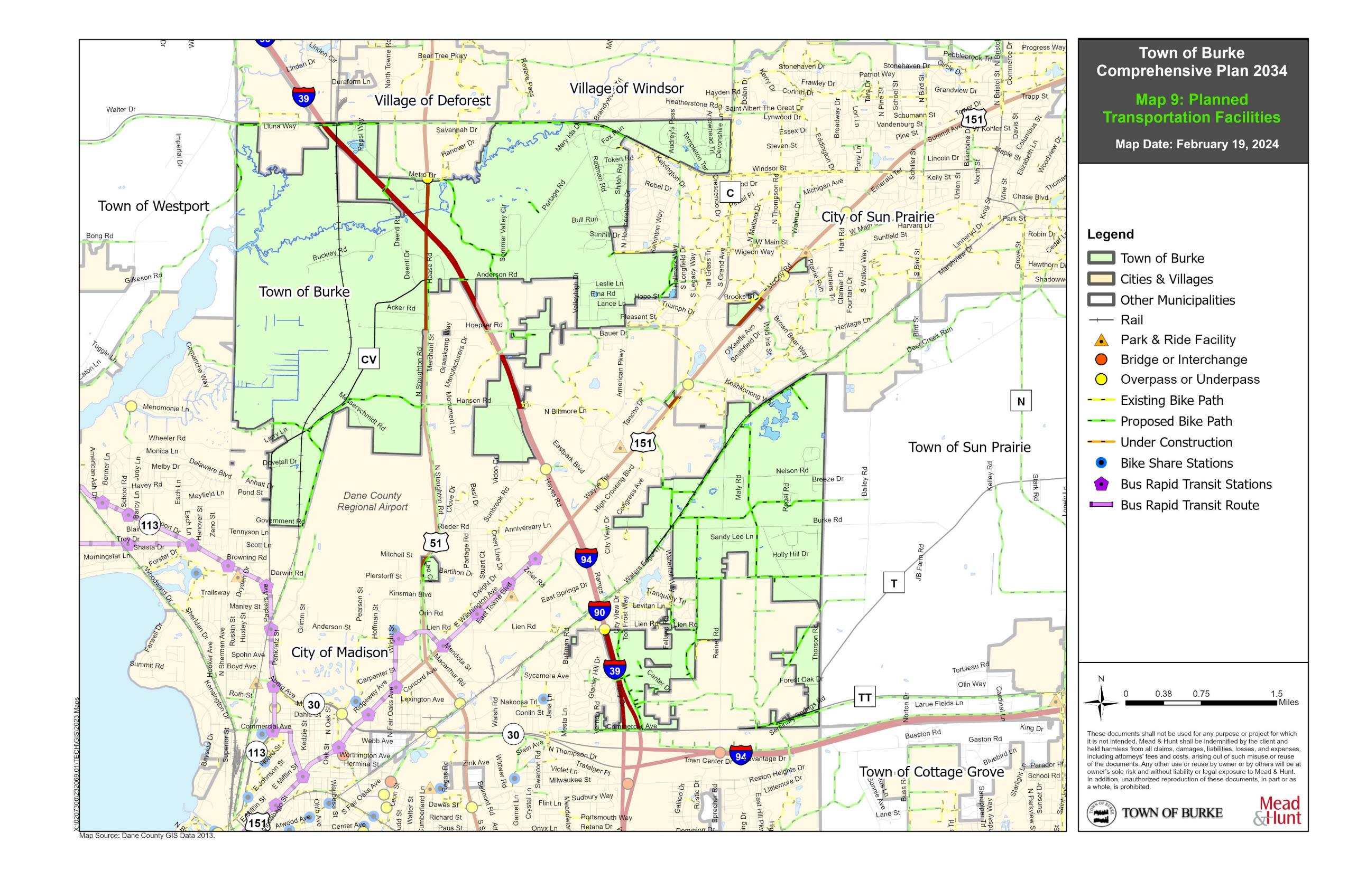

Map 9: Planned Transportation Facilities

County, State, and Regional Transportation Plans, Studies, and Projects______

The following is a review of county, state, and regional transportation plans, studies, and proposed projects relevant to the Town. While this list is not exhaustive, it does provide the major plans, studies and projects impacting the Town. There are no conflicts between the Town’s transportation plans and the plans, studies, and projects outlined below.

Wisconsin Six Year Highway Improvement Program 2023 – 2028 (Dane County)
The 2023 – 2028 Plan for Dane County identifies projects, ranging from bridge replacement to pavement spot patching. Of the projects, several directly involve the Town of Burke including bridge repairs and resurfacing of US 151, reconstruction of US 51, replacement of bridges along WIS 19, and major Interstate 39/90/94 reconstruction. More detail on these projects is provided below in the Studies and Projects section.

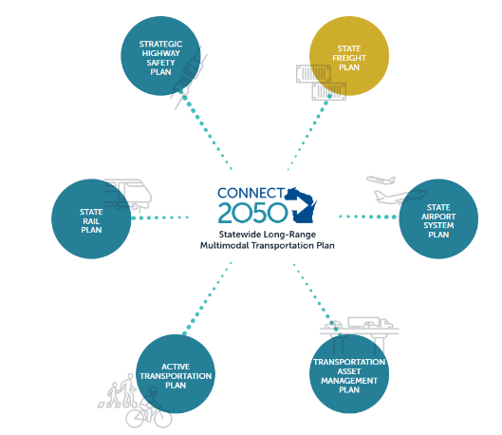
Wisconsin Department of Transportation Connect 2050 (2022)
Connections 2050 is the statewide long-range multi-modal transportation plan for the state of Wisconsin, completed in 2022. The plan addresses highways, local roads, air, water, rail, bicycle, pedestrian, and transit. Connections 2050 policy recommends a multimodal approach to transportation, system modernization, and innovation and directly links these policies with implementable projects identified within the thirty-seven system-level priority corridors which are critical to Wisconsin’s travel patterns and support the state’s economy. Six priority corridors within Dane County converge on the City of Madison. The Madison Area Transportation Board, the local Metropolitan Planning Organization (MPO), is the designated policy body responsible for transportation planning and decision making for the Madison Metropolitan Planning Area. More detailed information on projects specifically recommended by Connections 2030 can be found on the WisDOT website at https://www.wisdotplans.gov/.

Wisconsin Rail Plan 2050
The Wisconsin Rail Plan 2050 is a long range plan being developed by WisDOT to provide a vision for freight rail, intercity passenger rail and commuter rail. The plan identifies rail issues and recommendations and identifies priorities and strategies to establish a basis for future rail investment.

Wisconsin Active Transportation Plan 2050
The Wisconsin Department of Transportation is updating the Wisconsin Bicycle Transportation Plan and Wisconsin Pedestrian Policy Plan and combining them into the Wisconsin Active Transportation Plan 2050 (ATP).

The ATP will be a statewide long-range plan focused on human-powered modes of transportation, such as bicycling and walking. This plan will evaluate active transportation opportunities and needs, resulting in policies and actions that will align with and further Connect 2050, Wisconsin’s statewide long-range transportation plan.

Greater Madison Metropolitan Planning Organization (MPO)
The Greater Madison MPO is the federally designated Metropolitan Planning Organization (MPO) for the Madison Urban Area. As the MPO, it is the policy body responsible for cooperative, comprehensive regional transportation planning and decision making for the Madison Metropolitan Planning Area. The goal of the MPO planning process is to build regional agreement on transportation investments that balance roadway, public transit, bicycle, pedestrian, and other transportation needs and support regional land use, economic, and environmental goals. 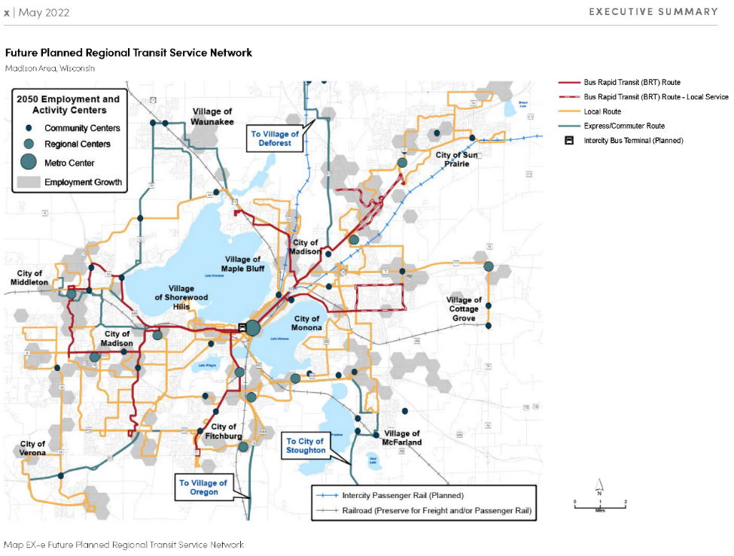
The Madison Metropolitan Planning Area includes the Madison Urban Area and all or portions of the 34 contiguous villages, cities, and towns that are or are likely to become urbanized within the 20+ year planning period as well as other areas containing important regional transportation corridors. Federal rules require the designation of MPOs in urbanized areas of 50,000 or more in population as a condition for spending Federal highway and transit funds.

The MPO Currently consists of:
- Cities of Madison, Fitchburg, Middleton, Monona, Stoughton, Sun Prairie, and Verona.
- Villages of Cottage Grove, Cross Plains, DeForest, Maple Bluff, McFarland, Oregon, Shorewood Hills, Waunakee, and Windsor.
- Towns of Blooming Grove, Burke, Dunn, Middleton, Westport, and a portion of the Towns of Berry, Bristol, Cottage Grove, Cross Plains, Dunkirk, Oregon, Pleasant Springs, Rutland, Springfield, Sun Prairie, Verona, and Vienna.

Madison Metropolitan Area & Dane County Bicycle Transportation Plan
The Bicycle Transportation Plan identifies on-street bicycle facility needs and recommends off-street paths/trails and bicycle routes for the Madison urban area and Dane County. The goals of the plan are to increase levels of bicycling throughout Dane County while reducing bicycle and motor vehicle crashes.

Transportation Goals, Objectives, and Policies_____________________________

Goal:
Provide a safe and efficient transportation system that encourages and meets the needs of multiple users.

Objectives:
- Maintain a safe and efficient road network.
- Encourage better east-west roadway connections within the Town.
- Ensure that transportation system improvements are coordinated with land use planning and land development and surrounding jurisdictions.
- Support biking, walking, and other alternative modes of transportation.
- Preserve the scenic views along roadways to protect the Town’s character.

Policies:
- Support appropriate improvements to existing state and county highways, local roadways, intersections, interchanges, and bridges.
- Coordinate with Dane County and the State to maintain and improve, as necessary, roads and bridges and promote safety for rural roadways.
- Consider cooperation with Dane County and surrounding municipalities to update design and layout standards for new Town roads to promote an interconnected system of roads.
- Continue to upgrade Town roads to current standards to the extent practical when repaving or reconditioning those roads, and coordinate upgrades with overlapping municipality.
- Continue to support additional transportation options for those without access to an automobile, including the elderly, disabled, and children.
- Participate on appropriate state, regional, and county transportation planning efforts that may have an impact on the Town and its transportation system, including initiatives related to water, rail, truck transportation, and recreational (walking/bicycling) trail routes.

Transportation Programs and Recommendations____________________________

Development to Fund Infrastructure Improvements
When new development occurs, it should be the responsibility of the developer or subdivider to shoulder the cost burden associated with roadway installation. The Town will have the long-term maintenance responsibilities (outlined in Chapter 6), but the initial, short-term construction shall be borne by the developer as the “price of doing business” rather than Town residents “subsidizing” development.

Protect Exurban Character along Scenic Roadways
In 1973 the Rustic Roads program was established in Wisconsin to help citizens and local units of
government preserve what remains of Wisconsin’s scenic, lightly traveled country roads. To qualify for the Rustic Road program, a road should have outstanding natural features along its borders such as rugged terrain, native vegetation, and native wildlife or include open areas with agricultural vistas, be a lightly traveled local access road, and should have a length of at least two miles.

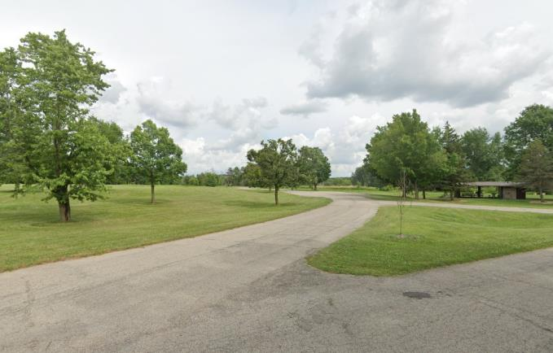
Three roadways within Dane County, near the Town of Burke, are included in the Rustic Road Program.
Token Creek County Park.

Promote and Accommodate Places to Bicycle and Walk
The Town is open to working with local and regional government agencies to develop safe bicycle and pedestrian routes throughout the community including both designated routes and wider roadway shoulders to accommodate bicycle traffic.

Support Other Transportation Options
The Town should continue to work with the county, state, and regional jurisdictions to support other transportation options including commuter facilities, paratransit, and public transportation. The Town will continue to support and identify needs for specialized transportation services for the elderly, persons with disabilities, and low-income people.

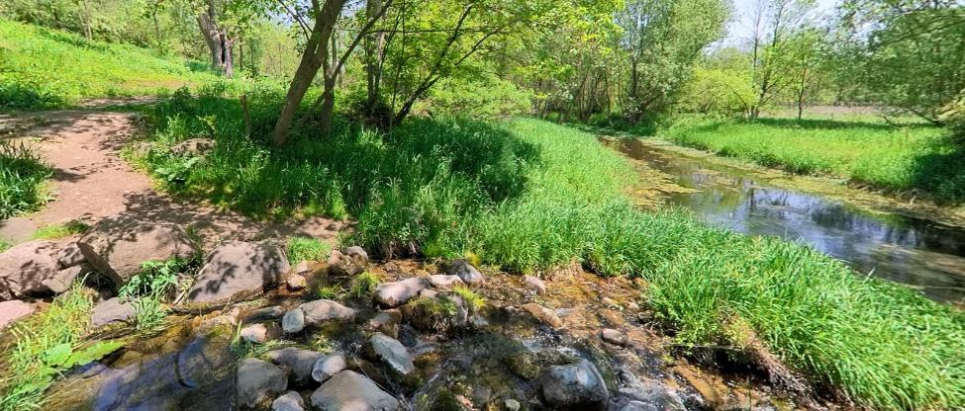
An isolated recreational trail along Token Creek in Token Creek Preserve Park.

Coordinate with State and Regional Agencies to develop Recreational Trails and Routes
Coordination among property owners, local governments, the WDNR, and other agencies will be necessary to implement future recreational trails within the Town. The Town would like to develop a working relationship with various agencies and neighboring jurisdictions to enhance existing trails, blaze new routes, improve marking on recreational routes in the Town, and establish wayfinding signage to new trails. Various funding sources are available through the WDNR and WisDOT to fund additional trail construction.

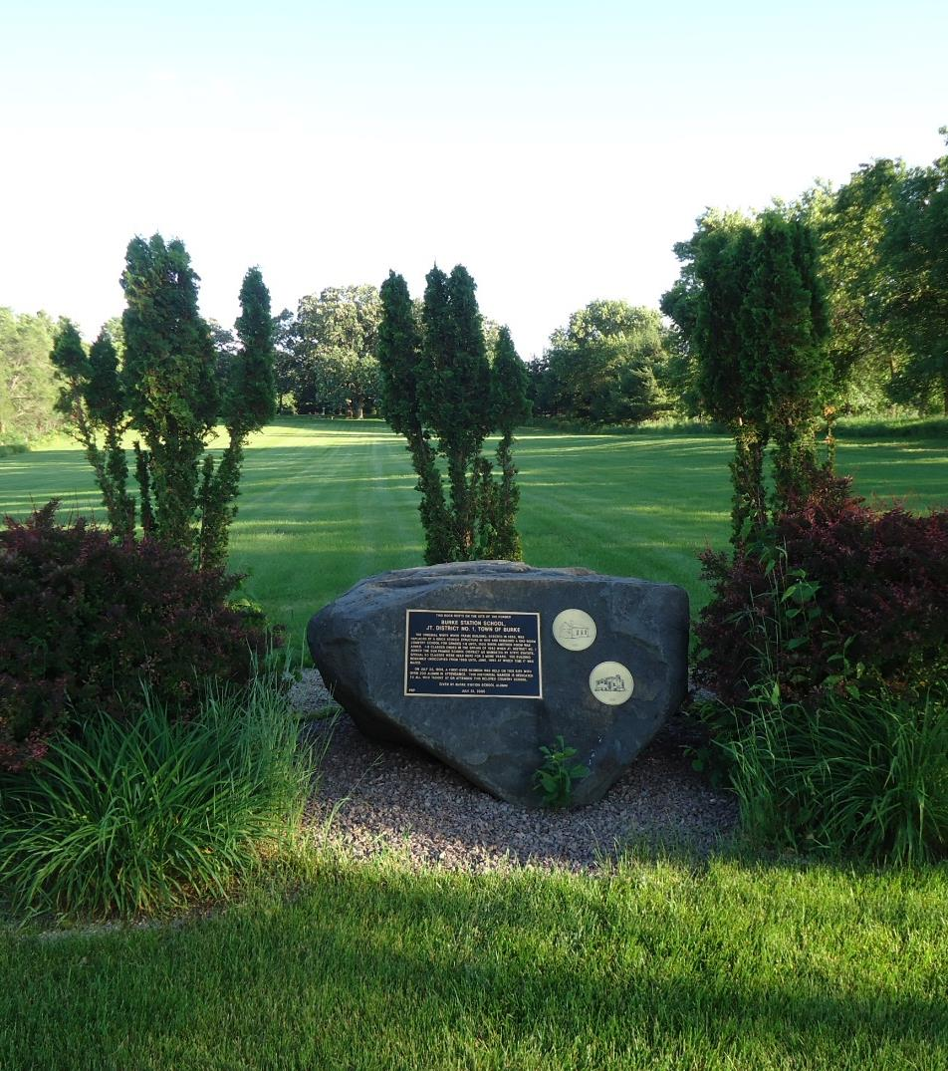

CHAPTER 6
UTILITIES & COMMUNITY FACILITIES

U
TILITIES & COMMUNITY FACILITIES

The utilities and community facilities chapter is intended to act as a guide to future development of utilities and community facilities in the Town. Facilities include parks, police, fire and emergency medical services (EMS), schools, libraries, sanitary sewer service, storm water management, water supply, solid waste disposal, recycling facilities, telecommunications facilities, power-generating plants and transmission lines, cemeteries, health care facilities, and other public facilities. This chapter describes the location, use, and capacity of existing public utilities and community facilities that serve Burke and includes an approximate timetable that forecasts the need to expand or rehabilitate existing utilities and facilities or to create new utilities and facilities. This element also includes a compilation of goals, objectives, policies, recommendations, programs, and maps.

Town Facilities
The Town of Burke Town Hall and offices is located at 5365 Reiner Road. The Town’s public works garage also operates out of this facility. This location has been designated as a Protected Area within the Cooperative Plan.
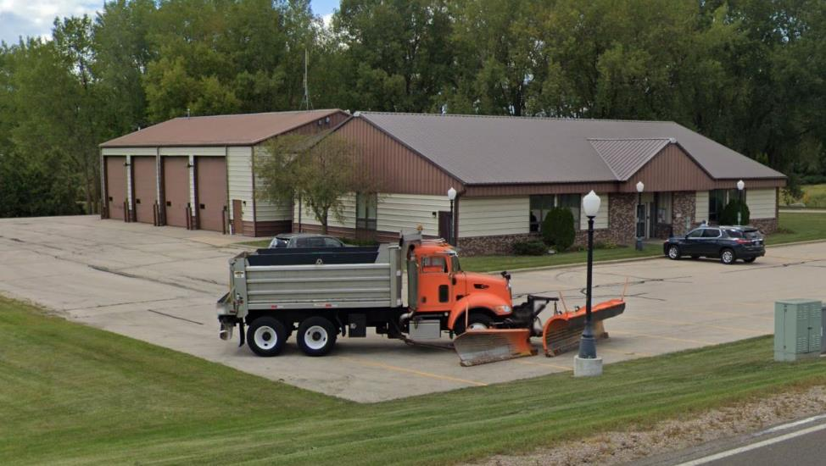
Town of Burke Town Hall and Garage.

County Facilities
Dane County’s government offices operate out of several buildings located within the City of Madison and throughout the County. The County’s Department of Human Services office is located within the City of Sun Prairie.
County and Local Park Facilities
In 2023 the Town of Burke updated its Park and Open Space Plan to provide long term preservation of its park system. The Plan identified Town Parks including traditional parks, cemeteries, undeveloped open space and tree/brush areas, and crop areas not currently used for agricultural purposes. Table 16 provides an inventory of these parks.

Token Creek County Park
Token Creek County Park and Token Creek Natural Resource Area are located near the intersection of Interstate 39/90/94 and US Highway 51. The Park is entirely within the Town and lies immediately adjacent to the interstate and US Highway 51, and south of Token Creek Lane. The natural resource area encompasses the park and includes a larger geographic area which includes land to the west and north of the County Park, extending into the Village of Windsor and City of Sun Prairie.

Table 16: Park Inventory

Name | Acreage | Classification
Token Creek County Park | 427 | County Park
Cherokee Marsh State Fisheries Area | 379 | Environmental Corridor
Burke Town Hall Park | 42.8 | Regional Park
Ledges Park | 2.8 | Mini-Park
Oak Ridge Park | 1.6 | Neighborhood Park
Rattman Heights Park | 5.1 | Neighborhood Park
Sunburst Park | 3.1 | Neighborhood Park
Ronald A. Hagen Park | 1.4 | Neighborhood Park
Huntington Meadows Park | 1.7 | Neighborhood Park
Foxmoor Hills Park | 5.3 | Neighborhood Park
Terrace Parklands Park | 1.7 | Neighborhood Play Area
Rain Garden | 0.09 | Undeveloped Open Space
Sherwood Glen Crop Area | 1.0 | Undeveloped Open Space
Leslie Lane / Parkwood Street Crop Area | 7.1 | Undeveloped Open Space
Hoffman Acres Open Space | 1.5 | Undeveloped Open Space
Terrace Parklands Open Space | 0.1 | Undeveloped Open Space
Foxmoor Hills Greenway East | 1.8 | Undeveloped Open Space
Foxmoor Hills Greenway West | 0.6 | Undeveloped Open Space
Hoepker Road Town Site | 3.0 | Undeveloped Open Space
Taff Subdivision Open Space | 1.0 | Undeveloped Open Space
Burke Station Cemetery | 3.0 | Undeveloped Open Space and Cemetery
Hoepker Road Cemetery | 1.5 | Undeveloped Open Space and Cemetery
Burke Conservancy Estates | 170 | Trail Development
Charlotte's Walk | 63 | Trail Development
Gehrke's Knoll | 56 | Trail Development
Source: Town of Burke 2023

The County Park is well known for its disc golf course but provides a variety of recreational opportunities including camping, hiking, picnic areas, a dog exercise area, and equestrian and snowmobile trails, among other activities. The iconic feature of the park, Token Creek, is the only stream in northeastern Dane County with the potential to support a cold-water fishery. Dane County Parks and the WDNR are continuing to work on a stream restoration project within the park to stabilize the banks and improve the habitat.

Town Hall Park
Burke Town Hall Park is located to the southwest of the intersection of Nelson Road and Reiner Road, adjacent to the Burke Town Office. This park is attractive and unique and provides local recreational opportunities like fishing, mushroom gathering and hiking. The park includes a picnic area and shelter, playground, and is accessible to the public or available for reservation. A popular spot for a photo opportunity, the parks identifying feature is an island surrounded by a catch and release fishing pond. Town Hall Park is a protected area in Burke and further programming and development of this park will play a significant role in establishing the Towns legacy.
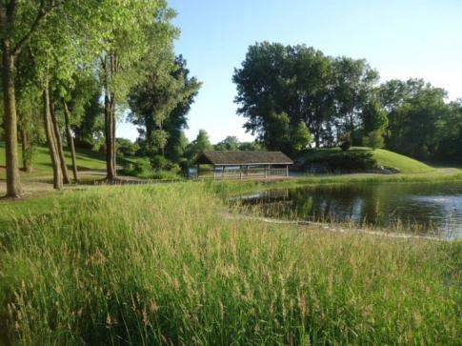
Burke Town Hall Park.

Neighborhood Parks
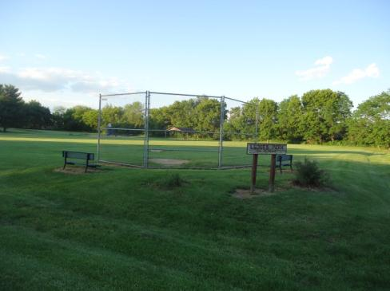
The Park and Open Space Plan identified eight Neighborhood Parks including one mini-park and one neighborhood play area. A neighborhood park is designed to provide both active and passive recreation activities to populations living within one quarter mile. Neighborhood parks are located within neighborhoods but because of this, they can be difficult for visitors to locate and utilize. Signage of parks helps identify public spaces and create a sense of place within neighborhoods.
Ledges Park. Photo courtesy Mead & Hunt, Inc., 2013

A mini-park is generally different than a neighborhood park because it provides fewer recreational opportunities and is smaller in size. A neighborhood play area is classified as a larger grass area which is not programed for specific activities. Ledges Park is a 2.8-acre mini-park that provides a ball diamond and backstop and a metal swing set. Huntington Meadows Park provides a picnic shelter, ball diamond and backstop, sand volleyball court, and picnic tables. While these two parks are physically adjacent to one another, they have very different programmed uses.

The Park and Open Space Plan provides descriptions and recommendations for each inventoried park in the Town. While the maintenance and preservation of the majority of the facilities is recommended, the plan also suggests that the Town seek to sell some open space and crop areas.

Schools
The Town is currently served by three school districts. The Madison Metropolitan, DeForest, and Sun Prairie School Districts all converge within the Town, as illustrated on Map 10: School Districts. Table 17 compares enrollment over the past five years in these school districts.

Table 17: School District Enrollment, 2018/19 – 2022/23

District Name | 2018-19 | 2019-20 | 2020-21 | 2021-22 | 2022-23 | % Change
Madison Metropolitan | 26,917 | 26,842 | 26,151 | 25,497 | 25,237 | (6.24)
Sun Prairie Area | 8,521 | 8,475 | 8,366 | 8,381 | 8,350 | (2.00)
DeForest Area | 3,828 | 3,951 | 3,870 | 4,039 | 4,147 | 8.33
Source: Wisconsin Department of Public Instruction

Madison Area Technical College (MATC), located at 1701 Wright Street in Madison, provides post-high school education ranging from associate degrees, technical diplomas, and certificates in career programs. The proximity of MATC to the Town provides the Town opportunity for economic development, housing, recreation, and an expansion of other resources.

Police, Fire, and Emergency Medical Service (EMS)
The Town is currently served by the Dane County Sheriff Northeast precinct. The Town currently has a contract with the City of Madison for Fire protection and EMS services.

The Northeast Community Court, presiding over the Towns of Burke, Bristol, Sun Prairie, Westport, and Blooming Grove, is held on the third Thursday of every month at the Town of Westport Town Hall. The Town provides administrative support.

Health Care Facilities
No health care facilities are located within the Town of Burke. Meriter Health Clinic (DeForest – Windsor Clinic) is located on WIS 19 and US Highway 51 in the Village of DeForest. A UW Health Clinic also exists adjacent to the Meriter Health Clinic at this location. A UW Health Clinic (East Clinic) is located along Eastpark Boulevard near American Parkway in the City of Madison. SSM Health Surgery Center is located on US Highway 151 at Reiner Road in the City of Sun Prairie.

Libraries
The Dane County Library Service Book Mobile.
Dane County is part of the South Central Library System (SCLS), which is composed of Adams, Columbia, Dane, Green, Portage, Sauk, and Wood Counties. Within the SCLS, Dane County Library Service (DCLS) is comprised of 28 individual libraries located throughout the county from Belleville to DeForest. The Town of Burke is served by the LINKcat Catalog system, which provides online access to media for all libraries within Dane County.

Access to Dane County libraries is most readily available through the DeForest Public Library, the Sun Prairie Public Library, or the Lakeview, Hawthorne, or Pinney Branches of the Madison Public Library. The Bookmobile, a mini library on wheels serving Dane County since 1967, makes weekly visits to cities, towns, and villages that do not have a public library. The closest Bookmobile stops for Town residents are in Windsor, Maple Bluff, or Cottage Grove.
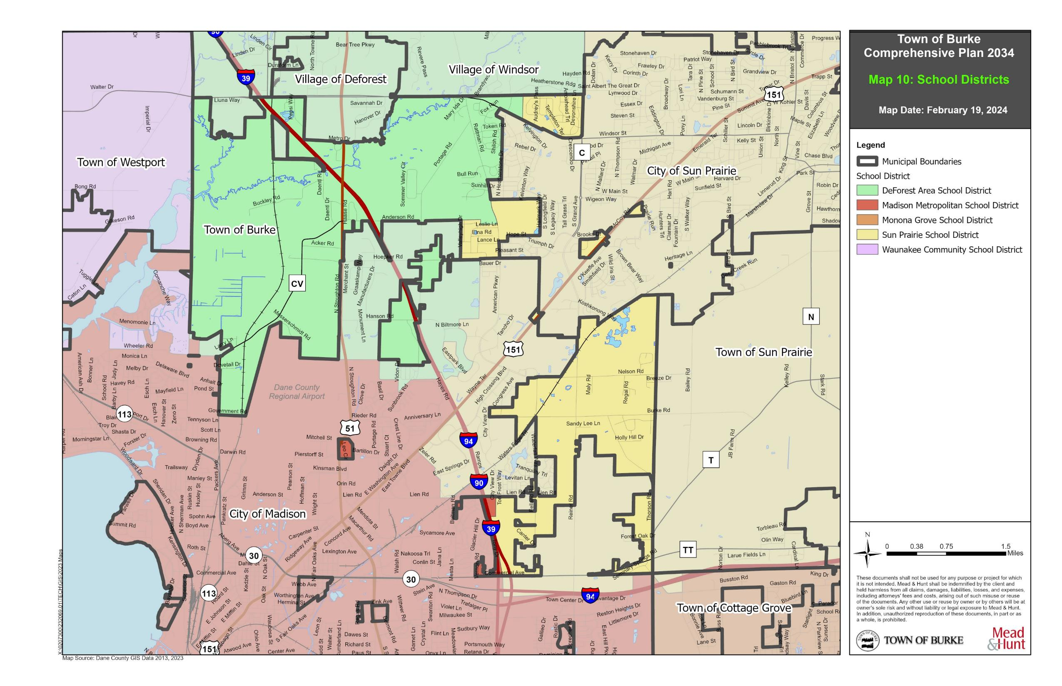

Map 10: School Districts

Sanitary Sewer and Water Service
The majority of Town residents obtain their water supply from private wells. Shallow sandstone aquifers serve private domestic wells in rural areas, while the deep Mt. Simon aquifer serves municipal wells. Most groundwater in Dane County is replenished from precipitation falling within county boundaries. Some residents obtain their water from the Village of DeForest municipal utility districts. One water tower exists along US 51 on an island of land owned by the Village of DeForest and one pump station, on Wheeler Road off County CV, within the jurisdiction of the Town.

Wellhead protection (WHP) plans are developed to achieve groundwater pollution prevention measures within public water supply wellhead areas. In some areas of the state, sophisticated groundwater flow modeling techniques were used to delineate source water areas for municipal wells. A WHP plan uses public involvement to delineate the wellhead protection area, inventory potential groundwater contamination sources, and manage the wellhead protection area. All new municipal wells are required to have a WHP plan. A WHP ordinance is a zoning ordinance that implements the WHP plan by controlling land uses in the WHP area.

Similarly, of those municipal water systems that have WHP ordinances, some ordinances apply to all of their wells and others just one or some of their wells. The Town of Burke has both a WHP plan and ordinance.

Token Creek Sanitary District
The Village of DeForest has acquired the Token Creek Sanitary District facilities, which were designed to specifically serve properties within the DeForest boundary adjustment area (BAA), although being located within the Madison BAA. The Token Creek Sanitary District is the former name of the utility which is now incorporated into the Village utility.

According to the Cooperative Plan, DeForest, Madison and Sun Prairie will plan for and construct public sanitary sewer and water service throughout the Cooperative Plan Area, outside of Protected Areas, as Town lands become attached to and developed in the respective municipality. In addition, the following will apply to promote the orderly development of utilities within the boundary adjustment areas.

DeForest
Public water and sanitary sewer service previously provided in the DeForest BAA by the Token Creek Sanitary District has been transferred to the Village for all land within the DeForest BAA. Details of the service provisions for Town lands in the DeForest BAA are provided by an existing Service Agreement which is included in the Cooperative Plan as Exhibit 8. The Village will also provide service within the DeForest Extraterritorial Water Service Area (DXWSA), which is within the Madison BAA, per the Cooperative Plan, and as outlined under Madison on the following page.
Sun Prairie
Public water and sanitary sewer service provided in the Sun Prairie BAA shall be provided by Sun Prairie as the City sees fit to extend those services. Sun Prairie intends to continue its policy of not extending public sewer and water to serve unincorporated territory.

Madison
Public water and sanitary sewer service provided in the Madison BAA shall be provided by Madison with the following exception. The DeForest Extraterritorial Water Service Area (DXWSA) lies within the Madison BAA and service provided in the DXWSA will be provided by the Village of DeForest. The Village also retains the right to continue service to any areas of the DXWSA that attach to Madison, whether before or after a service connection is made. However, within the service area of the Madison BAA, outside the DXWSA, service will be provided and extended by the City of Madison as they see fit.

Similar to Sun Prairie, Madison will continue its ordinance policy of not extending public sewer and water to serve unincorporated territory. Prior to lands being served by public sewer service, the land must be included in an Urban Service Area or a limited service area under the provisions of the Dane County Land Use and Transportation Plan and the Water Quality Management Plan.

The Village of DeForest will provide municipal water service to all properties within the geographical area described and depicted as the DXWSA. Service obligations shall continue to apply regardless of the attachment of any part of the DXWSA to Madison. Properties within the Madison BAA but outside the DXWSA shall be entitled to continued water service and new water service connections shall be permitted to the extent allowed under the terms of the Service Agreement attached to the Cooperative Plan as Exhibit 8.

Sanitary sewer service in the DXWSA shall continue to be provided by DeForest for all existing customers and any new customers who are connected to the DeForest system while the customer is located in Burke, regardless of the subsequent attachment of any such properties to Madison. No new sanitary sewer connections to the DeForest system shall be allowed for properties once they are attached to Madison, except by mutual agreement between the two municipalities. Additional details and terms of service by DeForest Utilities in Madison are provided in the Cooperative Plan.

On-Site Wastewater Treatment (Septic)
Large areas of the Town rely on private, on-site wastewater systems for domestic and commercial wastewater disposal. On-site systems, commonly referred to as septic systems, discharge wastewater to underground drainage fields. New development within the Town will transition to urban sewerage disposal provided by respective municipality service areas.

Refuse and Recycling Facilities
The Town currently provides residential curb side trash collection and recycling services and will expand these services to all new development areas. The Town also provides brush and yard waste pick up to residential areas within the Town.

Energy and Electric Systems
Madison Gas and Electric (MGE) provides electricity and natural gas service to the Town of Burke. Wisconsin Power and Light, a subsidiary of Alliant Energy has a substation located on Reiner Road, across from Burke Town Hall, and provides electricity to the Town. Alliant also has substations off WIS 19, just west of Portage Road and on Hanson Road, west of IH 39/90/94. Natural gas and electricity will continue to be provided to development within the Cooperative Plan Area by MGE and Alliant Energy in their respective service territories.

American Transmission Company, LLC has transmission line in the Town near the Charlotte’s Walk neighborhood. The City of Sun Prairie also has transmission facilities adjacent to the Town.

Telecommunications
Telephone service, cable service, and internet service is available through a variety of providers. Two communications towers are within the Town, located at the terminus of Maly Road near Burke Town Hall and at the terminus of Pepsi Way, off WIS 19. American Family Insurance Company also has a private telecommunications tower which runs through a portion of the Town, but only serve the company’s campus.

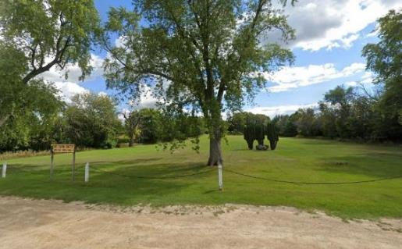
Area Cemeteries
Burke Station Cemetery.
Two cemeteries are within the Town of Burke. The Burke Station Cemetery, also known as the Burke School District Cemetery, is located on Burke Road. This cemetery is included in The Town of Burke Park and Open Space Plan as an area of unplanned open space recommended for preservation. The site was also once home to the Burke Station School which was erected in 1865 and razed in 1993 and is marked by a historical marker.

The Burke Lutheran Church Cemetery which is owned and operated by Burke Lutheran Church, has two historical sites. The Hoepker Road Cemetery is owned by the Town of Burke but is in the jurisdiction of the City of Madison.
Utilities and Community Facilities Goals, Objectives, and Policies______________

Goal:
Provide quality public services to all residents in an efficient, comprehensive, and cost-effective manner in order to maintain and improve the quality of life for the Town.

Objectives:
- Continue the existing relationship with the Dane County Sheriff’s Office Northeast precinct.
- Provide adequate facilities in which to have Town offices and equipment.
- Provide EMS services through contract service agreements with the Town of Blooming Grove.
- Coordinate public facility improvements with transportation improvements for cost-effective project implementation.
- Encourage smart growth development sites for cost-effective extension of sewer and water services.
- Do not extend sewer and water services to areas delineated as environmental corridors/open space on the Land Use map.
- Plan and adopt a Capital Improvement Program (CIP) that will identify, schedule and finance needed public facility improvements over the remaining time period.

Policies:
- Continue to provide basic services for Town residents, including public road maintenance, snow plowing, and emergency services in collaboration with neighboring communities.
- Protect the Burke Station Cemeteries and open spaces from development.
- Work with the City of Madison, Dane County, and the WDNR to develop a County Park or nonmetallic mine reclamation plan in the area generally north of Nelson Road and east of Reiner Road, centered on the cluster of surface water present in this area.
- Evaluate implementing a park improvement fee on new residential development to fund the installation of play equipment and make other improvements to Town parks and permitted by State Statutes.
- Evaluate the need for maintenance and replacement to worn and dated infrastructure to protect ground water quality and prevent flooding.

Utilities and Community Facilities Programs and Recommendations_____________

Maintain and Enhance Town Recreational Facilities
The Town owns and maintains several park facilities. Over the planning period, the Town will carefully evaluate the existing facilities and document the need for improvements or desire to enhance its current facilities. The Town of Burke Park and Open Space Plan provides policies and recommendations for maintenance and enhancement and this plan should be updated periodically to ensure the appropriate level of service is provided by the towns facilities. A few specific facility
recommendations from the plan are listed below.
- Work with neighborhood associates to outline park improvement issues.
- The Town may consider a long-range program to secure (through purchase, easements, dedication, etc.) environmental corridors to establish a linear park and trail system in conjunction with Dane County, the City of Sun Prairie, the City of Madison, the Village of DeForest, and the State of Wisconsin where these uses are designated in adopted land use plans and park and open space plans and are feasible for the Town of Burke.
- Explore completion of the Trail System at Burke Town Hall Park and evaluate potential development of future regional trails to connect this central park facility within the Town of Burke.
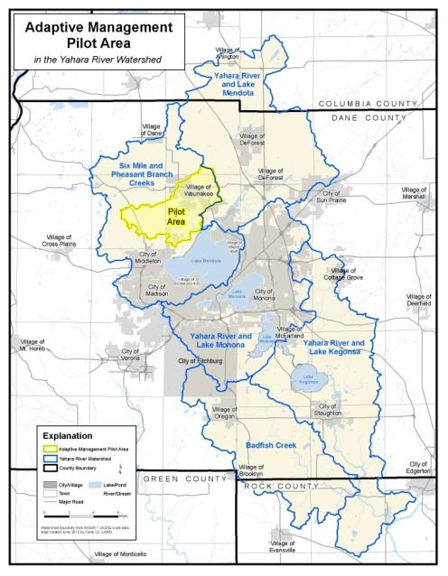
Adaptive Management Pilot Area courtesy of Yahara WINs.
Evaluate participation in Adaptive Management Projects
The Rock River Basin is the drainage area for all surface water from the lakes and water bodies in and surrounding the City of Madison. This includes the Yahara River and Lake Mendota and Yahara River and Lake Monona Watersheds, which are located in Burke and discussed in detail in Chapter 3. In an effort to protect water quality within the Rock River Basin, and meet permit levels, the WDNR implemented an Adaptive Management Pilot Project at the Six Mile and Pheasant Branch Creeks Watershed near the Village of Waunakee. This project is designed to reduce phosphorus at nonpoint sources within the Basin through adaptive solutions ranging from stream bank stabilization to porous pavement to retention and detention basins.

Town Utilities and Facilities
Continue to provide limited facilities and services including road maintenance, snow plowing, recycling and refuse collection. Continue to partner with surrounding and overlapping municipalities to provide police, fire, and EMS services. The Cooperative Plan defines municipal responsibilities for public sewer and water service and future service needs for the Town lands. The Town does not intend to provide regional stormwater management facilities, library facilities, or health care facilities.

Table 18: Timetable to Expand, Rehabilitate, or Create New Community Utilities or Facilities

Town Utilities & Community Facilities | Timeframe | Comments
Water Supply | N/A | Continue to support to Cooperative Plan to provide water supply.
Sanitary Sewer | N/A | Continue to support to Cooperative Plan to provide sanitary sewer.
Stormwater Management | Ongoing | Work with Dane County on stormwater management issues.
Refuse & Recycling | Ongoing | Continue to provide refuse and recycling services.
Town Buildings | Ongoing | Support ongoing Town Hall maintenance and evaluate the need for modernization of facilities. No major improvements are expected.
Parks | Ongoing | Update the Town of Burke Parks and Open Space Plan in five year increments.
Telecommunication Facilities | Ongoing | Support existing and proposed facilities
Health Care Facilities | N/A | Existing medical facilities outside the Town provide adequate service for Town residents
Schools | Ongoing | Work with School Districts serving the Town on long-range planning issues.
Libraries | N/A | Dane County library service meets current and forecasted needs.
Police | Ongoing | Services provided by County are expected to be adequate over the remaining time period
Fire and EMS | Ongoing | Continue to work with neighboring jurisdictions to provide Fire and EMS services.
Cemeteries | Ongoing | Existing cemeteries expected to be adequate over the remaining time period of the Town.

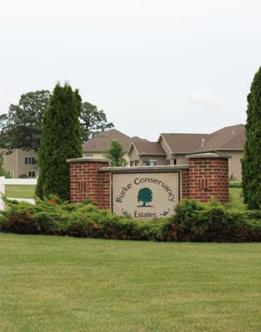

CHAPTER 7
HOUSING & NEIGHBORHOOD DEVELOPMENT

H
OUSING & NEIGHBORHOOD DEVELOPMENT

The housing and neighborhood development chapter provides an assessment of the age, structural, value, and occupancy characteristics of the Town’s housing stock. This chapter is intended to ensure the Town is providing for an adequate housing supply that meets existing and forecasted housing demand. A compilation of goals and objectives related to housing and neighborhood development helps to identify specific policies and programs that promote the development of housing for residents of the Town and provides a range of housing choices. The housing choices are intended to meet the needs of persons of all income levels and of all age groups and persons with special needs. Therefore, the chapter includes policies and programs that promote the availability of land for the development or redevelopment of low- and moderate-income housing, and policies and programs to maintain or rehabilitate the Town’s existing housing stock.

Existing Housing Framework_____________________________________________

Housing Type and Tenure
Between 2000 and 2011 the Town’s total housing stock increased six percent, from 1,208 to 1,281 housing units. However, between 2011 and 2021, the housing stock dropped nearly 11 percent. In general, the Town averages between five and ten new housing units per year. Table 19 shows the housing types located in the Town. The majority has always been single-family detached units. There are also a number of one-unit attached and multi-family units making up approximately three to four percent. No mobile homes have been historically present in the Town.

Table 19: Housing Types, 2000 - 2021

Units per Structure | 2000 Units | 2000 % | 2011 Units | 2011 % | 2021 Units | 2021 %
One Unit, Detached | 967 | 80.3 | 1,136 | 88.7 | 1,069 | 94.0
One Unit, Attached | 29 | 2.4 | 57 | 4.4 | 30 | 2.6
Two Units | 69 | 5.7 | 47 | 3.7 | 38 | 3.4
Multi-Family (3+ Units) | 143 | 11.6 | 41 | 3.2 | 0 | 0
Mobile Home | - | - | - | - | - | -
Total Housing Units | 1,208 | 100 | 1,281 | 100 | 1,137 | 100
Source: 2011 and 2021 American Community Survey 5 – Year Estimates & U.S. Census of Population and Housing, 2000

Table 20 compares other housing characteristics for the Town of Burke and relates those numbers to the surrounding jurisdictions, as in Chapter 1. The table shows the number of occupied housing units and the percentage of those that are owner versus renter occupied. The data shows that the Town of Burke has the highest percentage of owners (94.4 percent) to renters (5.6 percent) as compared to all the surrounding municipalities. The table also shows that greater percentages of renters tend to be located in cities and villages as opposed to towns.

Table 20: Select Housing Tenure and Householder Characteristics

 | Occupied Housing Units | % Owner Occupied | % Renter Occupied | % Moved in 2000 or later | % Moved in 1999 or earlier
Town of Burke | 1,137 | 94.4 | 5.6 | 70.4 | 29.6
Town of Blooming Grove | 648 | 77.6 | 22.4 | 64.4 | 35.6
Village of DeForest | 4,012 | 76.6 | 23.4 | 78.3 | 21.7
City of Sun Prairie | 14,701 | 62.8 | 37.2 | 84.3 | 15.7
Town of Sun Prairie | 801 | 86.0 | 14.0 | 60.3 | 39.7
Village of Waunakee | 5,318 | 76.6 | 23.4 | 84.7 | 15.3
Town of Westport | 2,013 | 64.0 | 36.0 | 75.3 | 24.7
Village of Windsor | 3,163 | 76.1 | 23.9 | 75.1 | 24.9
City of Madison | 129,717 | 48.6 | 51.4 | 85.4 | 14.6
Dane County | 252,136 | 57.4 | 42.6 | 86.4 | 13.6
Source: 2021 American Community Survey 5-Year Estimates.

In addition, the table illustrates a comparison of when the housing unit householder moved into the unit. This information provides an understanding of how transient the population might be. What the data shows is that the Town of Burke population is relatively stable. Furthermore, this data illustrates that there is a migration of the population towards living in cities and villages as those percentages of householders moving in after 2000 are the greatest.

Housing Age and Structural Characteristics
The overall conditions of the housing stock in the Town can be generally assessed through census data. Information available includes structural age, presence of complete plumbing and kitchen facilities, and house heating utility. According to the U.S. Census, 28 percent of the housing stock in the Town was constructed during the 1970s. Nearly 20 percent was constructed prior to 1970, and 50 percent of the total housing units were constructed between 1980 and 2000. Only two percent of the current housing stock was constructed since 2010, meaning modern homes are harder to find in the town. The composition of the Town’s housing stock by age is outlined in Figure 2.

Figure 3 presents the age of housing as a percentage of the total housing stock for Dane County. The County experiences its highest building rate during the same time period as the Town. However, the County data is spread far more evenly across the board as compared to the Town which shows a spike in building during the 1970s. The County has also seen a lot more development recently than the Town.

According to 2021 Census data, in the Town of Burke, house heating fuel is predominantly through the use of natural gas (88.1 percent). This figure has increases since 82 percent in 2000 and 83.1 percent in 2010. The majority of house heating fuel in the County is also through natural gas; however, a larger percentage of houses in the County are heated by electricity, over 25 percent. Between the years of 2016 and 2023 the Town has seen a rise in the addition of solar panels to homes for the benefit of reducing the reliance on gas and electricity. There have been 15 homes that added solar during this time frame with many more homes adding solar to their landscaping.

Figure 2: Age of Housing as a Percentage of the Total Housing Stock, Town of Burke

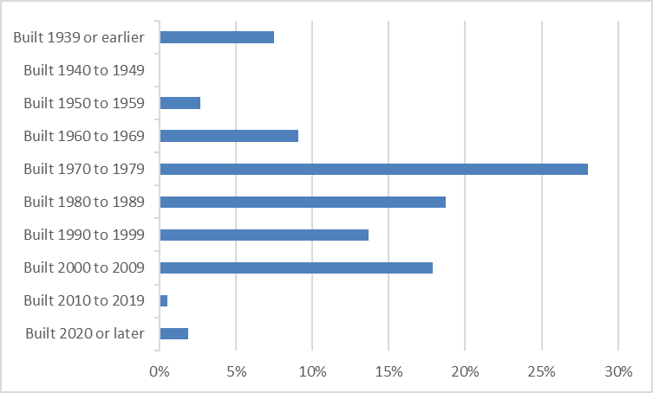

Figure 3: Age of Housing as a Percentage of the Total Housing Stock, Dane County

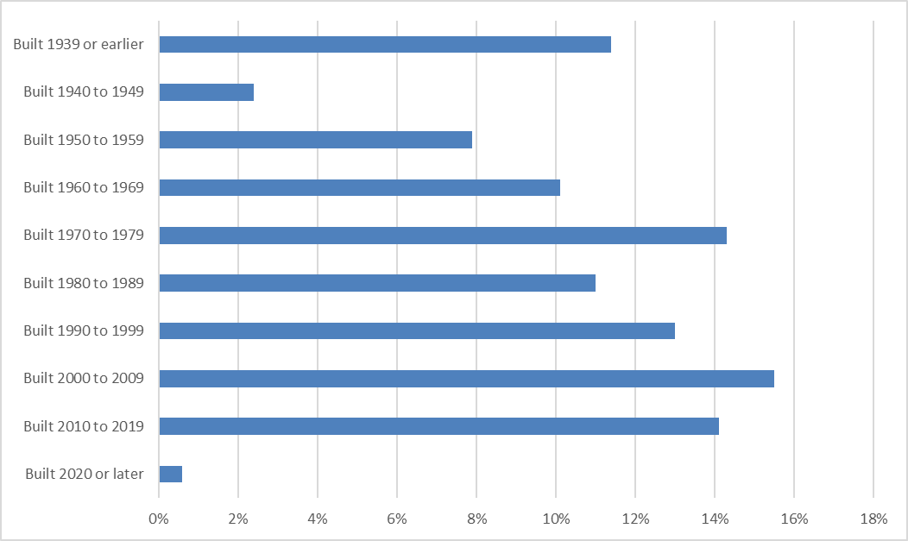

Housing Needs
The relationship between housing costs and household incomes is an indicator of housing affordability, which is gauged by the proportion of household income spent for rent or home ownership costs. The national standard for determining whether rent or home ownership costs comprise a disproportionate share of income is set at 30 percent of gross household income. Households spending more than 30 percent of their income for housing may be at risk of losing their housing should they be confronted with unemployment, unexpected bills, or other unexpected events. Figure 4 presents a comparison of the Town and Dane County in relation to the national standard for percent of income for housing for both renters and homeowners.

Figure 4: Housing Affordability

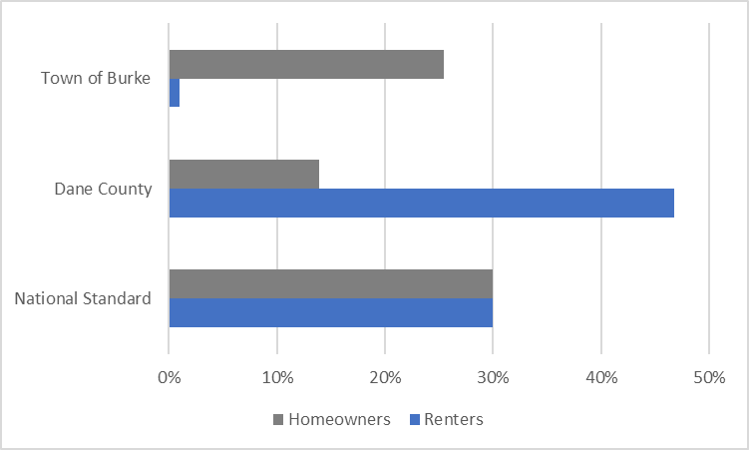

In 2021, one-quarter (25.4 percent) of all of homeowners in the Town paid a disproportionate share of their income for housing, which was nearly double Dane County (13.9 percent). 2021 data also reveals that nearly half of renters in Dane County (46.8 percent) paid a disproportionate share of their income for housing while none did so in Burke (0 percent).

Special Needs Housing
Special needs or subsidized housing is often necessary for individuals who require housing assistance or housing designed to accommodate persons limited by financial difficulties, disabilities, age, domestic violence situations, or drug abuse problems. Throughout Dane County, several governmental, private and nonprofit agencies provide some form of housing assistance to meet those types of situations.

Dane County Housing Authority (DCHA) was created in 1972 by the Dane County Board of Supervisors
to address the affordable housing needs of low-income families in Dane County (outside the City of Madison).
Housing Programs______________________________________________________

A variety of Housing Programs are provided by Dane County, the state, and at the federal level. The Dane County Housing Authority administers the Section 8 Housing Choice Voucher Program (HCVP), a major federal affordable housing program. The DCHA also provides a Conventional Public Housing Program, described in the Special Needs Housing section above, which has specific eligibility requirements including paying more than 50 percent of income towards rent and utilities, for those living in substandard housing and displacement. The Housing Center is a first time home buyer’s down payment program also administered by the DCHA. All of the programs listed above and below are resources available to residents of the Town.

In addition, the DCHA provides a list of resources for housing on its website. Some of those resources include:
- Fair Housing Council of Greater Madison helps ensure fair housing is provided throughout Dane County by combating illegal housing discrimination and by creating and maintaining racially and economically integrated housing patterns.
- Homebuyers Round Table is a Dane County home buying resource providing financial guidance, workshops, and down payment assistance.
- Dane County Community Development Grant (CDBG) Program & HOME Opportunities (HOME)
Program works through community-based groups on projects to strengthen communities and to expand opportunities for low- and moderate-income households throughout Dane County. The programs work with partnering agencies to provide assistance in the form of zero percent interest, deferred payment loans to low and moderate-income households that are purchasing homes in participating Dane County municipalities.
- Project Home provides resources for home weatherization, no or low-cost home repairs, home maintenance, and First-Time Home Buyers Education classes for Dane County.

The Wisconsin Housing and Economic Development Authority (WHEDA), an independent authority, provides low-cost, fixed interest rate mortgages to low- and moderate-income individuals and families and administers housing grants on a yearly basis to eligible applicants.

Existing Neighborhood Development Pattern_______________________________

Most housing in the Town of Burke is concentrated in two areas: east of Rattman Road, south of WIS 19 and along Nelson and Burke Roads, east of Reiner Road. Specifically, there are several subdivisions between Rattman Road and the City of Sun Prairie boundary south of WIS 19 in the Token Creek area. These include the Terrace Parklands, The Ledges, Huntington Meadows, Stony Ridge, and Wynbrooke subdivisions. There is a large concentration of homes in the northeast corner of the Town, north of WIS 19 and adjacent to the City of Sun Prairie and the Village of Windsor, which are part of the Charlotte’s Walk, Gehrke’s Knoll, and Foxmoor Hills subdivisions.

Further south, and on the west side of Rattman Road, are two additional Town subdivisions: Hoffman Acres and Sunburst. Rattman Heights is also located on Rattman Road to the northwest of the intersection of Rattman and Hoepker Roads. The Weybridge and Wyndham subdivisions, which are located adjacent to the Town’s subdivisions on the east side of Rattman Road, lie within the City of Sun Prairie and do not currently connect across jurisdictional boundaries.

There are a number of homes along Portage Road and one large lot single-family subdivision on Sommer Valley Circle, adjacent to Token Creek County Park.

A New Traditional Neighborhood Development (TND) in the City of Sun Prairie is under development to
the northeast of Rattman and Hoepker Roads, across from the Burke/Hoepker Road Cemetery. This planned development, named Providence, provides a mix of single-family units, apartments, condos, townhouses, and institutional uses. While this mixed-use development is not in the Town of Burke, it does provide services to Town residents in the form of retail uses, restaurants, religious institutions, and recreation space. This development also provides an example of clustered development and neighborhood/context sensitive design, which are two recommendations of this plan.

On the eastside of the Town are three subdivisions along Nelson Road at Sunnyburke Drive, Broken Bow Road, and Sunset Drive. Similarly, a number of homes are located along Burke Road in the Burke Conservancy Estates subdivision adjacent to the Towns eastern border with the Town of Sun Prairie. Other housing in the Town is scattered both along County CV and in the southeastern corner of the Town, including at Bridle Way on Felland Road.

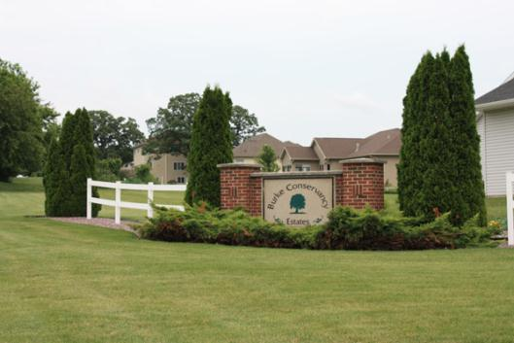
As depicted on Map 4: Protected Areas, a number of the existing residential subdivisions within Burke lie within the Protected Areas established by the Cooperative Plan. Protected Areas are the residential, commercial, or industrial territory of the Town that may not be attached to DeForest, Sun Prairie, or Madison until the end of the protected period, or until 2036 as the Town dissolves, except upon approval of attachment by the Town.
Burke Conservancy Estates neighborhood entrance gateway. Photo courtesy Mead & Hunt, Inc., 2013

Planned Neighborhood Development Pattern_______________________________

The City of Madison is proactive in planning for its extraterritorial areas, as evidenced by several Neighborhood Development Plans. The city contains more than 120 neighborhood associations and over 25 adopted neighborhood plans. Neighborhood Development Plans (NDP) stem from the general recommendations of the City’s Comprehensive Plan and are prepared with the purpose of guiding the long-term growth and development of largely undeveloped lands at the City’s urban edge. The NDP’s provide detailed recommendations for use within the City’s ETJ where development is expected to occur in the future and provide meaningful guidance to developers, neighborhoods, City agencies, policy makers, and other involved in the initiation or review of development projects. The City of Madison has eight Neighborhood Development Plan Areas and one Special Area Plan prepared for its ETJ area overlapping the Town for which development proposals are evaluated. The specific detailed plan should be consulted for additional information.

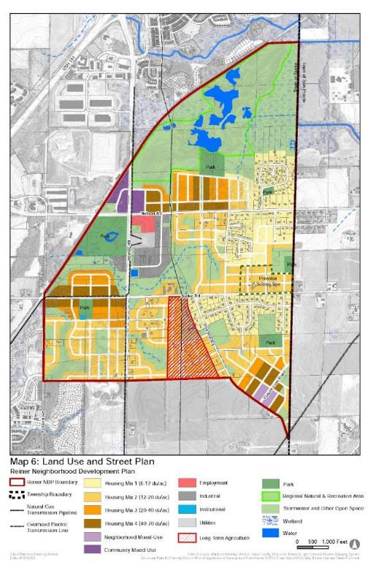
Reiner Neighborhood Development Plan (2023)
The planning area for the Reiner Neighborhood covers approximately 1,476 acres generally bounded by Felland Road and the Wisconsin & Southern railroad to the west and north, the Burke Town boundary to the east and Thorson Road on the south.

Rattman Neighborhood Development Plan (2019, Amendment 2023)
This plan proposes to fill out remaining development parcels with predominantly office uses. This plan area also preserves the northern area for park, and open space as part of the community separation area.

Hanson Road Neighborhood Development Plan (2000, 2021 Amendment)
This Plan, north of the Dane County Regional Airport proposes predominantly a mix of light industrial, which currently exists, and park and open space uses.
Nelson Neighborhood Development Plan (2019)
This plan proposes to continue development of office and retail services along High Crossing Boulevard. There is a mix of low- and high-density residential uses proposed east of High Crossing Boulevard intertwined with park and open space uses.

Northeast Neighborhoods Development Plan (2009)
TNDs are based on a framework of one-quarter mile pedestrian sheds, which represent a five-minute walk from center to edge and comprise approximately 160 acres. These neighborhoods are centered on organizing features such as mixed-use centers, parks, and institutional uses.
The Plan, south and east of the detailed Felland Neighborhood Plan, is a Peripheral Planning Area defined in 2006 in the City of Madison Comprehensive Plan. The Peripheral Planning Areas are areas that have near or long-term potential for future urban development and for which the Comprehensive Plan makes relatively broad recommendations. The plan, adopted in 2009, makes specific development recommendations including a series of Traditional Neighborhood Development (TND) clusters containing a variety of land uses within a condensed area which provide for the daily needs of residents. These pockets of development are most likely to occur adjacent to and along major transportation corridors and intersections.

Pumpkin Hollow Neighborhood Development Plan (2008)
This Plan was adopted in 2008. The neighborhood area is located generally east of I-39/90/94 and northwest of the American Family Insurance campus. This plan makes future land use recommendations as well as recommendations on the extension of the full range of urban services including public sewer and water. The Pumpkin Hollow Plan area overlaps a portion of the Rattman Neighborhood Development Plan south of Hoepker Road, but generally incorporates the Rattman Neighborhood Plan recommendations for future land use and development.

Cherokee Special Area Plan (2007)
This plan was adopted in 2007 and provides a plan for the area to the north and west of the Dane County Regional Airport. Park and open space or low density residential land uses are recommended in this area to aid in the protection of environmentally sensitive features associated with the Cherokee Marsh.

Felland Neighborhood Development Plan (2002)
This plan will primarily consist of single-family neighborhoods with low-density development. Residential areas will be linked to civic and commercial areas through an interconnected network of pathways.

East Towne – Burke Heights Neighborhood Development Plan (1987)
This Plan Area encompasses the area south of US 151 and west of I-39/90/94. There are two small, developed areas of Burke located within this plan area. The plan generally recommends commercial uses to the north of Lien Rd. and a mix of low and medium density residential uses south of the Soo Line railroad corridor. This plan area has seen significant investment since the NDP adoption and has been mostly developed.

Like the City of Madison, the City of Sun Prairie has developed future land use plans for the areas within its ETJ area. The majority of Sun Prairie’s ETJ area consists of the Burke protected area adjacent to Rattman Road. This area currently exists as single-family residential uses and the City of Sun Prairie proposes to add additional single-family infill development within the remaining, undeveloped areas to complement the existing neighborhoods. In a land locked Burke parcel, Sun Prairie’s future land use plan consists of more dense, mixed residential development between US 151 and County C and some single-family residential development adjacent to existing neighborhoods.

The Village of DeForest ETJ area contains a portion reserved for planned industrial and commercial uses along the IH 39/90/94 and US 51 corridors where some development activity is presently occurring. This is south of WIS 19. A large portion of the ETJ area is also reserved for parks, open space, and environmental corridor, adjacent to the Cherokee Marsh.

Housing and Neighborhood Development Goals, Objectives, and Policies________

Goal: Promote and ensure an adequate supply of safe and affordable housing and neighborhoods for all Burke residents.

Objectives:
- Provide for a variety of housing types throughout the Town serving persons of different income levels, ages, and needs.
- Encourage housing maintenance to preserve the quality of the Town’s existing housing stock.
- Encourage home siting in areas that protect residential areas from incompatible uses, preserve and promote the connectivity of environmental systems, or impair the existing Town character.
- Encourage high quality construction and maintenance standards for new and existing housing.

Policies:
- Plan for a sufficient supply of developable land for a range of different housing types – affordable housing and housing for the elderly – in areas consistent with overlapping jurisdictions.
- Encourage residential development in areas with existing residential development, and consistent with future land use plans of surrounding municipalities.
- Administer property maintenance standards and building inspection requirements set by the County or State.
- Coordinate with County, State, or Federal agencies to obtain funding – grants or low-interest loans – for maintenance or repair of residential homes and neighborhoods, as necessary.
- Strengthen the Design Review Guidelines and Site Plan and Landscape Guidelines found in the 1999 Land Use Plan and Town Ordinance.

Housing and Neighborhood Development Programs and Recommendations_______

Plan for a Sufficient Supply of Developable Land for Housing
The Town should accommodate anticipated residential development demand, especially the need for a range of housing types serving persons with different income levels, ages, and needs. This Plan recommends that new housing development be located near areas with existing development. A number of state and federal housing programs are available to assist in promoting affordable, elderly, and assisted housing in Dane County, as described earlier in this chapter.

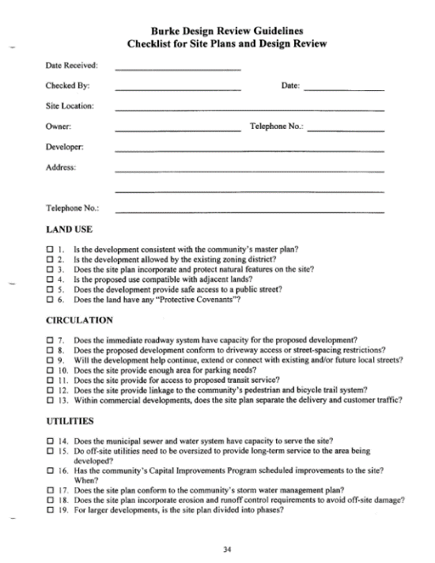
Strengthen Site Plan and Design Guidelines
The Burke Design Review Guidelines Checklist for Site Plans and Design Review developed in the 1999 Land Use Plan
The 1999 Land Use Plan created Design Review Guideline Checklist and a Site Plan and Landscaping Guidelines for the Town.

Site Plan and Design Guidelines should be prepared and implemented in conjunction with the Village of DeForest and Cities of Madison and Sun Prairie as they may affect the ETJ areas and overlapping neighborhood plans.

Encourage Cluster Development
Encouraging cluster development layouts where projects are adjacent to natural areas allow for greater protection of natural features and open space. Clustering involves the grouping of dwellings in a portion of the developable area and preserving the remaining area for open space to be utilized by the whole community. Benefits of cluster development include preservation of open space for enjoyment of the neighboring residents and the whole community, preservation of existing environmental corridors, preservation of viewsheds, steep slopes and unique natural features, management of the location of growth within a development area, and preservation of open space without a cost to the Town. In other words, the Town does not need to purchase the land in order to preserve it and can thus use this tool to preserve the character of the existing landscape.

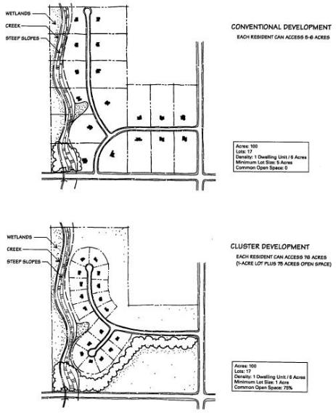
Cluster zoning ordinances can be written in many different ways. There is great flexibility for the Town to write the regulations in a way that will help achieve the community open space and exurban preservation objectives. In any set of cluster regulations three basic elements must be balances: development density, lot size, and the amount of required open space. As long as a working balance is maintained between these three elements, the Town can, for example, opt for the greatest amount of open space achievable, or can limit the minimum lot size, or can put a cap on the density. Whichever choice or limit is selected first, the other two elements can be adjusted to accommodate that choice.
The graphic above illustrates the basic concept of cluster development. Preservation of net density, as well as open space and natural features can be achieved by reducing lot size. Source: Rural Cluster Development Guide, Southeastern Wisconsin RPC, December 1996.

Encourage Context Sensitive Neighborhood Design and Locations
This plan endorses high-quality neighborhood design and layout in all newly planned residential areas in the Town. Within planned residential areas, the Town promotes the concepts of neighborhood design including a mix of housing lot sizes and densities and the development of neighborhood focal point such as parks. Many existing neighborhood contain a neighborhood or mini-park that provides a place for gathering and recreation, and helps develop a sense of place within the community. Homes should be arranged in desirable locations that consider topography, natural features and viewsheds, public and private access to open space, and privacy.

Also critical to quality neighborhood design is an interconnected network of streets sized to correlate to traffic volumes, yet oriented to its many users including bicyclists and pedestrians. The Town also is open to coordinating with neighboring municipalities to ensure development across boundaries is interconnected and the transition between map boundaries is seamless on the ground.

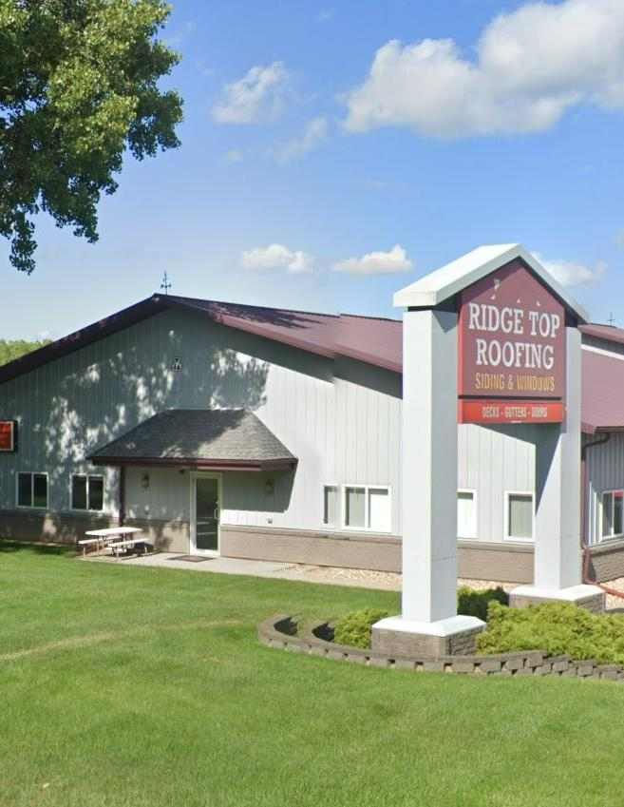

CHAPTER 8
ECONOMIC DEVELOPMENT

E
CONOMIC DEVELOPMENT

This chapter provides a compilation of goals, objective, policies, programs, and recommendations to promote the stabilization, retention, or expansion of the economic base and quality employment opportunities in the Town of Burke. An analysis of the existing labor force and economic base outlines the Town’s strengths and weaknesses with respect to attracting and retaining businesses and industries. Additionally, this chapter provides a breakdown of the number of sites required for such businesses and industries, including an analysis of the potential to redevelop environmentally contaminated sites. Finally, this chapter identifies county, regional, and state economic development programs that are available to Burke.

Existing Economic Development Framework_________________________________

The National Bureau of Economic Research, the organization that defines U.S. recessions, states that the most recent recession was in 2020 as a result of the COVID-19 pandemic. This recession was brief, however, lasting only a brief two-months, and in recovery, Dane County has fared slightly better than Wisconsin and the nation as a whole. The following information provides an overview of how the Town compared to Dane County, and how the past decade has helped shape the Town’s current economic framework.

Economic Base Analysis
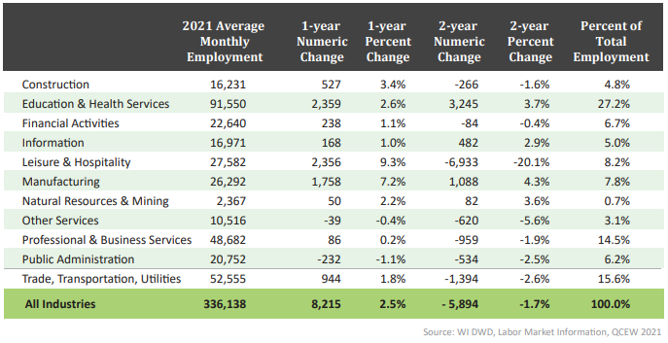
The number of jobs in the County grew 11.8 percent between 2012 and 2022 (with a reported 36,394 jobs being added). In 2021, the top industries by employment in Dane County were Education and Health Services and Professional and Business Services. The County’s employment has been and continues to be centered on the service-producing industries rather than the goods-producing industries, which is more common throughout much of Wisconsin. This can be attributed to the history of the area as the seat of Wisconsin government and the location of the state’s flagship university.
Employment Change by Industry. Dane County 2023 Workforce Profile. https://jobcenterofwisconsin.com/wisconomy/wits_info/downloads/CP/dane_profile.pdf
Commuting patterns (described below) indicate that the Town is economically linked with various cities and villages throughout the area. Many of the Town’s residents are employed within the City of Madison.

According to 2021 American Community Survey (ACS) 5-year estimates, the predominant employment sector in the Town remains Educational Services, and Health Care and Social Assistance, accounting for 24.6 percent of jobs. Comparatively, Educational Services is also the predominant employment sector at 28.4 percent for Dane County (2022, ACS 1-year estimates). The Town continues to see a slightly higher percentage of employment in the Manufacturing, Construction, and trade industries than Dane County. Further, Dane County has a significantly higher percentage (14.6 percent) of employment in Professional, Scientific, and Management and Administrative and Waste Management Services than the Town (3.5 percent).

Labor Force Trends
The labor force is the portion of the population age 16 and older that is employed or available for work. This includes people who are in the armed forces, employed, unemployed, or actively seeking employment. The 2021 ACS estimates that the Town of Burkes labor force consists of 2,745 people, up 373 from 2011. Of the 2,745 persons, 1,693 were employed and 227 were unemployed, resulting in an unemployment rate of eight percent. This is up 3 percent over the last decade. As a comparison, the unemployment rate of both Dane County and the State of Wisconsin were under two percent (2022, ACS 1-year estimates).

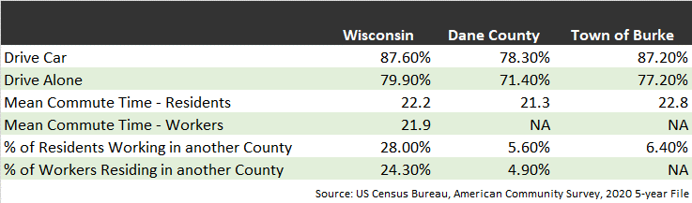
Commuting Patterns
According to the 2021 ACS 5-Year estimates, residents of the Town spend an average of 21.9 minutes commuting to work, down from 28.3 minutes a decade ago. Almost 80 percent (77.4%) of residents drove alone to work (up from 73.2 percent in 2011). This is slightly above Dane County. Further, only 3.5 percent of residents worked from home. This is comparable to a decade ago in the Town but is significantly below the County which sees 11.6 percent of residents working from home. Over half (52.1 percent) of residents travel 20 minutes or less to work. Spatially, 93.7 percent of residents worked within Dane County. Under two percent of residents take public transportation to work, which is comparable to that number from one decade ago.

Income
According to the 2021 ACS, the Town’s median household income was $94,738, up $20,000 from a decade ago and about $20,000 more than the County. In other words, half the Town households had income more than this amount, and half less. This indicates the amount of money everyone 16 years and older living in the household collectively earned during 2021. This is comparable to other Dane County communities surrounding the Town, as presented in Chapter 1: Issues and Opportunities.

Educational Attainment
Educational attainment refers to the highest level of education that an individual has completed and is one variable used to assess a community’s labor force potential. According to the 2021 ACS, 97.8 percent of Burke residents are a high school graduate or higher (up from 93.8 in 2010 and 92.7 percent in 2000) and 35.7 percent hold a bachelor’s degree or higher (up from 35.5 percent in 2010 and 28.8 percent in 2000). A comparison of the Town to surrounding municipalities can be found in Chapter 1, Issues and Opportunities.

Environmentally Contaminated Sites______________________________________

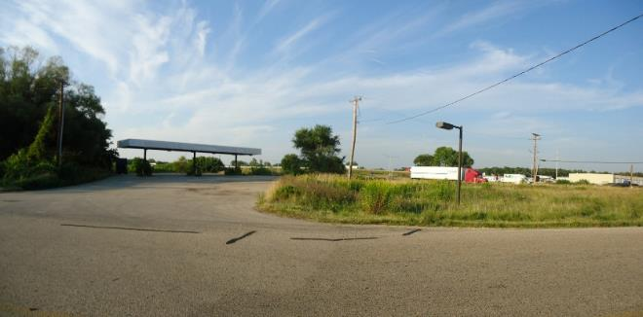
The WDNR Environmental Remediation and Redevelopment Program maintains a list of contaminated sites, or “brownfields,” in the state. The WDNR defines brownfields as abandoned, idle, or underused commercial or industrial properties, where the expansion or redevelopment is hindered by real or perceived contamination. Brownfields vary in size, location, and past use, but can be anything from a 500-acre automobile assembly plant to a small, abandoned gas station. These properties present public health, economic, environmental, and social challenges to the communities in which they are located. In Wisconsin there are an estimated 10,000 brownfields.
This former gas station near the interchange of Interstate 39/90/94 and US Highway 51 presents an opportunity not only for economic development but also for remediation of a brownfield.

The WDNR Bureau for Remediation and Redevelopment Tracking System (BRRTS) on the Web (BOTW) website, accessible at https://dnrmaps.wi.gov/H5/?viewer=rrsites, provides a database of contaminated properties and other activities related to the investigation and cleanup of contaminated soil or groundwater in Wisconsin. As of November 2023, there are approximately 25 BRRTS sites in the Town of Burke. These sites are located throughout the Town and consist of Spill sites, Leaking Underground Storage Tank (LUST) sites, and Environmental Repair (ERP) sites. Of the approximately 20 reported sites, only one ERP site (ongoing cleanup), is currently open.

Economic Development Programs_________________________________________

The Town of Burke has a limited number of tools, programs, or agencies of its own that are available to foster economic development. The surrounding village and cities each have a chamber of commerce and other economic development tools to attract and support development in the area. Dane County and the CARPC provide a number of economic development resources available to assist individuals and businesses interested in development and municipalities seeking to development within their own communities. In addition, state and federal agencies provide a wide range of useful economic development financing and planning tools available to communities and individuals. A handful of these tools are outlined below.

Dane County Community Development Block Grant (CDBG)
As described in Chapter 7: Housing & Neighborhood Development, the Dane County CDBG program provides housing assistance to low and moderate-income individuals through funds received from the HUD. In addition to housing assistance, the Dane County CDBG program provides financing to businesses that create jobs for low- and moderate-income individuals as well as businesses and real estate development projects that focus on downtown and commercial district redevelopment.

Dane County Economic Development Revolving Loan Fund (RLF)
The Economic Development Revolving Loan Fund provides low-interest loans to businesses and organizations located outside Madison that commit to creating or retaining jobs for low- and moderate-income residents of Dane County. The County has two RLF’s that have separate, on-going application cycles.

Dane County Commercial Revitalization Revolving Loan Fund (CRLF)
The County’s Commercial Revolving Loan Fund provides financing specifically for the revitalization of downtown and commercial districts. This program helps municipalities invest in infill redevelopment of traditional business districts and downtown areas in an effort to increase permanent employment or retain existing jobs that may have been lost locally due to competition from areas of new investment.

Dane County Economic Development Revolving Loan Fund (ED-RFL)
The County’s Economic Development Loan Fund provides gap financing for businesses that create jobs, 51 percent of which must go to low- and moderate-income persons.

Wisconsin Economic Development Corporation (WEDC)
The WEDC provides many programs to help communities spur economic development locally. These include programs focused on community and downtown re/development, infrastructure, and the environment. Additionally, the WEDC helps entrepreneurs looking to locate in a particular area connect with the local community and the resources available in the area. Below are summaries of a few of the programs available from the WEDC to the Town of Burke.

Capacity Building Grants
Capacity Building (CAP) Grants assist local economic development groups with assessments of the economic competitiveness of the area and with the development of a Comprehensive Economic Development Strategy.

Idle Industrial Sites Redevelopment Program
This program offers grants to communities for the implementation of redevelopment plans for large industrial sites that have been idle, abandoned or underutilized for at least five years.

Wisconsin DNR Safe Drinking Water Loan Program
This program provides financial assistance to communities to build, upgrade, or replace public water supply system infrastructure.

USDA Rural Development (Wisconsin Office)
The US Department of Agriculture Rural Development, Wisconsin office provides financial assistance to communities to support public facilities and services such as water and sewer systems, housing, health clinics, emergency service facilities, and electric service.

WDNR Ready for Reuse Program
This WDNR administered program provides loans and grants to communities to be used for
environmental cleanup or hazardous substances or petroleum at brownfield sites.

Capital Catalyst Program
This program provides seed grants, typically ranging from $50,000 to $500,000, to communities dedicated to stimulating entrepreneurship. Industry sectors targeted for Capital Catalyst seed grants includes advanced manufacturing, agriculture or food processing, information systems, medical devices, and renewable/green energy.

Seed Accelerator Program
The WEDC Seed Accelerator program provides grants to eligible communities to support a pre-seed (early stage) business model that incorporates training, mentoring, and financial assistance to entrepreneurs in their area. This program largely aims to connect aspiring businesses owners with the resources they need to support new companies.

US Economic Development Administration (EDA)
The US Economic Development Administration provides grant programs for economic development assistance, regional planning and local technical assistance. A database of available grants can be found at www.grants.gov.

Assessment of Desired Economic Development Focus_________________________

It is both important and required by Wisconsin State Statutes that comprehensive planning “assess categories or particular types of new businesses and industries that are desired by the local government unit”. Table 21 considers the strengths and weaknesses for economic development in the Town of Burke. Based on these strengths and weaknesses, the Town’s desired economic focus is reflected in the goals, objectives, policies, programs, and recommendations.

Table 21: Town Strengths and Weaknesses for Economic Development

Strengths | Weaknesses
Located adjacent to the communities of Madison, DeForest, and Sun Prairie | Limited sewer and water services available
Great regional access via Interstates 39, 90, and 94 and State Highways | Limited size of population
Recreational opportunities including Token Creek, wetlands, parks and lakes | Cooperative Plan favors development in cities and village, and pending dissolution
Strong education base and proximity to colleges and University of Wisconsin-Madison | Recreational opportunities at Token Creek County Park are administered by Dane County

Economic Development Goals, Objectives, and Policies_______________________

Goal: Encourage economic development opportunities in line with the resources and public services available in the Town.

Objectives:
- Focus economic development efforts on natural resources, nature and related businesses.
- Direct commercial development to planned areas identified on Map 8: Future Land Use.
- Discourage unplanned, continuous strip commercial development.
- Collaborate with adjacent and overlapping municipalities to attract appropriate economic development to the area.

Policies:
- Direct large-scale commercial and industrial development into areas where public utilities are available.
- Work with Dane County to administer the County’s performance standards (i.e., screening, landscaping) when reviewing development proposals. Consider inclusion in the Subdivision/Land Division Ordinance revisions.
- Implement standards for new commercial development to ensure that future development is high-quality. Consider inclusion in the Subdivision/Land Division Ordinance revisions.
- Encourage private landowners to clean up contaminated, vacant, and run-down sites and buildings that threaten public health and safety and impair the Town’s visual appearance.

Economic Development Programs and Recommendations______________________

Encourage Businesses that are related to Recreation
The Town’s vast natural resources (Token Creek, Cherokee Marsh, wetlands, and woodlands) make promoting businesses related to recreation viable in the area. The Town encourages the establishment of recreation-based businesses near the Cherokee Marsh and Token Creek County Park areas. As the Token Creek County Park and Natural Resource Area Master Plan is implemented to enhance and expand recreational opportunities in the area, the Town can capitalize by investing in economic development strategies which complement this expansion.

Direct Intensive Development into the Village of DeForest and cities of Sun Prairie and Madison
Large-scale residential and commercial development projects, which have the greatest opportunity for conflicts with agricultural uses and detract from open space and natural corridors, should be directed away from existing farms, areas of farm operations, and environmentally sensitive areas. The Town of Burke intends to direct intensive development into the Cities of Sun Prairie and Madison and the Village of DeForest. Specific development areas and criteria will be guided by the comprehensive plans and ordinances of each respective municipality.

Implement Enhanced Design Standards for Commercial Development to Ensure High-Quality Development
Burke should strengthen and enforce design standards for commercial projects to ensure high-quality, lasting projects that are compatible with the desired character for the Town. These standards should apply to all new non-residential development in the Town, with particular emphasis along key corridors like Interstate 39/90/94, US 151, US 51, and WIS 19. Outdoor storage and unscreened loading docks should be discouraged in high visibility yards, in order to maintain a high-quality appearance of development sites from the highway. Materials, colors, design of building facades, screening walls, and/or fences in such areas should be compatible with the predominant materials, colors, and design of the “front” of the principal building.
Commercial design standards should depict general design guidance for various types of retail/ commercial development projects. Overall, the following principles should be incorporated into site and building designs for new and expanded commercial uses, regardless of type:
- Limited number of access drives along arterial and collector streets.
- Common driveways serving more than one commercial use, wherever possible.
- High-quality landscaping of buffer yards, street frontages, paved areas, and building foundations.
- Parking lots landscaped with perimeter landscaping and/or landscaped islands.
- Intensive activity areas such as building entrances, service and loading areas, parking lots, and trash receptacle storage areas oriented away from less intensive activity areas.
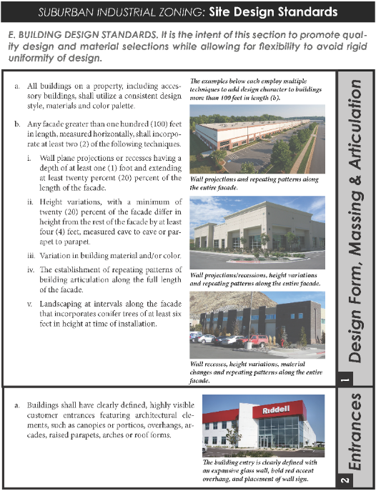
- Parking to the sides and rear of buildings, rather than having all parking in the front.
Sun Prairie Suburban Industrial Zoning Design Standards is one example of the type of design guidelines enforced in the City.
- Signage that is high quality and not excessive in height or total square footage.
- Safe, convenient, and separated pedestrian and bicycle access to the site.
- Use of cut‐off light fixtures to prevent light trespass.
- Use of high-quality building materials, such as brick, wood, stone, and tinted masonry.
- Variations in building height and roof lines, including parapets, multi‐planed, and pitched roofs and staggered building facades
- Arrange/group buildings so their orientation complements adjacent development, frames streets/intersections and parking lots.

Design Standards for Commercial Development should be prepared and implemented in conjunction with the Village of DeForest and Cities of Madison and Sun Prairie as they may affect the ETJ areas and overlapping neighborhood plans.

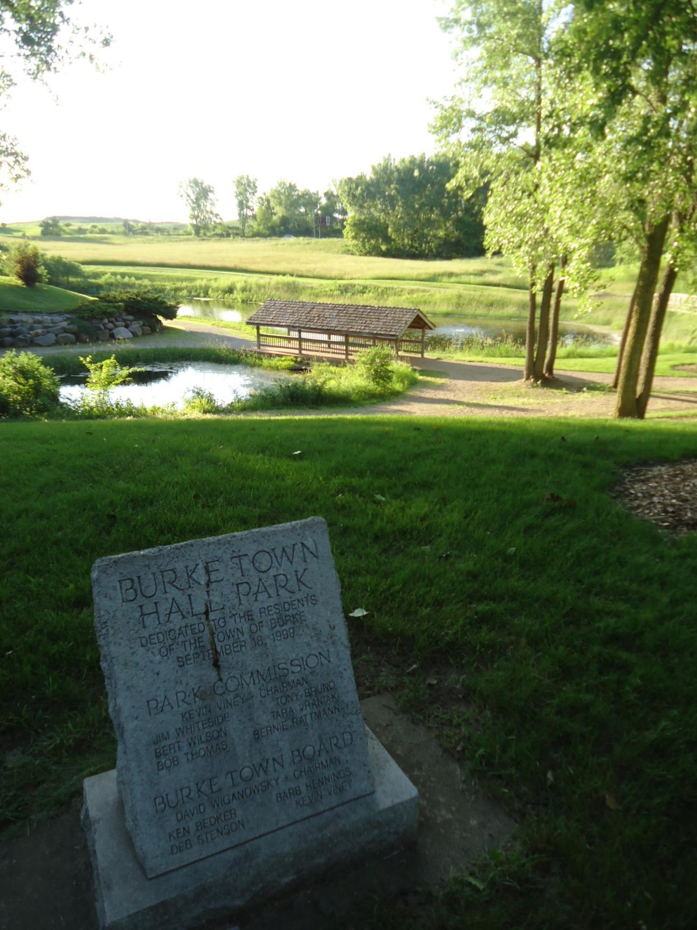

CHAPTER 9
IMPLEMENTATION

I
MPLEMENTATION

The implementation chapter outlines specific actions to be completed for implementation of this Plan. Actions include proposed changes to any applicable zoning ordinances, official maps, or subdivision ordinances, and to implement the objectives, policies, plans and programs contained in this plan. This chapter describes how each of the elements of this Plan will be integrated and made consistent with the other elements of the comprehensive plan and includes a mechanism to measure the Town’s progress toward achieving all aspects of this Comprehensive Plan.

Plan Adoption Process__________________________________________________

The Town of Burke Comprehensive Plan was adopted following procedures specified by Wisconsin’s “Smart Growth,” or comprehensive planning legislation. This included public participation throughout the process; a Town Plan Commission recommendation; distribution of the recommended Plan to affected local, county, and state governments; a formal public hearing; and Town Board adoption of the Plan by ordinance. Specifically, the Town used the following procedure to update this Plan:
- Plan Commission initiates the proposed Comprehensive Plan update or amendment.
- The Town Board adopts a resolution outlining the procedures that will be undertaken to ensure public participation during the plan update or amendment process (Statutes Section 66.1001(4)a).
- The Town Plan Commission prepares or directs the preparation of the plan update or specific text or map amendment to the Comprehensive Plan.
- The Town Plan Commission holds one or more public meetings on the Proposed Comprehensive Plan update or amendment. Following the public meeting(s), the Plan Commission makes a recommendation by resolution to the Town Board by majority vote of the entire Commission (see Section 66.1001(4)b of Statutes and model resolution in this Plan.
- At least 30 days before the public meeting is held, the Town shall provide written notice to all of the following:
  - An operator who has obtained, or made application to obtain, a nonmetallic mining reclamation permit.
  - A person who has registered a marketable nonmetallic mineral deposit.
  - Any other property owner or leaseholder who has an interest in property pursuant to which the person may extract nonmetallic mineral resources, if the property owner or leaseholder requests in writing that the Town provide the property owner or leaseholder notice of the public hearing.
- The Town Clerk directs the publishing of a Class 1 notice, with such notice published at least 30 days before a Town Board public hearing and containing information required under Section
66.1001(4)d, Wisconsin Statutes.
- The Town Board holds a formal public hearing on an ordinance that would adopt the Comprehensive Plan or incorporate the proposed update or amendment.
- Following the public hearing, the Town Board approves (or denies) the ordinance adopting the proposal. Adoption must be by a majority vote of all members. The Town Board may require changes from the Plan Commission recommended version of the proposal.
- The Town Clerk sends a copy of the adopted ordinance and Plan update or amendment to all adjacent and surrounding government jurisdictions as required under Section 66.1001(4)b and c, Wisconsin Statutes.
- The Town Clerk sends copies of the adopted Plan update or amendment to the Dane County Planning and Development Department for incorporation, as appropriate, into the County’s Comprehensive Plan.

Implementation Recommendations_________________________________________

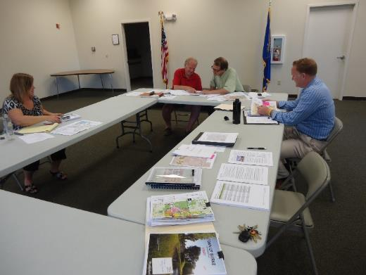
Table 22 provides a detailed list and timeline of the major actions that the Town may take to implement the Comprehensive Plan. These actions will require substantial cooperation with other jurisdictions and, often, property owners. Other Town government priorities, time constraints, and budget constraints may affect the completion of the recommended actions in the timeframes presented. The table has three different columns of information, described as follows:
PJ, get new image in March?
2013 Comprehensive Plan Work Session.

- Category: The list of recommended actions is divided into six different categories generally based on different chapters of this Plan.

- Implementation Programs and Recommendations: The second column lists the actual actions recommended to implement key aspects of this Plan. The recommendations are for Town actions that might be included, for example, in annual work program or as part of the annual budgeting process.

- Implementation Timeframe: The third column responds to the State comprehensive planning law, which requires implementation actions to be listed in a “states sequence.” The suggested timeframe for completion of each recommendation reflects the priority attached to the recommendation. Suggested implementation timeframes are all within the next 10 years (and not the full 20-year planning period), because this Plan will need to be updated by 2024.

Table 22: Recommended Implementation Programs and Actions

Category | Implementation Programs and Recommendations | Implementation Timeframe
Intergovernmental Cooperation (chapter two) | Provide a copy of this Comprehensive Plan and all subsequent amendments to surrounding and overlapping governments. | 2024 and as amended
 | Encourage Dane County Board adoption of this Comprehensive Plan as presented. | 2024
Agriculture, Natural, and Cultural Resources  (chapter three) | Work with Dane County, the WDNR, and surrounding municipalities to preserve, enhance and promote local and regional natural resources for tourism. | 2024 and ongoing
 | Direct large-scale development away from active agricultural uses and environmentally sensitive areas. | 2024 and ongoing
 | Work cooperatively with neighboring municipalities and the WDNR to maintain the quality of the Town’s water resources | 2024 and ongoing
 | Cooperate with the County on a comprehensive survey of historic and archeological resources and the promotion of cultural heritage tourism. | As the need arises
Land Use  (chapter four) | Work with Dane County, the Capital Area Regional Planning Commission, and surrounding municipalities to update the land use inventory and maps. | 2024 and in five year increments subsequently
 | Update land division/subdivision code. | As the need arises
 | Cooperate with surrounding and overlapping jurisdictions to update and implement Design Review Guidelines. | 2024 and ongoing
Transportation (chapter five) | Support appropriate improvements to existing highways. | 2024 and ongoing
 | Work with local property owners, the WDNR, and surrounding municipalities to promote both on-street and off-street bicycle and pedestrian facilities. | 2024 and ongoing
 | Work with the County and surrounding jurisdictions on transportation options for those without access to vehicles and to link residents to programs. | 2024 and ongoing
 | Work with the County and State to promote the preservation of unique and scenic roadways | 2024 and ongoing
Utilities & Community  Facilities  (chapter six) | See Table 19 in the Utilities & Community Facilities Chapter.
Housing & Neighborhood Development (chapter seven) | Cooperate with surrounding municipalities to plan for and preserve a sufficient supply of developable land for housing. | Ongoing
 | Cooperate with surrounding municipalities on development review to support context sensitive design and encourage cluster development. | Ongoing
Economic Development (chapter eight) | Support appropriate improvements to Interstate 39/90/94 and existing State and County Highways to benefit Town business opportunities. | 2024 and Ongoing
 | Cooperate with surrounding municipalities to implement enhanced design standards for commercial development. | 2024 and ongoing
 | Work with surrounding municipalities to plan for and guide intensive development into planned development areas. | Ongoing
Plan Monitoring and Use, Amendments, and Update___________________________

Plan Monitoring and Use
The Town continually evaluates its land use decisions (private development proposals, public investments, regulations, incentives, etc.) against the recommendations of this Comprehensive Plan. This Plan should be used as the first “point of reference” when evaluating all proposals related to land use and development.

Plan Amendments
Amendments to this Comprehensive Plan may be appropriate in the year following Plan adoption and in instances where the Plan becomes irrelevant or contradictory because of emerging policy or trends. “Amendments” are generally defined as minor changes to the Plan document or maps. Frequent amendments to accommodate specific development proposals should be avoided. Therefore, amendments will be considered before the Plan Commission three times per year in February, June, and October.
Amendments to this plan will be considered before the Plan Commission three times per year in February, June, and October.

The state comprehensive planning law requires that the Town use the same process to amend, add to, or update the Comprehensive Plan as it used to initially adopt the Plan. This does not mean that the public participation process in the Comprehensive Plan needs to be replaced. It does mean that the procedures, defined under Section 66.1001(4), Wisconsin State Statues and outlined in the Plan Adoption Process above, need to be followed.

Plan Update
Once adopted, the Town should regularly evaluate its progress towards achieving the recommendation of this Comprehensive Plan and amend and update it as appropriate. The state comprehensive planning law requires that this Plan be updated at least once every 10 years. As opposed to an amendment, an update is often a substantial re-write of the plan document and maps. This plan is an update to the 1999 Land Use Plan and complements the Cooperative Plan, which will dissolve the Town by October 27, 2036. The Town will also monitor any changes to the language or interpretations of the state law over the next several years.

Consistency Among Plan Elements________________________________________

Wisconsin Statutes require that local governmental units enacting or amending any of the following ordinances, the ordinances shall be consistent with a locally adopted comprehensive plan: official mapping, local subdivision, county zoning, city or village zoning, town zoning, and shorelands or wetlands in shorelands zoning. The chapters of this Plan were prepared concurrently to minimize the potential for inconsistency, and this Plan was adopted with no known internal inconsistencies between the different elements of this Plan. The Town will regularly evaluate community issues and Board and Plan Commission decisions to identify circumstances not anticipated with drafting the Plan document and may proposed updates as outlines above.

APPENDIX A
PUBLIC PARTICIPATION PLAN

Public Participation Plan________________________________________________

Introduction
In 2013 the Town of Burke began updating its comprehensive plan to comply with Wisconsin's “Smart Growth” planning law. A key required component of the state’s new planning legislation is to actively involve local residents and community stakeholders throughout the comprehensive planning process. Encouraging public participation is a key goal in the Town’s planning effort. The Town believes that public participation will help ensure that the resulting comprehensive plan accurately reflects the vision, goals, and values of its residents and business community.

Section 66.1001(4)(a) of Wisconsin Statutes specifically requires the Town’s governing body to adopt by resolution written procedures designed to foster public participation—including open discussions, communication programs, information services, and public meetings for which advance notice has been provided—at every stage in the preparation of the comprehensive plan. The written procedures must provide for wide distribution of the comprehensive plan, an opportunity for the public to submit written comments on the plan, and provisions for the Town’s response to such comments. This document meets this statutory requirement.

Approach
The Town of Burke has agreed on a set of participation activities designed to foster public participation throughout every stage of the comprehensive planning process. These activities are described below. The Town’s list of participation events have been selected because they typically return public input with relatively modest public expenditures. By actively involving and engaging the public, the Town will meet both the letter and spirit of Wisconsin’s “Smart Growth” legislation and will follow these general approaches:
- The Town will encourage the widest degree of public involvement possible within budget constraints, to produce a plan that truly reflects the ideas, desires, and objectives of most residents and property owners.
- The Town will use the Smart Growth Steering Committee as a foundation for the process, with input from the Town’s other committees and staff.
- All meetings are open to the public, and will be noticed as required by state open meeting regulations.
- All public meetings will provide at least some opportunity for public comment. Several of the meetings are particularly meant to encourage wide participation from the public. Other meetings are intended to be work sessions for the Smart Growth Steering Committee.
- The Town will share information and materials for the comprehensive plan update on its Web page throughout the planning process. Press releases will also be provided to local media outlets at key times during the planning process.
- The Town will inform neighboring and overlapping governments to encourage regional cooperation.

Selected Techniques to Involve the Public
- Smart Growth Steering Committee Meetings: Monthly Smart Growth Steering Committee meetings are planned over the course of the planning process. The Committee, appointed by the Town Board, consists of representatives from the Town Board, the Plan Commission, and Town Staff. The Committee will be tasked with reviewing background and demographic materials, developing the plan document and objectives, and recommending the final plan to the Plan Commission and Board for review and adoption. All Committee meetings will be noticed and held as open public meetings, and will provide for a public comment period. Some Committee meetings are specifically intended to solicit public input throughout the meeting, while others will be Committee work sessions with a limited public comment period.
- Direct Notification to Property Owners: The Town will send a letter to property owners informing them of the planning process and letting them know how to provide input. The letter will also clearly explain areas that are covered by existing plan(s) will not be changing as a result of the updated Comprehensive Plan. A map will be included that clearly depicts which areas are covered by existing plans.
- Use of Internet: The Town will share information and materials on its Web page—www.townofburke.com—throughout the planning process. In addition to legal posting and publishing requirements, the Town also intends to publicize and promote the planning process, provide information on upcoming meetings, supply the results of meetings, along with draft plan documents and maps.
- Intergovernmental Cooperation: As the Town is completely surrounded by other incorporated municipalities and there are a significant amount of infrastructure that is the responsibility of other agencies, the Town will incorporate the 2007 Cooperative Plan with the City of Madison, City of Sun Prairie, and Village of DeForest without change. As required by statute, the Town will provide draft plan materials to adjacent and overlapping governments for review and comment.
- Public Comment at Plan Commission Meeting: The Plan Commission will formally act on the completed draft Comprehensive Plan near the end of the planning process. This will be a public meeting and will provide an opportunity for written public comment to be reviewed by the Plan Commissioners.
- Formal Public Hearing: The Town will hold one formal public hearing on the draft Comprehensive Plan and the adopting ordinance prior to adoption. All members of the public will have an opportunity to present testimony and offer comments at that public hearing. The public hearing will be noticed and held per the requirements of Wisconsin Statutes, Section 66.1001.

Opportunities for Comments/Responses on the Draft Comprehensive Plan
This section addresses statutory requirements to provide wide distribution of the plans, opportunities for written public comments, and an approach to respond to such comments.

The Town will provide copies of draft plan materials though the Web page, at Town Hall, and by mail in digital format to adjacent and overlapping governments, to owners of property, or to persons who have a leasehold interest in property pursuant to which the persons may extract nonmetallic mineral resources as required by statute, and to members of the participating public as requested. The Town may charge for public copies an amount equal to the costs of time and materials to produce such copies.

Public comments will be solicited and responded to at every stage of comprehensive plan creation. Steering committee meetings provide an opportunity for oral and written input, and at the public hearing(s) near the end of the process.

Written comments on the comprehensive plans may also be mailed, faxed, or e-mailed to the Town Clerk. Comments may also be communicated by telephone or in person to Steering Committee members and/or the consultant. The Town will respond to written comments via mail, e-mail, fax, telephone, meeting, and/or through consideration of appropriate changes in the comprehensive plan.

City of Madison Northeast Neighborhoods Development Plan, Adopted October 20, 2009
The Princeton Review. University of Wisconsin – Madison. http://www.princetonreview.com/universityofwisconsinmadison.aspx
Madison Region Economic Partnership
Dane County Parks. https://www.danecountyparks.com/
Dane County Parks & Open Space Plan Report 2018 – 2023.
City of Madison 2018 – 2023 Park and Open Space Plan
Urban Service Areas. Capital Area Regional Planning Commission https://www.capitalarearpc.org/environmental-resources/service-areas/
2022 Dane County Farmland Preservation Plan. Volume II: Agricultural Inventory & Trends.
Department of Agriculture, Trade, and Consumer Protection, Wisconsin Working Lands Initiative, 2006
Southeast Glacial Plains Ecological Landscape. http://dnr.wi.gov/topic/landscapes/index.asp?mode=detail&Landscape=9
Dane County Farmland Preservation Plan, 2022
Dane County Wetlands Resource Management Guide, 2008.
Natural Heritage Inventory County data by Township. https://dnrx.wisconsin.gov/nhiportal/public/data/township
Dane County Place-Names, Frederic G. Cassidy
Token Creek County Park and Natural Resource Area Master Plan, May 2011.
Says Town of Burke Named After Patriot. Capital Times, Madison, August 31, 1934. http://www.wisconsinhistory.org/
Says Town of Burke Named After Patriot. Capital Times, Madison, August 31, 1934. http://www.wisconsinhistory.org/wlhba/articleView.asp?pg=4&id=4586&hdl=&np=Capital+Times&adv=yes&ln=&fn=&q=&y1=&y2=&ci=&co=&mhd=&shd=
The average household size in the City of Madison, which contains 50 percent of housing units occupied by renters, was 2.17 in 2010 and 2.20 in 2020 and may have had an impact on the data.
Residential development fluctuates based on the willingness of both a seller and buyer. The amount of land therefore needs to be flexible because the willingness of buyers and sellers is relatively unpredictable at any given time.
Wisconsin Department of Transportation. www.wisdot.maps.arcgis.com Accessed July 9, 2013.
Cherokee Special Area Plan, Recommendations for Land Use and Development. 2007. City of Madison, Department of Planning and Development, Planning Unit. https://www.cityofmadison.com/dpced/planning/documents/Cherokee_NDP.pdf
Quarterly Census of Employment and Wages, Bureau of Labor Statistics, United States Department of Labor. https://www.bls.gov/cew/data.htm

