NOTICE OF PUBLIC INPUT MEETING

NOTICE IS HEREBY GIVEN, that a Public Input Meeting will be held before the Town of Burke Board of Supervisors and Town of Burke Plan Commission on Wednesday, July 1, 2026, at 5:30 p.m. at the Burke Town Hall located at 5365 Reiner Road, Madison Wisconsin, regarding:

- An application for a Conditional Use Permit to allow the owner to exceed the height limit for accessory buildings. An application has been submitted to the Town of Burke and Dane County Zoning by Brandon Scullion to build an accessory building with 12 ft walls and a 4’10” peak for a total build of 16 feet 10 inches at the property is located at 3754 Elna Road (parcel number 0810-104-0952-7).

Copies of the application are available for viewing at the Town Hall 9:00 a.m. - 4:00 p.m. Monday - Thursday, or Friday by appointment. Please call 608-825-8420 to schedule an appointment.

NOTE: If you cannot attend the Public Meeting, and wish to express your opinion on this issue, you may write a letter of support or opposition to the Town and mail it to:

Town of Burke
5365 Reiner Road
Madison WI 53718
Clerk@TownofBurke.com

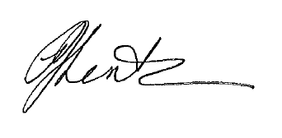
PJ Lentz, CMC, WCMC
Administrator/Clerk/Treasurer
Town of Burke

